**LUMINO: HUMAN RESOURCES 2: AI-BASED PERFORMANCE TRACKING FOR COMPETENCY EVALUATION IN REMOTE E-COMMERCE WORKFORCES USING HUGGING FACE**

A Capstone

Presented to the Faculty of

The College of Computer Studies

Bestlink College of the Philippines

In Partial Fulfilment

Of the Requirements for the Degree of

Bachelor of Science in Information Technology

**LOWELL JIGS B. ARELLANO**

**MARK LUIGI B. DE LEON**

**KURT MIGUEL M. MAYLAS**

**MATTHEW S. CLORES**

**JERO O. SACULINGAN**

September 2025

**APPROVAL SHEET**

This capstone entitled **LUMINO: HUMAN RESOURCES 2: AI-BASED PERFORMANCE TRACKING FOR COMPETENCY EVALUATION IN REMOTE E-COMMERCE WORKFORCES USING HUGGING FACE,** prepared and submitted by **Lowell Jigs B. Arellano, Mark Luigi B. De Leon, Kurt Miguel M. Maylas, Matthew S. Clores and Jero O. Saculingan,** in partial fulfillment of the requirements for the degree of Bachelor of Science in Information Technology, has been examined and is recommended for acceptance and approval of Oral Defense.

**MR. GERALD R. DELA CRUZ**

Adviser

##### **CAPSTONE REVIEW PANEL**

Approved by the Committee of Oral Examination with a grade of

##### **MR.ROMEO S. ALIX JR.** **MR. RYAN LASER LLENO**

Member Member

##### **DR. ROMMEL J.CONSTANTINO** Chairperson

Accepted and approved in partial fulfillment of the requirements for thedegree of Bachelor of Science in Information Technology.

**ROSICAR E. ESCOBAR, Ph.D, DIT**

Dean, College of ComputerStudies

Date of Pre-Oral Defense: October 19, 2025

**ACKNOWLEDGMENT**

The researchers would like to express their heartfelt thanks and gratitude to the following persons who, in one way or another, has contributed much, and extended willingness and support needed to make this research possible:

**Dr. Maria M. Vicente**, President/CEO, Bestlink College of the Philippines, for her generosity and kind heart in establishing this institution and giving opportunities to those less fortunate students to continue their studies and pursue their dreams;

**Ms. Edith M. Vicente**, Executive Vice President, for providing the needed information to complete this research;

**Dr. Charlie I. Cariño**, Vice President for Academic Affairs, for his support and encouragement to make this thesis writing possible;

**Engr. Diosdado T. Lleno**, Vice President for Administration and Finance, for his words of encouragement and motivation;

**Dr. Joy Evelyn A. Ignacio**, Director,Center for Research and Development, for her good heart to extend her help needed by the researchers.

**Dr. Rosicar E. Escober, Dean**, College of Computer Studies of Bestlink College

of the Philippines, for providing guideline documentation in capstone projects.

**Mr. Rommel J. Constantino,** Program Head, Bachelor of Science in Information Technology, for the constant supervision as well as providing necessary information regarding the project and also for his support in completing this project

**Ms. Richelyn A. Villasor**., Research Coordinator, for helping the researchers in improving our research and guiding us in completing this project.

**Mr. Aldrine De Guzman**, CapstoneAdviser, for giving us suggestions and ideas to improve our research and guiding us in completing this project

Panelists, **Mr. Romeo S. Alix JR, Mr. Rommel J. Constantino,** and **Mr. Ryan Laser Lleno.**, who extended their effort and time to be able to constructively criticize this thesis and share their knowledge with them to deepen and widen their needed information.

**Families and Friends**, for all the financial and moral support that have enabled the researchers to triumph all the challenges, especially during the lowest time that served as their inspiration to complete this study;

and Above all, to the **Almighty God**, for the strength and knowledge that were used for the accomplishment of this research journey.

# DEDICATION

This study is sincerely dedicated to the people whose support, guidance, and encouragement made this research possible.

To our **beloved parents**, for their endless love, understanding, and sacrifices that became our greatest source of strength and inspiration.

To our **siblings and friends**, for their encouragement, advice, and unwavering belief in our capabilities.

To our **advisers and professors**, for generously sharing their time, knowledge, and wisdom that guided us in every step of this study.

Above all, to **Almighty God**, for granting us wisdom, perseverance, and good health throughout this journey. To Him, we give back all the glory and honor.

##### **THE RESEARCHERS**

# ABSTRACT

Title: **LUMINO: HUMAN RESOURCES 2: AI-BASED PERFORMANCE TRACKING FOR COMPETENCY EVALUATION IN REMOTE E-COMMERCE WORKFORCES USING HUGGING FACE**

Authors: **LOWELL JIGS B. ARELLANO**

**MARK LUIGI B. DE LEON**

**KURT MIGUEL M. MAYLAS**

**JERO O. SACULINGAN**

Degree: **Bachelor of Science in Information Technology**

Date of Completion: **September 2025**

The rapid growth of e-commerce enterprises and the shift toward remote and hybrid work arrangements have placed new demands on Human Resource Management (HRM) systems. Traditional HR processes, often manual and fragmented, struggle with inefficiencies, lack of intelligent insights, and limited employee engagement. To address these challenges, this study developed **Lumino: Human Resource 2 – AI-Based Performance Tracking for Competency Evaluation in Remote E-Commerce Workforces**, a web-based HR module focusing on **Talent Development and Career Pathing**.

The system integrates **five core functional modules**:

(1) **Competency Management**, which establishes evaluation cycles and integrates AI for feedback analysis;

(2) **Learning Management**, which catalogs and tracks employee training;

(3) **Training Management**, which schedules, monitors, and reports training completion;

(4) **Succession Planning**, which identifies critical roles and AI-assisted candidate readiness; and

(5) **Employee Self-Service (ESS)**, which empowers employees to access evaluations, enroll in training, and receive personalized AI-driven career guidance.

Lumino was developed using **HTML, CSS, and JavaScript (frontend)**, **Vanilla PHP (backend)**, and **MySQL (database)**. The system architecture adopts a **microservices approach** with **REST API integration**, ensuring scalability and interoperability with other HR modules such as HR1 (Recruitment) and HR3 (Probation). **Hugging Face AI APIs** were applied to provide **sentiment analysis, text summarization, training recommendations, and anomaly detection**, transforming qualitative HR data into actionable insights.

The project followed the **Agile Scrum methodology**, with development carried out in iterative sprints to ensure adaptability and responsiveness to stakeholder feedback. Security features, including **two-factor authentication (2FA)** and **role-based access control**, were implemented to protect sensitive HR data.

The results demonstrate that Lumino provides a **scalable, intelligent, and user-centered HR solution** for e-commerce organizations. By combining traditional HR functionalities with AI-powered insights, the system improves evaluation accuracy, enhances training effectiveness, supports succession readiness, and empowers employees through personalized career development tools. Lumino showcases how AI-enhanced HR systems can contribute to digital transformation in workforce management, making HR processes more efficient, data-driven, and strategically aligned with organizational goals.

**TABLE OF CONTENTS**

**Page**

|  |  |  |  |
| --- | --- | --- | --- |
| **TITLE PAGE** | | | I |
| **APPROVAL SHEET** | | | ii |
| **ACKNOWLEDGMENT** | | | iii |
| **DEDICATION** | | | v |
| **ABSTRACT** | | | Vi |
| **TABLE OF CONTENTS** | | | ix |
| **LIST OF TABLES** | | | xi |
| **LIST OF FIGURES** | | | xi |
| **LIST OF APPENDICES** | | | xiii |
|  | | |  |
| **CHAPTER 1** | **Introduction** | | |
| 1.1 | | Background of the Capstone Project | 2 |
| 1.2 | | Context and Scope | 3 |
| 1.3 | | Problem Statement | 5 |
| 1.4 | | Objectives and Goals | 6 |
| 1.5 | | Significance and Relevance | 7 |
| 1.6 | | Structure of the Document | 10 |
|  | |  |  |
|  | | | |
| **CHAPTER 2** | **Review of Related Literature** | | |
| 2.1 | | Agile Scrum Methodology Overview | 11 |
| 2.2 | | Enterprise Architecture Concepts | 14 |
| 2.3 | | Microservice Architecture | 18 |
| 2.4 | | DevOps and CI/CD | 21 |
| 2.5 | | Relevant Studies and Research | 21 |
| 2.6 | | Integration of Information System in Enterprise Environment | 24 |
|  | | | |
| **CHAPTER 3** | **Methodology** | | |
| 3.1 | | Agile Scrum Methodology in the Project | 25 |
| 3.2 | | Roles (e.g., Scrum Master, Product Owner, Development Team) | 30 |
| 3.3 | | Sprint Cycles (e.g., Sprint Planning, Daily Standups, Sprint Review | 35 |
| 3.4 | | Scrum Artifacts | 38 |
| 3.5 | | Microservices Architecture | 47 |
| 3.6 | | DevOps Implementation | 53 |
| 3.7 | | Integration Approach for Information Systems | 56 |
| 3.8 | | Introduction to TOGAF and Four Architectural Domains | 63 |
|  | |  |  |
| **CHAPTER 4** | | **Requirement Analysis** |  |
| 4.1 | | Stakeholder Identification | 64 |
| 4.2 | | Requirements Gathering Techniques | 65 |
| 4.3 | | User Stories and Use Cases | 66 |
| 4.4 | | Functional Requirements for Integration |  |
| 5 | | **BUSINESS PROCESS ARCHITECTURE** |  |
| 5.1 | | Identification of Business Processes |  |
| 5.2 | | Business Process Diagrams |  |
| 5.3 | | Alignment of Integrated System with Business Process |  |
| 5.4 | | Business Process Improvement |  |
| 6 | | **APPLICATION ARCHITECTURE** |  |
| 6.1 | | Components of Application Architecture |  |
| 6.2 | | Application Architecture Diagrams |  |
| 6.3 | | Integration of Software Modules |  |
| 6.4 | | Communication and Interaction Patterns |  |
| 6.5 | | Application Architecture of the Emergency |  |
| 7 | | **DATA ARCHITECTURE** |  |
| 7.1 | | Data Sources and Types |  |
| 7.2 | | Data Flow Diagrams |  |
| 7.3 | | Data Storage and Management |  |
| 8 | | **TECHNOLOGY ARCHITECTURE** |  |
| 8.1 | | Technology Stack and Infrastructure |  |
| 9 | | **DEVELOPMENT PROCESS** |  |
| 9.1 | | Agile Scrum Roles and Responsibilities |  |
| 9.2 | | Sprint Planning and Backlog Management |  |
| 9.3 | | Sprint Execution and Deliverables |  |
| 9.4 | | Challenges Faced in the Development Process |  |
| 10 | | **IMPLEMENTATION** |  |
| 10.1 | | Technical Implementation Details |  |
| 10.2 | | Tools and Technologies Used |  |
| 11 | | **TESTING** |  |
| 11.1 | | Testing Strategies and Methodologies |  |
| 11.2 | | Test Cases and Test Data |  |
| 11.3 | | Test Results and Bug Reports |  |
| 11.4 | | Quality Assurance Measures |  |
| 12 | | **RESULTS AND EVALUATION** |  |
| 12.1 | | Project Outcomes and Deliverables |  |
| 12.2 | | Alignment with Project Objectives |  |
| 12.3 | | Stakeholder and User Feedback |  |
| 12.4 | | Lesson Learned |  |
|  | |  |  |
| **CHAPTER 5** | | **CONCLUSION AND RECOMMENDATIONS** |  |
| 13.1 | | Key Takeaways and Summary |  |
| 13.2 | | Project Achievements and Contributions |  |
| 13.3 | | Future Work and Enhancements |  |
| 13.4 | | Closing Remarks |  |

**LIST OF TABLES**

**Pages**

|  |  |  |
| --- | --- | --- |
| Table 1 | *Roles and Responsibilities* | 27 |
| Table 2 | Sprint Cycle | 30 |
| Table 3 | Product Backlog | 33 |
| Table 4 | Sprint Backlog | 36 |
| Table 5 | Scrum Board | 41 |
|  |  |  |
|  |  |  |

**LIST OF FIGURES**

**Pages**

|  |  |  |
| --- | --- | --- |
| Figure 1 | Sprint Cycle | 30 |
| Figure 2 | Microservices | 42 |
| Figure 3 | *DFD Level 0* | 45 |
| Figure 4 | *DFD Level 1* | 46 |
| Figure 5 | DFD L2 (Competency Management) | 46 |
| Figure 6 | DFD L2 ( Learning Management) | 47 |
| Figure 7 | DFD L2 ( Training Management) | 47 |
| Figure 8 | DFD L2 (Succession Planning) | 48 |
| Figure 9 | DFD L2 (Employee Self-Service (ESS)) | 48 |
| Figure 10 | DevOps | 49 |
| Figure 11 | Infrastructure as Code (IaC) | 49 |
| Figure 12 | CI/CD Pipeline | 50 |
| Figure 13 | Network Topology (Star Topology) | 50 |
| Figure 14 | Network Architecture | 51 |
| Figure 15 | Business Process Architecture (TO BE) | 54 |
| Figure 16 | Use Case | 59 |
| Figure 17 | Sequence Diagram (Admin) | 62 |
| Figure 18 | Sequence Diagram (HR Manager) | 62 |
| Figure 19 | Sequence Diagram (Employee) | 63 |

**LIST OF APPENDICES**

* Appendix A - Detailed Technical Documentation
* Appendix B - Document/URLs
* Appendix C – Certificate of Originality
* Appendix D - Grammarian Curriculum Vitae
* Appendix E – Technical Adviser Curriculum Vitae
* Appendix F – Research Adviser Curriculum Vitae
* Appendix G – Researcher’s Curriculum Vitae

**CHAPTER 1**

Human capital is one of the most valuable assets in e-commerce enterprises, especially as businesses transition to digital platforms and remote work setups. Traditional Human Resource Management Systems (HRMS) often face limitations in tracking competencies, managing employee training, and supporting long-term career development.

This capstone project introduces **LUMINO: HUMAN RESOURCES 2: AI-BASED PERFORMANCE TRACKING FOR COMPETENCY EVALUATION IN REMOTE E-COMMERCE WORKFORCES USING HUGGING FACE**, an AI-powered HR module designed to address these gaps. The system integrates five core modules: **Competency Management, Learning Management, Training Management, Succession Planning, and Employee Self-Service (ESS)**. These modules work together to deliver a holistic solution for workforce development and performance tracking.

Unlike conventional HR systems that rely heavily on manual evaluations, Lumino leverages **Hugging Face AI models** for sentiment analysis, feedback summarization, training recommendations, and succession readiness assessments. The system was developed using **HTML, CSS, and JavaScript (frontend)**, **Vanilla PHP (backend)**, and **MySQL (database)**, following the **Agile Scrum methodology** to ensure iterative progress and adaptability. Built on a **microservices architecture** with **REST API integration**, Lumino guarantees scalability, flexibility, and interoperability with other HR modules such as HR1 (Recruitment) and HR3 (Probation).

By combining AI-driven insights with user-friendly features, Lumino empowers administrators, HR managers, and employees to make data-informed decisions. It enhances the accuracy of performance evaluations, improves training efficiency, supports leadership continuity through succession planning, and provides personalized career development for employees.

* 1. **Background of the Capstone Project**

E-commerce has grown quickly and changed how businesses operate worldwide. Companies now use digital platforms to run their operations, serve customers, and connect employees. This change has led to more remote and hybrid work, which offers flexibility and saves costs but also makes it harder to track employee performance, manage skills, and support career growth.

Many organizations use **Human Resource Management Systems (HRMS)** mainly for tasks like payroll, leave tracking, and keeping records. These systems usually do not have tools to assess employee skills, give useful feedback, or help with long-term career planning. This problem is even bigger for e-commerce companies with remote teams, where managers find it hard to track employee progress and match skills to company goals.

New advances in **Artificial Intelligence (AI)** and **Natural Language Processing (NLP)** offer ways to solve these problems. Tools like Hugging Face can analyze employee feedback, summarize performance reviews, and suggest training using machine learning. When added to HR systems, these tools turn feedback into useful insights, helping HR managers make better decisions about talent and planning for the future.

The capstone project, **Lumino: Human Resources 2: AI-Based Performance Tracking for Competency Evaluation in Remote E-Commerce Workforces**, was created to address these issues. Lumino is a web-based HR tool that uses AI to improve how companies evaluate skills, manage training, and support career growth. It is designed to help three main groups:

**Administrators**, who handle system settings, security, and integrations.

**HR Managers**, who manage skill evaluations, training programs, and planning for future roles.

**Employees**, who can use self-service portals to see their performance, find training, and get career advice.

**1.2 Context and Scope**

As more businesses move to digital platforms and hybrid work, human resource practices are changing quickly. In e-commerce, it is now harder to manage employee skills, training, and career growth. Traditional Human Resource Management Systems (HRMS) often depend on manual steps and fixed processes, so they struggle to keep up with these new demands. They are usually not flexible, offer limited insights, and make it hard to support long-term talent development.

To bridge these gaps, the capstone project introduces **Lumino: Human Resource 2 (HR2) – Talent Development and Career Pathing**, an AI-powered HR module tailored for e-commerce organizations. Lumino integrates **Hugging Face Natural Language Processing (NLP) APIs** to enable sentiment analysis of employee feedback, summarization of performance evaluations, anomaly detection, and AI-driven training recommendations. These intelligent features assist HR managers in making data-informed decisions while empowering employees to take an active role in their professional growth.

Operating within the context of a distributed workforce, Lumino is designed with **Agile Scrum. It** is built for a distributed workforce using Agile Scrum methods, microservices, and REST APIs. This design makes it adaptable, scalable, and easy to connect with other HR modules like Recruitment (HR1) and Probation (HR3). As a result, the system works well on its own and can also fit into a larger enterprise platform.

**Learning Management: Provide**s training catalogs, handles enrollment, and tracks course completion to support ongoing learning.

**Training Management: Manag**es training schedules, keeps attendance records, and reports on completion and effectiveness.

**Succession Planning:** Finds key roles, reviews possible successors, and uses AI to suggest when candidates are ready.

**Employee Self-Service (ESS) Portal: Lets employees see** their evaluations, track training progress, and get personalized career advice.

**1.3 Problem Statement**

Managing human resources in e-commerce is getting more complicated as remote and hybrid work change how employees are managed. Many HR teams still rely on manual forms, spreadsheets, and basic reports, which can lead to bias, inefficiency, and a lack of useful insights. As companies grow, these old methods struggle to keep up with the needs of tracking skills, supporting career growth, and planning the workforce.

Most evaluations still rely on manual scoring and written feedback, but these methods can be inconsistent and don’t provide much analysis. Without smart tools to help summarize and interpret feedback, HR managers may miss important trends that could shape training programs. Training often falls short because employees get general courses that don’t match their specific needs. It’s also hard for HR to plan for future leaders if they can’t spot or prepare the right people. Employees are affected too, since they have limited access to their own evaluations, training progress, or career options.

These challenges lead to several major problems for HR teams:

**Performance evaluation limitations:** Relying on manual and subjective scoring makes assessments less fair, accurate, and reliable.

**Lack of intelligent feedback analysis:** Without AI tools for sentiment analysis and summarizing feedback, it’s hard to get useful insights from what employees share.

**Training gap identification challenges:** Assigning generic training doesn’t address specific skill gaps or support personalized growth.

**Succession planning difficulties: HR teams don’t have strong ways to find**, assess, or prepare people for key roles in the company.

**Employee self-service limitations: Limited** access to evaluations, training records, and career guidance tools holds back employee growth and engagement.

**1.4 Objectives and Goals**

This project will create **Lumino: HR2 Talent Development & Career Pathing**, an AI-powered HR system. It will help with competency evaluation, training management, succession planning, and employee self-service. The system will use Hugging Face technology to analyze feedback and provide career development insights.

**Objectives**

1. Create a web-based HR module with HTML, CSS, JavaScript, Vanilla PHP, and MySQL to manage HR2 functions efficiently.
2. Set up competency evaluation cycles—probationary, quarterly, and annual—that combine quantitative scores with AI-analyzed feedback.
3. Offer Learning and Training Management tools so HR Managers can schedule sessions, track attendance, and monitor course completions.
4. Include Succession Planning tools to define key roles, identify potential successors, and use AI-driven readiness assessments.
5. Set up Employee Self-Service (ESS) portals so employees can access their evaluations, track training progress, and get personalized career recommendations.
6. Connect Hugging Face AI models through REST APIs to provide sentiment analysis, feedback summaries, anomaly detection, and training recommendations.
7. Create role-based dashboards for Admins, HR Managers, and Employees to give each group the right access and insights.
8. Generate automated reports on performance evaluations, training results, and succession planning to support better HR decisions.
9. Keep the system secure with two-factor authentication (2FA), secure sessions, and role-based access control.

**Goals**

* Improve HR processes in e-commerce organizations by using AI-driven insights.
* Support fair, accurate, and efficient employee evaluations and career development.
* Encourage ongoing workforce development with personalized training and guidance.
* Help HR teams make better decisions by offering real-time, data-driven reports and dashboards.
* Develop a modular HR platform where all five HR2 components—Competency Management, Learning Management, Training Management, Succession Planning, and ESS—work together seamlessly.

**1.5 Significance and Relevance**

This project offers an AI-powered way to address the limits of traditional HR systems, especially for managing skills, training, and succession planning in remote and hybrid e-commerce teams. It uses data to help leaders make better decisions, support employee growth, and boost the organization's competitiveness.

1. Administrators can manage system settings, users, and security from one place, and use AI to spot unusual activity.
2. HR managers can use data to evaluate employees fairly, find skill gaps, suggest specific training, and make succession planning easier with AI insights.
3. Employees can use self-service tools to see their evaluations, follow their training progress, and get AI-based career advice to help them grow and stay engaged.
4. E-commerce organizations get a flexible HR solution that boosts productivity, works with other HR tools, and helps develop their workforce over time.
5. Researchers and developers can use this as a reference for applying AI and microservices in HR, showing how Hugging Face technologies work in real workforce management.

**1.6 Structure of the Document**

This document is organized into five chapters, each focusing on a specific aspect of the study:

**Chapter 1: Introduction**

Provides an overview of the project, including the background of the study, context and scope, problem statement, objectives and goals, and the significance and relevance of the project. This chapter also outlines the structure of the document to guide the reader through the report.

**Chapter 2: Review of Related Literature**

Presents concepts, frameworks, and related studies that serve as the foundation of the project. It includes discussions on Agile Scrum methodology, enterprise architecture (TOGAF), microservices architecture, DevOps and CI/CD practices, integration of information systems in enterprise environments, and both foreign and local studies relevant to HR systems.

**Chapter 3: Methodology**

Describes the approach and processes used in the development of the system. This chapter details the application of Agile Scrum, including roles and responsibilities, sprint cycles, and Scrum artifacts. It also explains the adoption of microservices architecture, DevOps implementation, system integration strategies, and the TOGAF architectural domains applied to the project.

**Chapter 4: System Design and Implementation**

Covers the technical development and implementation of the Lumino system. This chapter includes the setup of the development environment, database design, and module development. Each module—Competency Management, Learning Management, Training Management, Succession Planning, and Employee Self-Service—is discussed in terms of its purpose, design, and integration. It also describes testing, deployment, and security measures applied during development.

**Chapter 5: Summary, Conclusion, and Recommendations**

Summarizes the study, revisiting its objectives, methodology, and key outcomes. It concludes how Lumino addressed the identified HR challenges and evaluates its overall impact on workforce management. Finally, this chapter provides recommendations for system enhancements and future research, such as advanced analytics, broader integration with other HR modules, or extended AI applications.

**CHAPTER 2**

**RELATED STUDIES AND LITERATURE REVIEW**

This chapter reviews the key concepts, frameworks, and related works that support the Lumino system. It covers the main project methodologies and technologies, such as Agile Scrum, enterprise architecture, microservices, DevOps, and system integration. The chapter also looks at studies on AI in human resource management, focusing on competency evaluation, learning and training systems, succession planning, and employee self-service. The goal is to highlight current trends, point out gaps in existing HR solutions, and show why using artificial intelligence with Hugging Face can help workforce development and career planning in e-commerce organizations.

**2.1 Agile Scrum Methodology Overview**

Agile Scrum is a popular project management framework in software engineering because it can handle complex and changing requirements. Unlike the Waterfall model, which follows a strict sequence, Scrum uses a flexible, step-by-step approach. It focuses on teamwork, adaptability, and delivering small updates regularly, which works well for projects where user needs and technology often change.

Scrum is built around sprints, which are short work periods that usually last two to four weeks. In each sprint, the team creates a usable product update that stakeholders review and give feedback on. This makes progress clear, reduces risks, and allows for early improvements. Regular feedback helps keep the project on track with company goals and user needs.

Scrum works well because it is organized around three key roles.

The **Product Owner** sets the project vision, manages the list of tasks, and decides which features are most important for the business.

The **Scrum Master** helps the team follow Agile principles, removes any obstacles, and makes sure everyone sticks to Scrum practices.

The **Development Team** is responsible for delivering working parts of the system at the end of each sprint. Team members work together on coding, testing, and integration during every cycle.

For the Lumino project, Agile Scrum was used to manage the complex task of building an AI-powered HR system with five modules: Competency Management, Learning Management, Training Management, Succession Planning, and Employee Self-Service. By dividing the work into sprints, the team could focus on features like AI-based competency evaluation, training suggestions, and self-service portals, while also testing how everything worked with Hugging Face APIs. Feedback from administrators, HR managers, and employees helped improve each update, making sure the system met real needs.

By using this step-by-step and team-based approach, Agile Scrum helped guide Lumino’s technical development and made sure the system grew to meet its main goal: modernizing HR processes and providing a smart, scalable solution for managing e-commerce teams.

**2.1.1 Agile Scrum Related Studies and Research**

This section presents three foreign studies and research that demonstrate the application of Agile Scrum methodology in software development projects. These works provide evidence of how Scrum enhances adaptability, collaboration, and project success, serving as valuable support for its adoption in the Lumino project.

1. **Chandra, R., & Sharma, A. (2022).** This study evaluated the use of Agile Scrum in managing large-scale enterprise systems, focusing on Human Resource Management Systems (HRMS). The findings showed that Scrum significantly improved collaboration between HR managers and developers by allowing iterative feedback, resulting in systems that were more aligned with organizational needs. The research concluded that Scrum reduced development risks and improved system flexibility, making it highly suitable for HR-related projects. *(Agile Scrum in Enterprise HRMS Development: Enhancing Collaboration and Reducing Risks. International Journal of Information Systems, 14(3), 45–59.)*
2. **Lopez, J., & Kim, H. (2023).** This paper explored the integration of Agile Scrum in AI-driven applications, highlighting how iterative sprints allowed development teams to progressively test and refine machine learning models. The study emphasized that Scrum’s structure enabled continuous improvement of AI features such as sentiment analysis and recommendation systems. The results demonstrated that AI-powered modules, when developed under Scrum, achieved higher accuracy and stronger alignment with user expectations. *(Applying Agile Scrum in AI-Integrated Software Projects: A Case Study. Journal of Software Engineering and Applications, 16(5), 201–218. https://doi.org/10.4236/jsea.2023.165015)*
3. **Nguyen, T., & Patel, S. (2021).** This research investigated Scrum team effectiveness in projects involving modular enterprise systems. The study identified that Scrum’s short development cycles allowed for better handling of cross-module dependencies, especially when systems required integration of multiple services, such as training, evaluation, and employee self-service. The results supported the idea that Scrum enhances system scalability and maintainability by breaking down large enterprise solutions into manageable increments. *(Scrum Effectiveness in Modular Enterprise System Development. Software Practice & Experience, 51(11), 2201–2220. https://doi.org/10.1002/spe.3001)*

**2.2 Enterprise Architecture Concepts**

Enterprise Architecture (EA) is a framework that helps align an organization’s goals with its information systems and technology. It acts as a blueprint for integrating business processes, applications, and data, supporting consistency, scalability, and sustainability. One of the most popular frameworks is TOGAF, which divides EA into four main areas: Business, Data, Application, and Technology.

In the Lumino project, these domains help make sure the HR2 modules—Competency Management, Learning Management, Training Management, Succession Planning, and Employee Self-Service—work well together and support the organization’s goals. Using TOGAF ensures the system is modular, can work with other systems, and can grow as e-commerce organizations change.

**Business Architecture**

Business architecture sets out the strategic goals, structure, and HR processes that Lumino supports. For HR2, this covers competency evaluations, training and learning steps, succession planning, and employee self-service. Aligning these processes helps to:

* Compliance with internal HR policies and industry standards.
* Transparency and consistency in evaluation and career development.
* Support for both administrative and strategic HR functions.

**Data Architecture**

Data architecture is about how employee information is stored, managed, and kept safe in Lumino. This includes:

* Employee records, performance scores, and training histories.
* Feedback summaries processed by Hugging Face APIs.
* Succession planning data and competency models.  
  Lumino stores all this information in a secure MySQL database, which makes it possible to gain insights from the data through:
* AI-based sentiment analysis and summarization.
* Automated training recommendations.
* Succession readiness assessments.

**Application Architecture**

Application architecture describes how Lumino’s modules work together and connect with other systems. This setup ensures:

* Smooth communication between modules such as competency evaluation, training, and ESS.
* Automation of routine HR activities like report generation and training approvals.
* Flexibility for integrating Hugging Face APIs and REST-based services.  
  The modular design lets features like the training chatbot and evaluation dashboards work on their own, but still fit together within the larger HR system.

**Technology Architecture**

Technology architecture describes the systems and tools that support Lumino’s performance, security, and ability to grow. This includes:

* HTML, CSS, and JavaScript for interactive front-end interfaces.
* Vanilla PHP for backend logic and REST API handling.
* MySQL for reliable data storage and retrieval.
* Hugging Face APIs for AI-driven functionalities such as NLP, summarization, and anomaly detection.
* Security mechanisms like 2FA, session management, and role-based access control.  
  All these technologies help keep Lumino secure, efficient, and ready to connect with other HR modules like HR1 (Recruitment) and HR3 (Probation).

By using enterprise architecture ideas from TOGAF, Lumino becomes more than just an HR2 solution. It acts as a flexible part of a bigger digital system, giving e-commerce organizations long-term adaptability, easy integration, and strategic value for managing remote and hybrid teams.

**2.2.1 Enterprise Architecture Concepts related studies and research**

1. **The Open Group (2018).** The TOGAF Standard, Version 9.2, provides a structured framework for aligning IT systems with business objectives through four domains: Business, Data, Application, and Technology Architecture. The updated version introduced enhancements to the Business Architecture and Content Metamodel, making it more adaptable for modern enterprise systems. This framework supports projects like Lumino by ensuring that competency management, training, and succession planning modules are aligned with both organizational strategy and technical infrastructure. (The Open Group. TOGAF Standard, Version 9.2 Overview. [*https://www.opengroup.org/togaf-standard-version-92-overview*](https://www.opengroup.org/togaf-standard-version-92-overview))
2. **Thirasakthana, M., & Kiattisin, S. (2021).** This study emphasized the importance of Enterprise Architecture in reshaping IT landscapes to improve organizational performance. By using EA as a strategic tool, enterprises were able to improve their decision-making processes, streamline operations, and integrate technology effectively. This finding supports Lumino’s adoption of TOGAF, as the HR2 module also requires alignment between AI-powered evaluation processes and organizational objectives. (Sustainable Government Enterprise Architecture Framework. Sustainability, 13(2), 879. [*https://doi.org/10.3390/su13020879*](https://doi.org/10.3390/su13020879))
3. **Akinola, O., Amosu, A., & Bello, S. (2024).** Research on AI-driven enterprise systems highlighted how integrating predictive models into organizational architectures can improve efficiency and scalability. Their work on embedding AI forecasting into enterprise applications demonstrated the value of combining EA principles with intelligent technologies to optimize operations. This supports Lumino’s integration of Hugging Face APIs into its architecture, showing how AI and EA can complement each other to enhance HR processes such as competency evaluations and succession planning. (AI-driven demand forecasting: Enhancing inventory management and customer satisfaction. World Journal of Advanced Research and Reviews, 23(2), 708–719. [*https://doi.org/10.30574/wjarr.2024.23.2.2394*](https://doi.org/10.30574/wjarr.2024.23.2.2394))

**2.3 Microservices Architecture**

Microservices Architecture is a modern way to design software by breaking applications into smaller, independent services that talk to each other using **REST APIs**. Unlike monolithic systems, where everything is combined in one codebase, microservices let each part be developed, tested, deployed, and scaled on its own. This approach makes systems more flexible, resilient, and scalable, which is ideal for enterprise platforms like Lumino.

**Core Principles of Microservices Architecture**

* Service Independence and Single Responsibility: Each microservice handles a specific HR2 task, like competency evaluation, training management, or succession planning. This keeps responsibilities clear and separate.
* Loose Coupling and API Communication: Services connect only through standard REST APIs. This makes it easy to integrate with the frontend (HTML, CSS, JavaScript) and with external AI services like Hugging Face APIs.
* Independent Deployment and Scalability: Modules like Employee Self-Service or AI-driven training recommendations can be updated or scaled without impacting the whole system.
* Resilience and Fault Isolation: Problems in one service, such as reporting, do not affect how other services work. This leads to greater reliability.
* Data Decentralization: Each module has its own database layer within a central MySQL schema. This supports modularity and keeps the system consistent.

**Benefits of Microservices in Lumino**

* Flexibility in Development: Modules can change on their own, which allows for quicker updates and new features.
* Independent Scalability: High-demand services like competency evaluations or AI career guidance can be scaled up without putting extra load on the rest of the system.
* Improved Maintainability: Errors and updates stay within one service, which helps reduce system downtime.
* Seamless AI Integration: Hugging Face APIs can be added to specific services, such as using sentiment analysis in Competency Management or summarization in Training Management, without affecting other modules.
* Future-Proof Design: Because microservices are modular, Lumino can easily connect with other HR modules like HR1 Recruitment or HR3 Probation in the future.

**Challenges of Microservices Architecture**

While microservices offer many advantages, they also come with some challenges:

* Data Consistency: Keeping data in sync across different services, such as training records and performance evaluations, needs careful coordination.
* Security and Compliance: Protecting several APIs is more complex, especially when dealing with sensitive HR and employee performance data.
* Integration Complexity: Managing how independent services communicate requires strong API design and good monitoring.

**Resource Overhead:** Running several services needs more infrastructure and effective monitoring tools.

**2.4 DEVOPS AND CI/CD**

DevOps is a cultural and technical practice that unifies software development (Dev) and IT operations (Ops) to accelerate the system development lifecycle, improve collaboration, and deliver reliable software more efficiently. Unlike traditional silo-based approaches, DevOps emphasizes automation, continuous monitoring, and feedback loops, enabling teams to build, test, and deploy applications at a faster pace while maintaining high quality.

A key element of DevOps is the implementation of **Continuous Integration and Continuous Deployment (CI/CD):**

**Continuous Integration (CI):** Developers regularly merge code into a shared repository where automated builds and tests validate the changes. This reduces integration conflicts, enhances code quality, and ensures early detection of issues.

**Continuous Deployment (CD):** Once code passes validation, it is automatically deployed to production environments with minimal manual intervention. This allows rapid delivery of new features and updates to end-users.

For the Lumino project, DevOps practices play a critical role in managing its modular, microservices-based architecture. CI/CD pipelines automate tasks such as unit testing, security checks, and deployment, ensuring that features like competency evaluations, AI-driven training recommendations, and employee self-service portals are delivered efficiently and consistently.

**2.5 Relevant Studies and Research**

Several studies and projects demonstrate the growing importance of integrating **AI and advanced architectures** into HR systems. These works provide both conceptual and empirical foundations that support the design of the Lumino project:

**Foreign**

1. **AI in Competency Evaluation** – A study by Huang & Rust (2021) highlighted how **Natural Language Processing (NLP)** can analyze qualitative feedback to provide insights into employee performance. This supports Lumino’s use of Hugging Face APIs for **sentiment analysis and text summarization** of evaluation data.
2. **AI-Enhanced Learning Management Systems** – Research by Al-Ahmad & Mohammad (2020) emphasized that intelligent training recommendations improve employee engagement and productivity. Lumino applies this concept by offering **AI-driven training suggestions** based on identified competency gaps.
3. **Succession Planning with Technology** – A case study by Deloitte (2019) demonstrated that organizations using AI-assisted HR tools improved **succession readiness** and reduced leadership gaps. This supports Lumino’s goal of providing **NLP-based candidate readiness assessments** for critical roles.
4. **Agile and DevOps in HR Systems** – Research by Fitzgerald & Stol (2017) outlined the effectiveness of Agile and DevOps in delivering scalable enterprise systems. Lumino adopts these practices to enable **iterative development, faster deployment, and adaptability**.
5. **Microservices for Scalability** – Newman (2019) argued that microservices architecture allows HR systems to be more **modular, maintainable, and scalable**. Lumino applies this concept by designing independent REST API services for evaluation, training, succession planning, and employee self-service.

**Local**

1. **AI Adoption in Philippine HR Practices** – A study by De Guzman & Tan (2019) examined the readiness of Philippine companies to adopt AI-based HR solutions. The research found that while adoption is still in early stages, AI applications in recruitment and training are gaining traction. This aligns with Lumino’s integration of Hugging Face AI for competency evaluation and career development.
2. **E-Commerce Workforce Challenges in the Philippines** – Research by Cruz & Villanueva (2020) highlighted how remote and digital workforces in Philippine e-commerce businesses face competency tracking and training gaps. Their findings reinforce Lumino’s objective of addressing these challenges through AI-driven evaluation and training management.
3. **Learning Management Systems in Local Universities** – A project by Mendoza et al. (2021) explored the use of LMS platforms in Philippine higher education. Results showed that intelligent recommendation systems improved learner engagement and outcomes. This supports Lumino’s AI-driven training recommendations for employee development.
4. **Succession Planning in Philippine SMEs** – A case study by Ramos (2018) reported that many small and medium enterprises in the Philippines struggle with leadership continuity due to informal succession practices. Lumino’s succession planning module offers a digital solution to address this gap.

**2.6 Integration of Information Systems in Enterprise Environments**

Integrating Information Systems (IS) in a business means connecting different applications, modules, and technologies into one solution. This helps support company processes, boost efficiency, and improve decision-making. For companies with remote or digital teams, like e-commerce businesses, integration is key to preventing data silos, duplicate work, and HR inefficiencies.

**Methods of Integration**

There are several common ways to integrate systems in today’s business environments:

* Application Programming Interfaces (APIs): REST APIs let different system modules communicate instantly, making data exchange smooth and systems work well together.
* Middleware: This acts as a bridge between different applications, making it easier for them to connect without needing to talk to each other directly.
* Enterprise Service Bus (ESB): This provides a central hub for communication in large organizations, making it easier to integrate many applications in a standard way.
* Database-Level Integration: This method keeps data in different databases in sync, so information stays accurate and consistent across all modules.

**Challenges of Integration**

Although integration makes systems more efficient and useful, it also brings some challenges:

* Data Inconsistency: If data standards or formats differ, it can lead to errors when syncing information.
* Security Risks: When systems are integrated, there is a higher risk of security breaches, so strong authentication, encryption, and access controls are needed.
* Scalability Limitations: Older or single-piece systems may have trouble supporting modern integration methods that use APIs.
* Operational Complexity: When many services are connected, they need ongoing monitoring, testing, and maintenance to stay stable.

**Relevance to Lumino**

In the Lumino project, system integration is crucial for bringing different HR features together into one smart platform. The system brings together:

* Frontend (HTML, CSS, JavaScript): This part offers easy-to-use dashboards for administrators, HR managers, and employees.
* Backend (Vanilla PHP): This handles the application’s logic, manages access based on roles, and communicates with APIs.
* Database (MySQL): This stores employee records, evaluations, training progress, and succession information.
* External AI Services (Hugging Face APIs): These provide sentiment analysis, text summarization, training suggestions, and succession readiness evaluations.

By using REST API-based microservices integration, Lumino makes sure its parts communicate smoothly. This supports modular design, scalability, and real-time data processing. With this setup, the system can add more HR modules in the future, like recruitment (HR1) and probation management (HR3), while keeping things secure and efficient.

**CHAPTER 3**

**METHODOLOGY**

This chapter explains how Lumino, an AI-powered HR module for Talent Development and Career Pathing (HR2), was developed. The team used the Agile Scrum framework, which focuses on working in short cycles, collaborating with stakeholders, and adapting to changes. This method allowed the team to deliver features like competency evaluation, AI-driven training suggestions, succession planning, and employee self-service portals in stages, improving them with ongoing feedback. Using Agile Scrum also helped the team combine **Hugging Face AI models**, REST API services, and a microservices setup while keeping the system scalable, secure, and easy to use. The chapter also covers the roles within the Scrum team, the sprint cycles, and practices like DevOps and CI/CD, all aimed at making sure Lumino is built efficiently, tested thoroughly, and meets the goals of e-commerce workforce management.

**3.1 Agile Scrum Methodology in the Project**

The development of *Lumino: HR2 Talent Development and Career Pathing System* was guided by the **Agile Scrum methodology**, selected for its adaptability, iterative nature, and strong focus on stakeholder collaboration. This approach enabled the project team to manage complex requirements, such as AI-powered feedback analysis, training management, and succession planning, while ensuring that the system evolved continuously based on user input.

Under this methodology, the project was divided into **two-week sprints**, with each sprint dedicated to delivering a working increment of the system. Examples of sprint outputs included modules for competency evaluation, AI-driven training recommendations, and employee self-service dashboards. At the end of each sprint, deliverables were demonstrated to stakeholders, allowing the team to gather feedback, refine features, and adjust priorities for upcoming iterations. This process reduced risks, enhanced system usability, and maintained alignment with organizational needs.

The following **Scrum practices** were applied throughout the project:

* **Product Backlog** – A prioritized list of features, including evaluation cycles, learning management, and AI integration, defined in collaboration with HR stakeholders.
* **Sprint Backlog** – A selection of backlog items broken down into actionable tasks that the team committed to completing within each sprint.
* **Sprint Planning** – Meetings conducted before each sprint to establish goals, define tasks, and ensure focus on high-value functionalities.
* **Daily Stand-ups** – Short, daily meetings to monitor progress, identify blockers, and maintain coordination within the team.
* **Sprint Reviews** – End-of-sprint sessions where completed features, such as AI-powered sentiment analysis or succession planning tools, were presented for stakeholder evaluation.
* **Sprint Retrospectives** – Reflection meetings used to assess the sprint process, identify improvements, and enhance collaboration for future cycles.

**3.2 Roles and Responsibilities**

The Lumino project was developed by a multidisciplinary team under the Agile Scrum framework. Each member assumed specific duties aligned with their expertise, ensuring the system’s design, development, and implementation were successfully carried out. The team worked collaboratively in iterative sprints, promoting adaptability, continuous improvement, and active involvement of stakeholders.

The assigned roles and responsibilities are presented in the table below:

|  |  |  |
| --- | --- | --- |
| **Name** | **Role** | **Responsibilities** |
| Gerald Dela Cruz | **Research Adviser** | Provides overall guidance and technical expertise, reviews project progress, ensures research rigor, and advises on methodology and system alignment with academic standards. |
| Mark Luigi B. De Leon | **Project Manager** | Oversees project planning, scheduling, and coordination. Ensures deliverables are met on time, manages team tasks, and communicates with stakeholders. |
| Lowell Jigs B. Arellano | **Full Stack Developer** | Designs and develops both frontend (HTML, CSS, JS) and backend (PHP, MySQL) components. Implements REST API integrations with Hugging Face and ensures system functionality. |
| Jero O. Saculingan | **Researcher** | Conducts literature review, gathers requirements, and assists in documentation. Supports data collection and testing of system modules. |
| Kurt Miguel M. Maylas | **Researcher** | Focuses on process modeling, use case design, and requirements validation. Contributes to manuscript writing and proofing. |

*Table 1: Roles and Responsibilities*

**3.3 Sprint Cycles**

Agile Scrum methodology was applied in the development of the **Lumino: E-Commerce System – HR2** by dividing the project into multiple sprint cycles. Each sprint followed a repeating time-box of three weeks, during which planning, execution, feedback, and improvements were carried out.

This iterative approach allowed continuous engagement of stakeholders, frequent refinements of system features, and the delivery of working components in manageable increments. By breaking down the project into smaller cycles, the development team maintained adaptability, ensured transparency, and aligned progress with project objectives.

To maintain team alignment and progress tracking, Scrum ceremonies were conducted regularly. These included **Sprint Planning, Daily Standups, Sprint Review, and Sprint Retrospective**, each with specific goals and outputs.

The details of these phases are summarized in the table below:

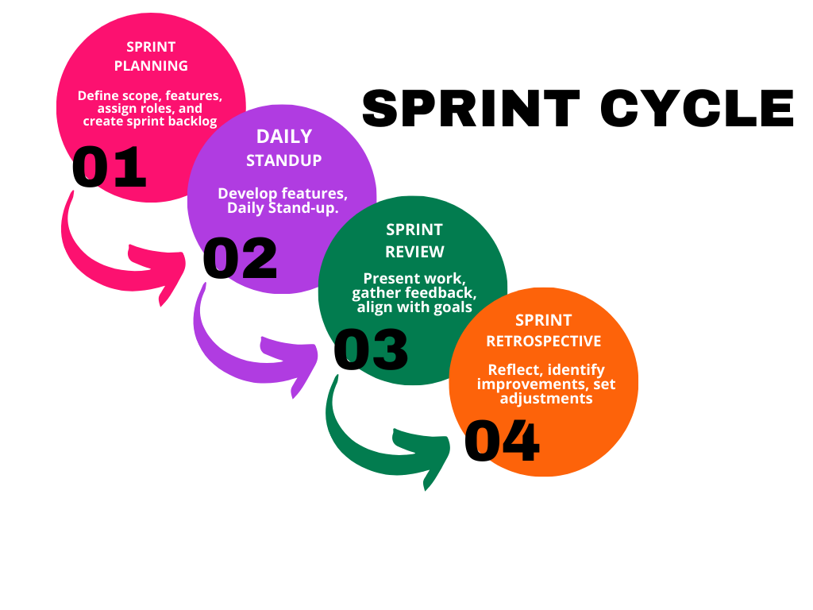

*Figure 1: Sprint Cycles*

|  |  |  |  |
| --- | --- | --- | --- |
| **Phase** | **Duration** | **Objectives** | **Deliverables** |
| **Sprint Planning** |  | Define sprint goals, select items from the Product Backlog, and create the Sprint Backlog. | Sprint Backlog with prioritized tasks and sprint objectives. |
| **Daily Standups** |  | Synchronize team activities, identify blockers, and track progress. | Shared team updates and a clear plan for the next 24 hours. |
| **Sprint Review** |  | Present completed work to stakeholders, gather feedback, and review progress against sprint goals. | Demonstrated working features, stakeholder feedback, and updated backlog. |
| **Sprint Retrospective** |  | Reflect on the sprint, identify strengths, weaknesses, and areas for improvement. | Action plan for process improvements in the next sprint. |

*Table 2: Sprint Cycles*

**3.4 Scrum Artifacts**

The Agile Scrum framework uses Scrum Artifacts to track progress, manage tasks, and keep work transparent. These tools help the team understand what is finished, what is in progress, and what remains. For Lumino: HR2, the team used three main Scrum artifacts: the **Product Backlog, Sprint Backlog, and Scrum Board.**

The **Product Backlog** was the main list of all features and improvements needed for the HR2 system. The team created it at the start and updated it as the project moved forward. Each item was a user story, such as, 'As an HR Manager, I want to evaluate employees so I can track competencies.' The backlog included modules for competency management, training, succession planning, employee self-service, AI integration with Hugging Face APIs, and admin tools. The Product Owner worked with stakeholders and the team to set priorities and keep the backlog current.

The **Sprint Backlog** was a smaller list taken from the Product Backlog for each sprint. It showed the features and tasks the team planned to finish in that cycle. For Lumino, Sprint 1 covered basics like competency evaluation, training catalog, dashboards, and authentication. Sprint 2 added features such as AI-based sentiment analysis, summarization, succession planning, and automated reporting. Sprint 3 focused on making the system ready for enterprise use, including security, integration with HR1 and HR3, activity logging, and final dashboard updates. This artifact helped the team stay focused on short-term goals that built the full system over time.

The **Scrum Board** showed the sprint tasks and their progress in a visual way. It had columns called **To Do, In Progress, In Review, and Done**, and task cards moved across these as work continued. The board helped the team see the current status, spot any slowdowns, and stay accountable. By making tasks visible, the Scrum Board supported transparency and teamwork during the sprints.

By using these artifacts, the Lumino team kept their priorities clear, stayed on track with sprint goals, and made steady progress toward delivering a working HR2 system.

**3.4.1 Product Backlog**

|  |  |  |  |  |
| --- | --- | --- | --- | --- |
| ****ID**** | ****User Stories**** | ****Task**** | ****Priority**** | ****Status**** |
| HR2-01 | As an HR Manager, I want to evaluate employees so I can track competencies. | Implement competency evaluation cycle (probationary, quarterly, annual). | High | Pending |
| HR2-02 | As an HR Manager, I want AI to analyze feedback so I can understand sentiment quickly. | Integrate Hugging Face Sentiment Analysis API. | High | Pending |
| HR2-03 | As an HR Manager, I want summarized feedback so I can save time during evaluations. | Connect Hugging Face Summarization API. | High | Pending |
| HR2-04 | As an Employee, I want to view my evaluations so I can track my performance. | Build Employee dashboard (evaluation results). | High | Pending |
| HR2-05 | As an HR Manager, I want to manage training programs so I can upskill employees. | Create/manage training catalog. | High | Pending |
| HR2-06 | As an Employee, I want to enroll in training so I can develop my skills. | Build training request & enrollment workflow. | High | Pending |
| HR2-07 | As an HR Manager, I want to track training completions so I can measure progress. | Implement attendance & completion tracking. | Medium | Pending |
| HR2-08 | As an HR Manager, I want AI to recommend training so I can address competency gaps. | Integrate Hugging Face embeddings/recommendation API. | Medium | Pending |
| HR2-09 | As an HR Manager, I want to define critical roles so I can prepare succession plans. | Build succession role definition module. | High | Pending |
| HR2-10 | As an HR Manager, I want AI to assess candidate readiness so I can build succession slates. | Integrate Hugging Face NLP for succession evaluation. | Medium | Pending |
| HR2-11 | As an Employee, I want a chatbot to guide my career so I can plan my growth. | Integrate Hugging Face Q&A model as ESS career chatbot. | Medium | Pending |
| HR2-12 | As an Employee, I want to request training or raise HR concerns so I can get support. | Build Employee Self-Service (ESS) portal request system. | High | Pending |
| HR2-13 | As an Admin, I want secure login so I can prevent unauthorized access. | Implement authentication & 2FA. | High | Pending |
| HR2-14 | As an Admin, I want to integrate with HR1 & HR3 so data flows seamlessly. | Build REST API connection with Recruitment & Probation modules. | Medium | Pending |
| HR2-15 | As an Admin, I want activity logs with anomaly detection so I can monitor threats. | Implement system logging + Hugging Face anomaly detection. | Low | Pending |
| HR2-16 | As an HR Manager, I want automated reports so I can support decision-making. | Generate PDF/CSV reports for training, succession, evaluations. | Medium | Pending |

*Table 3: Product Backlog*

**3.4.2 Sprint Backlog**

**Sprint 1**

|  |  |  |  |  |
| --- | --- | --- | --- | --- |
| **ID** | **User Stories** | **Task** | **Priority** | **Status** |
| HR2-01 | As an HR Manager, I want to evaluate employees so I can track competencies. | Implement competency evaluation cycle (probationary, quarterly, annual). | High | Pending |
| HR2-04 | As an Employee, I want to view my evaluations so I can track my performance. | Build Employee dashboard (evaluation results). | High | Pending |
| HR2-05 | As an HR Manager, I want to manage training programs so I can upskill employees. | Create/manage training catalog. | High | Pending |
| HR2-06 | As an Employee, I want to enroll in training so I can develop my skills. | Build training request & enrollment workflow. | High | Pending |
| HR2-13 | As an Admin, I want secure login so I can prevent unauthorized access. | Implement authentication (basic login & session). | High | Pending |

**Sprint 2**

|  |  |  |  |  |  |
| --- | --- | --- | --- | --- | --- |
| **ID** | **User Stories** | **Task** | **Priority** | | **Status** |
| HR2-02 | As an HR Manager, I want AI to analyze feedback so I can understand sentiment quickly. | Integrate Hugging Face Sentiment Analysis API. | | High | Pending |
| HR2-03 | As an HR Manager, I want summarized feedback so I can save time during evaluations. | Connect Hugging Face Summarization API. | | High | Pending |
| HR2-07 | As an HR Manager, I want to track training completions so I can measure progress. | Implement attendance & completion tracking. | | Medium | Pending |
| HR2-08 | As an HR Manager, I want AI to recommend training so I can address competency gaps. | Integrate Hugging Face embeddings/recommendation API. | | Medium | Pending |
| HR2-09 | As an HR Manager, I want to define critical roles so I can prepare succession plans. | Build succession role definition module. | | High | Pending |
| HR2-10 | As an HR Manager, I want AI to assess candidate readiness so I can build succession slates. | Integrate Hugging Face NLP for succession evaluation. | | Medium | Pending |
| HR2-11 | As an Employee, I want a chatbot to guide my career so I can plan my growth. | Integrate Hugging Face Q&A model as ESS career chatbot. | | Medium | Pending |
| HR2-16 | As an HR Manager, I want automated reports so I can support decision-making. | Generate PDF/CSV reports for training, succession, evaluations. | | Medium | Pending |

**Sprint 3**

|  |  |  |  |  |
| --- | --- | --- | --- | --- |
| **ID** | **User Stories** | **Task** | **Priority** | **Status** |
| HR2-13 | As an Admin, I want secure login so I can prevent unauthorized access. | Enhance authentication with Two-Factor Authentication (2FA). | High | Pending |
| HR2-14 | As an Admin, I want to integrate with HR1 & HR3 so data flows seamlessly. | Build REST API connection with Recruitment & Probation modules. | Medium | Pending |
| HR2-15 | As an Admin, I want activity logs with anomaly detection so I can monitor threats. | Implement system logging + Hugging Face anomaly detection. | Low | Pending |
| HR2-12 | As an Employee, I want to request training or raise HR concerns so I can get support. | Enhance ESS with request/concern submission system. | High | Pending |
| HR2-13 | As an Admin, I want role-based dashboards so I can monitor all user activities. | Finalize consolidated dashboards (Admin, HR, Employee). | High | Pending |

*Table 4: Sprint Backlog*

**3.4.3. Scrum Board**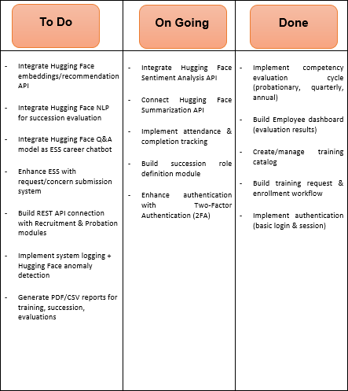

*Table 5: Scrum Board*

**3.5 Microservices Architecture**

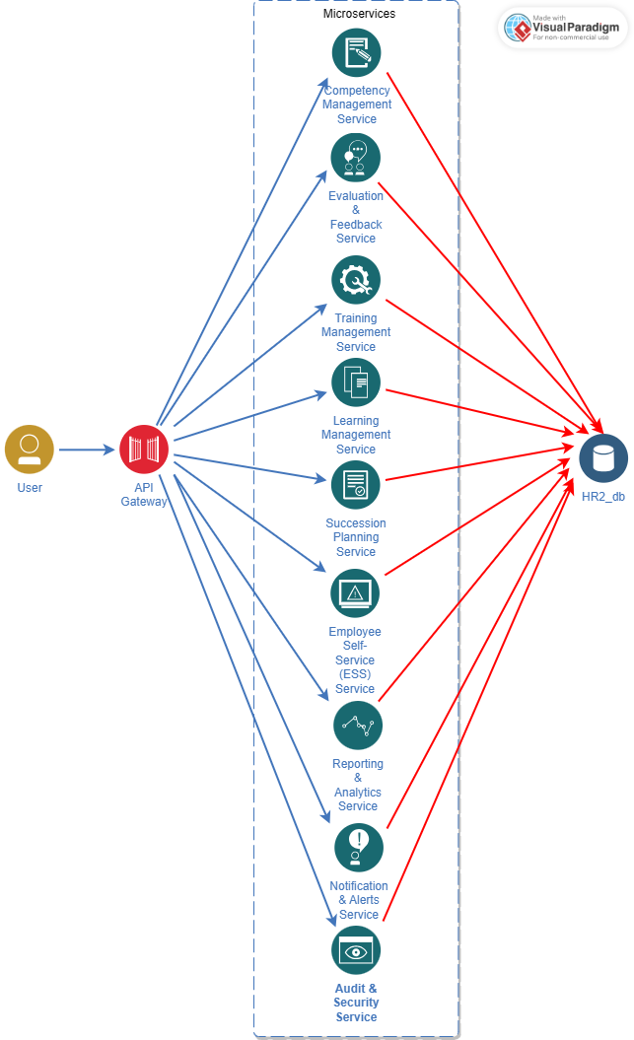

*Figure 2: Microservice*

**1. User Interaction**

Users (Admin, HR Managers, Employees) interact with the system through a web-based portal.

Requests such as starting evaluations, enrolling in training, or viewing career guidance are made through the interface.

All requests are funneled into the **API Gateway** for security and routing.

**2. API Gateway**

Serves as the single access point to the system.

Functions:

**Authentication & Authorization** – Confirms valid login and role-based permissions (Admin, HR, Employee).

**Routing** – Directs the request to the appropriate HR2 microservice (e.g., Evaluation → Evaluation Service).

**Monitoring** – Tracks API traffic and logs suspicious activity for anomaly detection.

**3. Microservices**  
The HR2 module is decomposed into independent services, each responsible for a specific function:

**Competency Management Service**

Creates competency models, assigns assessment criteria, and manages evaluation cycles (probationary, quarterly, annual).

Ensures competencies are aligned with organizational needs.

**Evaluation & Feedback Service**

Handles employee performance evaluations.

Uses **AI (Hugging Face APIs)** for sentiment analysis of qualitative feedback and automatic summarization.

**Training Management Service**

Allows HR Managers to create training modules, approve requests, track attendance, and record completions.

Supports AI-driven training recommendations based on identified skill gaps.

**Learning Management Service**

Provides employees access to a catalog of learning resources.

Enables self-enrollment, progress tracking, and course completion monitoring.

**Succession Planning Service**

Identifies critical roles in the company.

Allows HR to nominate employees, then applies AI to assess readiness and potential for promotion.

**Employee Self-Service (ESS) Service**

A self-service portal where employees view evaluation results, request training, and access an **AI chatbot** for career guidance.

**Reporting & Analytics Service**

Generates reports on evaluations, training outcomes, succession slates, and overall workforce development.

Provides AI-assisted insights for HR decision-making.

**Notification & Alerts Service**

Sends automated notifications (e.g., evaluation results released, training request approved, upcoming deadlines).

**Audit & Security Service**

Logs all user activities for accountability.

Integrates with anomaly detection models to flag irregular usage patterns.

**4. Database (HR2_db)**

A centralized HR2 database stores:

Employee competency models and evaluation results.

Training catalogs, enrollment data, and completion records.

Succession planning data (roles, candidates, readiness scores).

ESS requests, chatbot interaction logs, and reports.

Security logs for audit and compliance.

**3.5.1 Data Flow Diagram (DFD)**

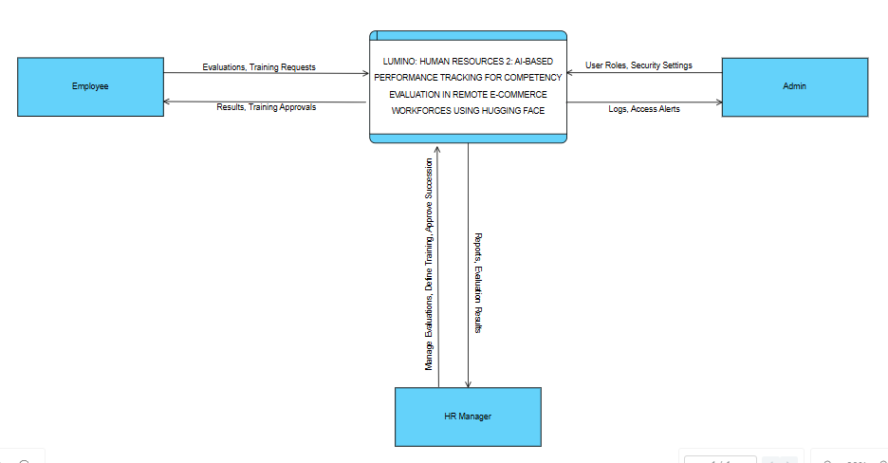

*Figure 3: Data Flow Diagram (Level 0)*

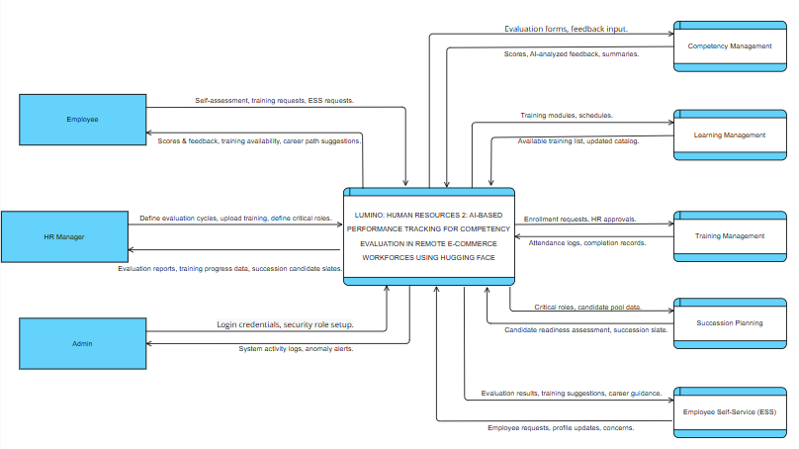

*Figure 4: Data Flow Diagram (Level 1)*

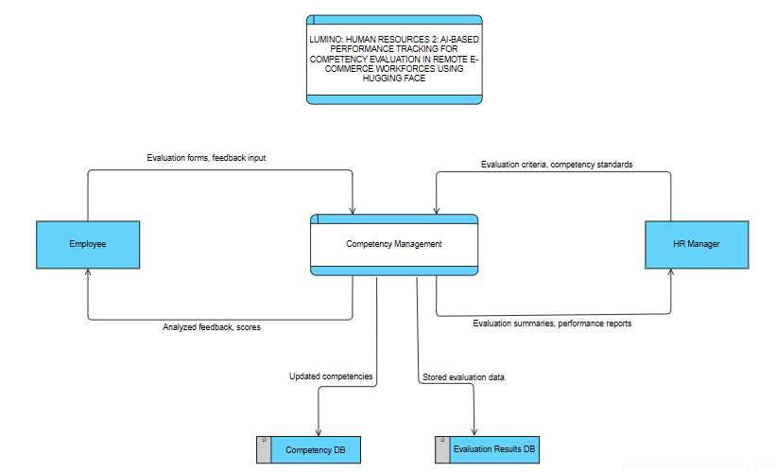

*Figure 5: Data Flow Diagram (Level 2) - Competency Management*

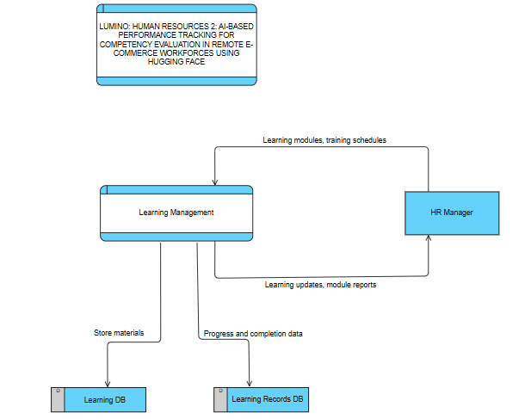

*Figure 6: Data Flow Diagram (Level 2) - Learning Management*

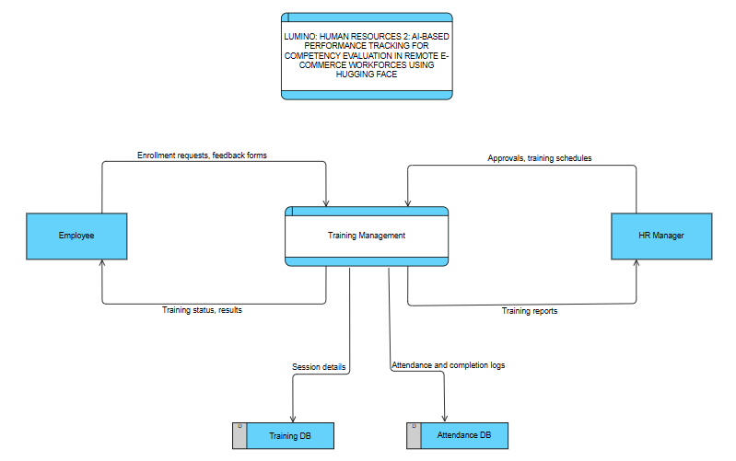

*Figure 7: Data Flow Diagram (Level 2) – Training Management*

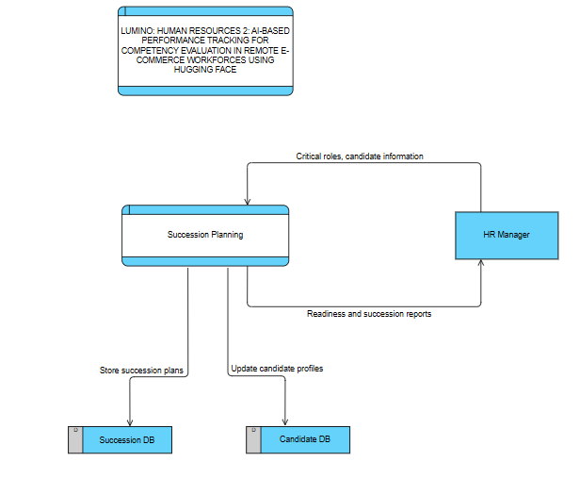

*Figure 8: Data Flow Diagram (Level 2) – Succession Planning*

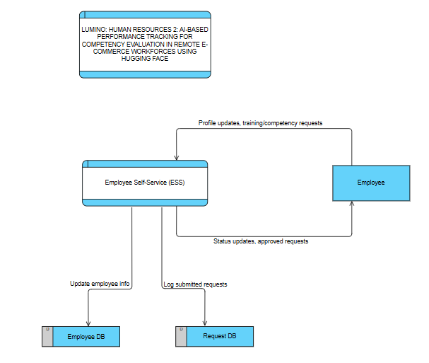

*Figure 9: Data Flow Diagram (Level 2) – Employee Self-Service (ESS)*

**3.6 DevOps Implementation**

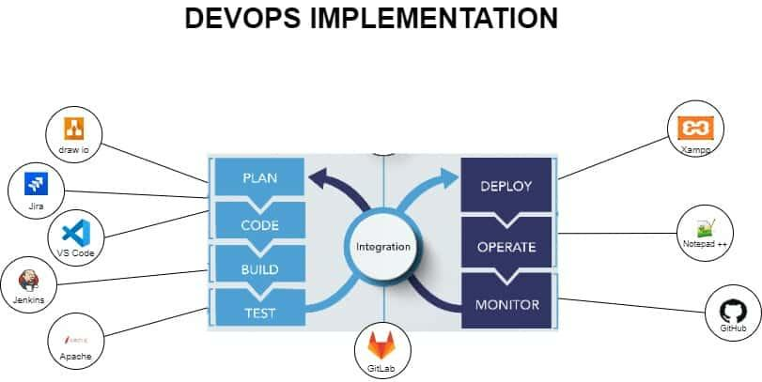

*Figure 10: DevOps*

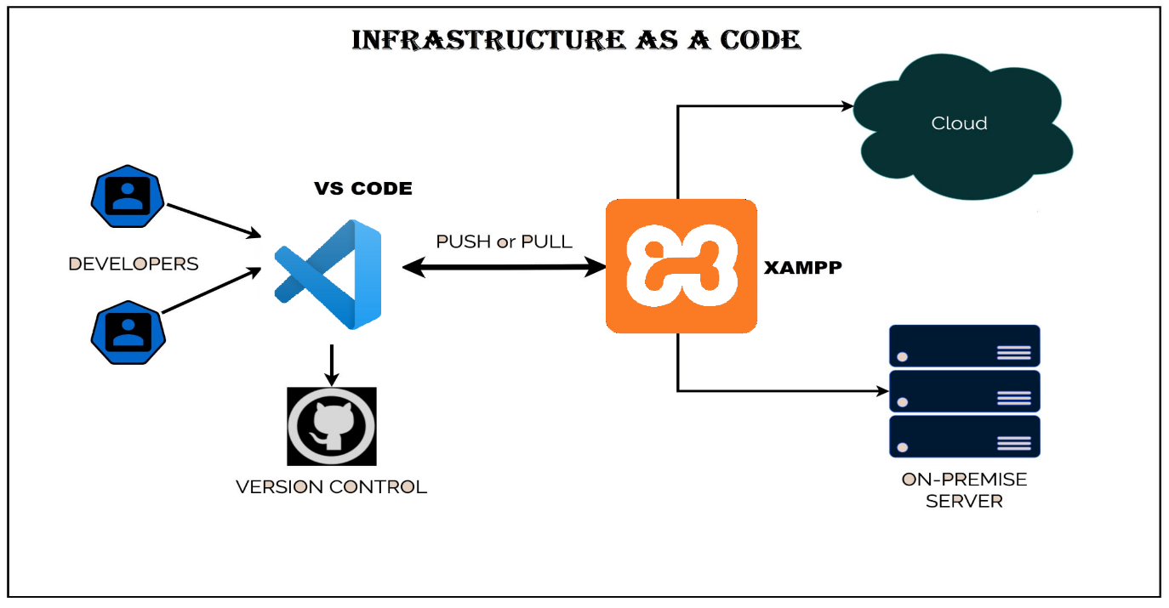**3.6.1 Infrastructure as Code (laC)**

*Figure 11: Infrastructure as Code (IaC)*

**3.6.2 CI/CD Pipeline**

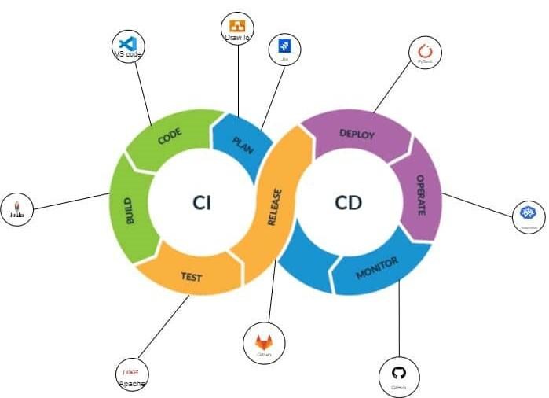

*Figure 12: CI/CD Pipeline*

* + 1. **Network Topology**

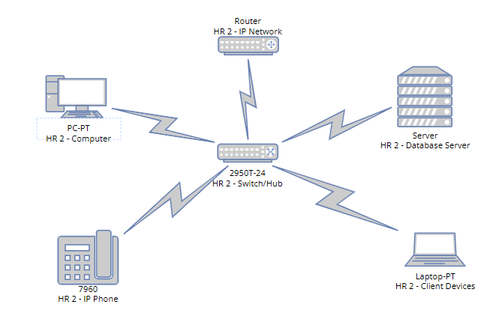

*Figure 13*: *Network Topology (Star Topology)*

**3.6.4 Network Architecture**

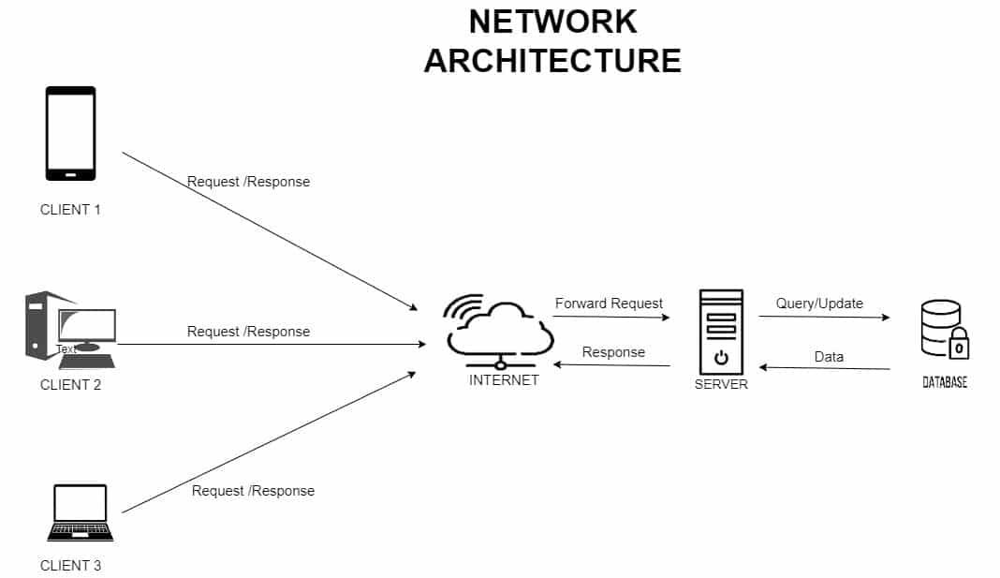

*Figure 14: Network Architecture*

**3.7 Integration Approach for Information Systems**

**Lumino HR2** is an AI-based performance tracking system for remote e-commerce teams. It uses a modular, microservices architecture to make sure HR modules work together smoothly, scale easily, and keep data secure. The system focuses on automation, consistent data, and collaboration across its five main submodules: **Competency Management**, **Learning Management**, **Training Management**, **Succession Planning**, and **Employee Self-Service (ESS)**.

Each submodule works on its own but connects with others using RESTful APIs and a central MySQL database. This setup means that changes, like new competency evaluations or completed training, show up right away in all related parts of the system. The system also links with other HR tools, such as HR1 (Recruitment) and HR3 (Probation), through standard API connections to keep employee records up to date.

The system uses AI features powered by the Hugging Face API to help interpret data and support better decisions in HR2. This AI integration focuses on two main functions:

**AI Analysis** is built into the Competency Management submodule. It reviews employee feedback and evaluation comments, analyzing their tone and context. The system then summarizes this information into clear insights, helping HR managers spot strengths, weaknesses, and engagement levels.

**AI Recommendations** are used in the Learning Management and Succession Planning submodules. This feature gives each employee personalized learning or career suggestions based on their skill gaps, training history, and performance. It helps the organization support skill growth and prepare employees for future roles.

The integration uses these main strategies:

**Microservices and Modular Design:** Each submodule works independently and communicates through set REST APIs. This allows for flexible updates and separate deployments.

**API-Based Communication: RESTful APIs let the system work** with other HR modules like HR1 (Recruitment) and HR3 (Probation) to keep employee data in sync.

**Centralized Database Synchronization:** The MySQL database keeps all employee data consistent and up to date across all submodules.

**AI Integration with Hugging Face API: This add**s automated analysis and recommendations for competency evaluation, learning management, and succession planning.

**Secure** Authentication: Role-based access and two-factor authentication (2FA) help protect data and privacy in the system.

**Agile Integration Process: The team used Agile Scrum methods, which allowed for ongoing testing and quick responses** to stakeholder feedback.

**Scalability and Flexibility: The system’s design makes it easy to add** analytics dashboards, connect with other HR APIs, or link to government compliance systems like SSS or BIR in the future.

With this integration, Lumino HR2 brings together data-driven evaluation, learning, and career planning in one smart HR system. It helps remote and hybrid e-commerce teams grow and develop talent continuously.

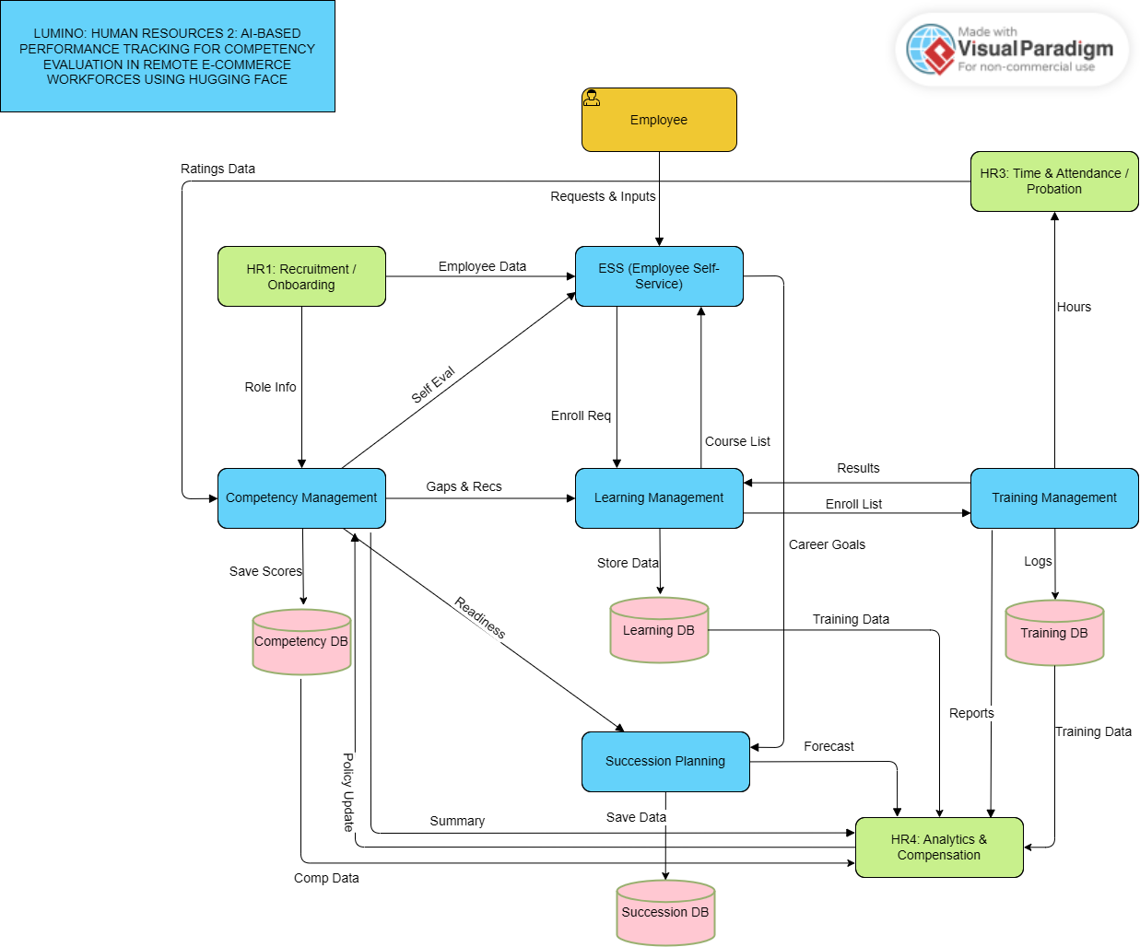

*Figure 15: Business Process Architecture (TO BE)*

The **Lumino HR2** system is the main platform for tracking employee growth and competencies in remote e-commerce teams. It connects with other HR systems, includingHR1 (Recruitment and Onboarding), HR3 (Time and Attendance / Probation), and HR4 (Analytics and Compensation), to support consistent workforce development and evaluation.

**Employee Self-Service (ESS)**  
The Employee Self-Service (ESS) portal is the main way employees interact with the HR2 system. It gets new hire and employee data from HR1. Employees use ESS to submit self-assessments, request training, and set career goals.  
ESS is where employees start actions and updates that feed into the competency and learning processes.

**Competency Management**  
Competency Management gets role details and self-evaluations from ESS and HR1. It also uses data from HR3, like attendance and probation results, to assess employee performance. The results are saved in the Competency Database and shared with Learning Management and Succession Planning.  
This module reviews skills and performance gaps to find learning needs and possible career growth paths.

**Learning Management**  
Learning Management gets training suggestions from Competency Management and shares available courses with ESS. It also works with Training Management to enroll employees and track their progress. All course information is kept in the Learning Database.  
This module manages courses, handles enrollment, and helps create learning paths for employees based on their competency gaps.

**Training Management**  
Training Management gets lists of enrolled employees from Learning Management and sends completion and attendance records to HR3. It also shares training results and reports with HR4 for performance and compensation reviews. All data is stored in the Training Database.  
This module manages and tracks training sessions, including participation, completion rates, and how effective the training is.

**Succession Planning**  
Succession Planning collects readiness and performance summaries from Competency Management and Learning Management to spot potential leaders. It shares forecasts and succession data with HR4 for compensation planning and strategy, and stores this information in the Succession Database.  
This module supports career growth and builds a leadership pipeline, making sure important roles have qualified candidates.

**HR4 Analytics & Compensation**  
HR4 Analytics & Compensation gathers reports from all HR2 submodules, including Competency, Learning, Training, and Succession, to study workforce trends and guide pay and reward strategies.  
This module uses HR2’s results to support performance-based pay and overall workforce analysis.

To sum up, HR1 supplies employee and role data to start development in HR2. HR3 adds attendance and performance details for evaluations, and HR4 gets combined results for pay and analytics. All HR2 submodules work together to support talent growth, evaluation, and succession in the organization.

**3.8 Introduction to TOGAF and the four Architectural Domains**

TOGAF (The Open Group Architecture Framework) offers a clear approach for designing, developing, and managing enterprise systems. When used with **LUMINO: HUMAN RESOURCES 2: AI-BASED PERFORMANCE TRACKING FOR COMPETENCY EVALUATION IN REMOTE E-COMMERCE WORKFORCES USING HUGGING FACE, it helps alig**n business goals, system processes, and supporting technologies. This framework improves how data and services connect across the HR ecosystem, making performance tracking more efficient, supporting AI-based competency evaluation, and helping with workforce planning in remote e-commerce settings.

**Business Architecture:**  
The business architecture shows how Lumino HR2 helps meet key HR goals like employee development, succession planning, and ongoing learning. It connects business processes such as competency evaluation, training management, and career planning to the organization’s goals. By organizing workflows between HR1 (Recruitment), HR3 (Time & Attendance), and HR4 (Compensation & Analytics), Lumino creates a unified process that supports data-driven decisions, employee engagement, and talent growth.

**Data Architecture:**  
The data architecture manages how HR data is collected, stored, and shared between modules. Lumino HR2 brings together competency scores, training records, and succession plans in a central MySQL database to keep data consistent and accurate. This setup allows smooth data sharing between HR modules and follows data privacy and security rules. By combining different types of data, the system can give useful analytics to both employees and managers.

**Application Architecture:**  
This section explains how the Lumino HR2 system’s submodules—Competency Management, Learning Management, Training Management, Succession Planning, and Employee Self-Service (ESS)—work together. These applications use RESTful APIs to connect smoothly with other HR systems like HR1 and HR3. The design allows each application to grow on its own while still working well with others through shared APIs and central data services.

**Technology Architecture:**  
The technology architecture lists the tools, platforms, and infrastructure that support Lumino HR2. The system uses PHP, MySQL, HTML, CSS, and JavaScript, and connects to Hugging Face AI through APIs for analytics and recommendations. This setup allows for future growth, strong security with two-factor authentication, and reliable performance in both local and cloud environments. These technologies help Lumino HR2 provide a smart, efficient, and flexible HR management solution.

**3.9 Additional Consideration**

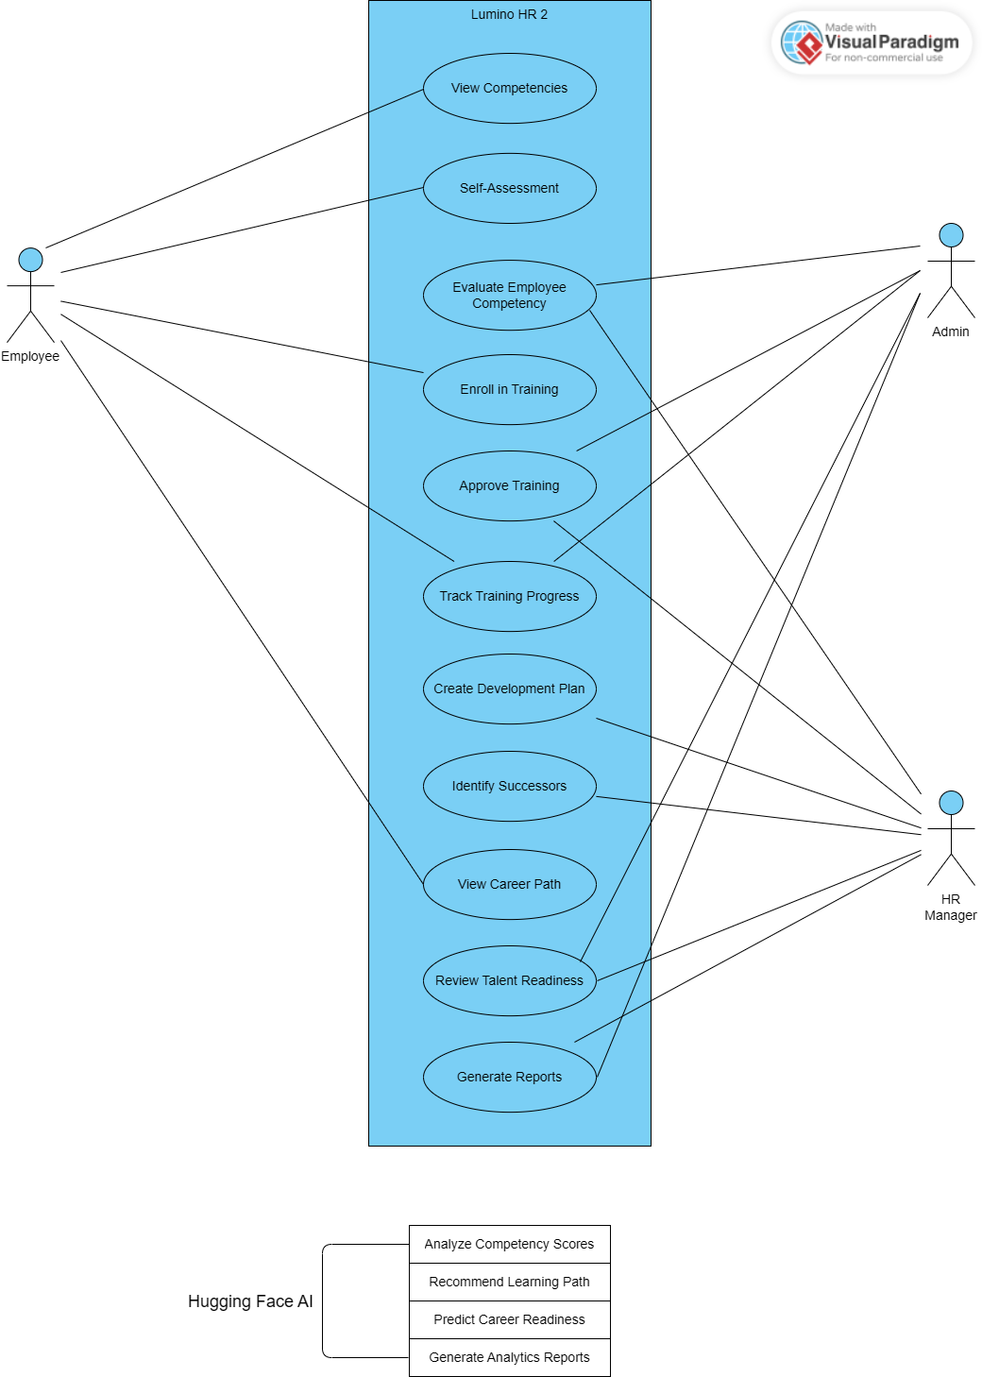

*Figure 16: Use Case*

The diagram illustrates the interaction between multiple actors (users) and the **Lumino HR2: Talent Development & Career Pathing System**, showcasing how the **Hugging Face AI integration** enhances automation and decision intelligence across HR processes.

**Actors**

**Employee** – Performs self-assessment, enrolls in learning activities, and monitors personal development progress through the Employee Self-Service (ESS) portal.

**Admin** – Manages employee competency data, oversees training and succession programs, and ensures accurate storage of learning and performance records.

**HR Manager** – Reviews competency results, approves learning requests, monitors training outcomes, and plans career progression strategies.

**Use Cases (Functions)**

**Evaluate Competency** – Employees perform self-evaluations, and HR reviews competency scores to assess skill levels and readiness.

**Recommend Learning Path** – Based on competency results, the system recommends suitable training or development courses for employees.

**Manage Learning Records** – HR Admin maintains and updates employee learning data, ensuring training completions and results are properly recorded.

**Enroll in Training** – Employees request to enroll in training programs, which are then reviewed and approved by HR Managers.

**Monitor Training Progress** – HR Admin and Managers track employee participation, progress, and completion rates.

**Plan Succession** – HR Managers identify potential future leaders based on competency and performance data.

**View Development Reports** – HR Admins and Managers generate analytical reports summarizing competency trends, learning outcomes, and succession readiness.

**Audit Activities** – Super Admin reviews system activity logs and ensures compliance with HR policies and data governance standards.

**Hugging Face AI Integration**

The system integrates **Hugging Face AI** to provide intelligent automation and predictive analytics that enhance HR decision-making:

**Analyze Competency Scores** – Evaluates employee self-assessment and performance data to identify skill gaps and strengths.

**Recommend Learning Pathways** – Suggests personalized training programs aligned with employees’ competency gaps and career goals.

**Predict Career Readiness** – Forecasts employee readiness for promotion or succession based on learning progress and historical performance.

**Generate Analytical Reports** – Automates the generation of reports summarizing training outcomes, competency improvements, and succession trends.

This AI-driven integration empowers the HR2 module to automate evaluation processes, enhance career planning accuracy, and support continuous employee development within the larger Lumino HR ecosystem.

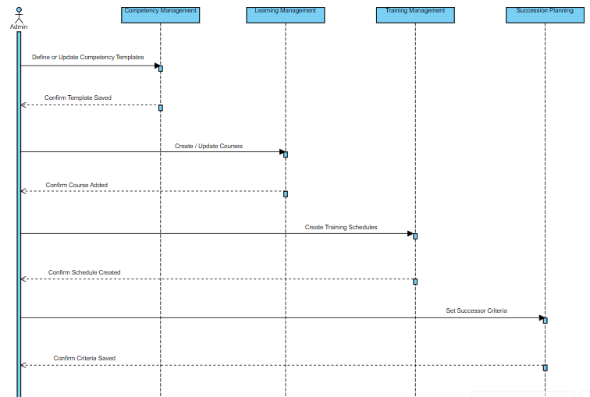

*Figure 17: Sequence Diagram (Admin)*

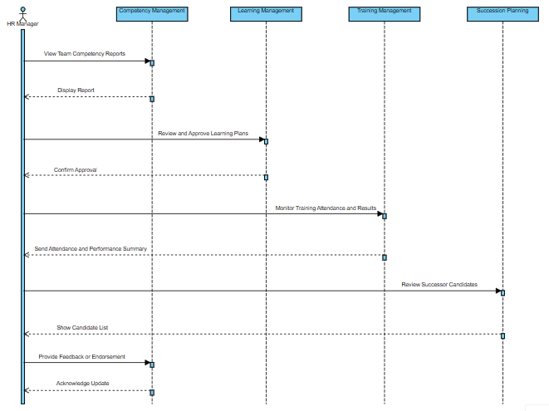

*Figure 18: Sequence Diagram (HR Manager)*

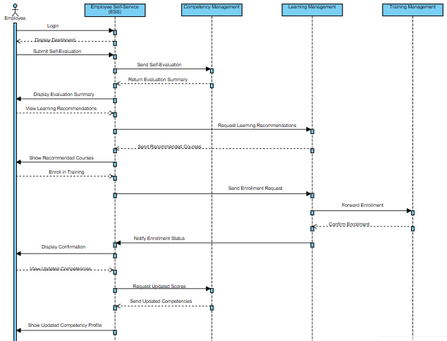

*Figure 19: Sequence Diagram (Employee)*

**CHAPTER 4**

**REQUIREMENT ANALYSIS**

**4.1 Stakeholder Identification**

The Lumino HR2: Talent Development & Career Pathing module is part of the E-commerce Management System. It helps employees grow by managing skills, training, succession planning, and career paths. The system works with other HR modules (HR1, HR3, HR4) and main business modules to keep data consistent and support better decisions. Internal stakeholders help develop, manage, and use the system. They are chosen based on their roles, responsibilities, and how much they influence the HR2 module’s success. Defining each stakeholder’s role helps the system meet company goals and support talent development.

|  |  |  |
| --- | --- | --- |
| **Stakeholder** | **Role in the System** | **Responsibilities** |
| **Employees** | Primary users and beneficiaries | View competency profiles and career paths, enroll in training programs, track learning progress, submit self-assessments, and access Employee Self-Service (ESS) features |
| **Supervisors / Team Leaders** | Operational and evaluative users | Assess employee competencies, recommend training and development plans, review performance data, and support career path planning |
| **Human Resource Officers (HR Department)** | Administrative and management users | Manage competency frameworks, training programs, learning records, and succession plans; monitor employee development progress and generate HR reports |
| **HR Managers** | Supervisory and decision-making users | Approve training initiatives, evaluate talent readiness for promotion, review succession planning outcomes, and align talent development strategies with organizational goals |
| **Top Management / Executives** | Strategic users | Review analytics and reports on workforce competencies, talent pipelines, and career development outcomes to support strategic planning and decision-making |
| **System Administrator (IT Personnel)** | Technical operations and maintenance | Manage system configuration, user access, data security, integrations with other modules, and ensure system availability and performance |
| **System Development Team (Developers, Analysts, UI/UX Designers)** | System designers and builders | Design, develop, test, and maintain the HR2 module, implement system integrations, and ensure usability, functionality, and data integrity |

Table 00. **Stakeholder Identification**

**Rationale**

Identifying these stakeholders clarifies their roles, responsibilities, and level of involvement throughout the lifecycle of the **Lumino HR2: Talent Development & Career Pathing** module, from system development and integration to daily operation and maintenance. Clearly defining the participation of employees, supervisors, HR officers, managers, executives, system administrators, and the development team ensures that key HR functions such as competency assessment, training management, career path planning, and succession planning are effectively supported. This stakeholder identification aligns the HR2 module with organizational goals, promotes consistent data flow across integrated HR and core business modules, strengthens accountability, and supports informed operational and strategic decision-making, ultimately ensuring that Lumino HR2 functions as a coordinated and user-centered talent development system.

**4.2 Requirements Gathering Techniques**

To support the development of the Lumino HR2: Talent Development & Career Pathing module, we used online requirements gathering methods. These methods helped us identify both functional and non-functional needs, making sure they fit with company goals, other HR modules (HR1, HR3, HR4), and main E-commerce processes.

**1. Review of Existing HR Systems and Online Platforms**

An analysis of existing Human Resource Management Systems (HRMS), Learning Management Systems (LMS), and talent development platforms was conducted using online resources, system documentation, and product case studies. This review provided insights into standard practices for competency management, training tracking, career path planning, and succession planning, which helped define core functional requirements of the HR2 module.

**2. Analysis of Organizational HR Processes and Module Integration**

Online references and system flow documentation were used to analyze common HR workflows related to recruitment (HR1), performance evaluation (HR3), and payroll and employee records (HR4). This analysis ensured that HR2 requirements support seamless data flow, consistency of employee information, and integration with existing HR and core business modules.

**3. Review of Industry Standards and Best Practices**

Industry standards, HR frameworks, and best practices related to talent management, competency modeling, and career development were reviewed through academic journals, white papers, and reputable online HR publications. This ensured that the system requirements support structured competency frameworks, measurable learning outcomes, and effective succession planning.

**4. Study of AI-Based Talent Evaluation Techniques**

Online research was conducted on AI-driven performance tracking, competency assessment, and recommendation systems. This technique supported the definition of system requirements for automated competency evaluation, training recommendations, and career path suggestions using AI models and analytics.

**5. Review of Legal, Data Privacy, and Compliance Requirements**

Relevant labor laws, data privacy regulations, and HR data protection guidelines were reviewed through official online government portals and regulatory publications. This ensured that system requirements comply with data security, access control, and employee privacy standards, particularly for sensitive competency and performance data.

**6. Technical Feasibility and System Architecture Analysis**

A technical feasibility analysis was conducted using online documentation and developer resources to evaluate the integration of AI services, databases, and web technologies. This helped define non-functional requirements related to system performance, scalability, reliability, and security to support long-term system use.

**4.3 User Stories and Use Cases**

This section covers the user stories and use cases for Lumino HR2: Talent Development & Career Pathing, part of the E-commerce Management System. User stories show system features from each stakeholder’s point of view, while use cases outline how users interact with the system. These tools help make sure the system’s requirements are clear, match what stakeholders need, and support goals like competency development, training management, succession planning, and career pathing.

**User Stories:**

|  |  |
| --- | --- |
| **User Role** | **User Story** |
| Employee | As an employee, I want to view my competency profile so that I can understand my current skills and areas for improvement. |
| Employee | As an employee, I want to enroll in recommended training programs so that I can develop competencies needed for career growth. |
| Employee | As an employee, I want to track my learning progress and completed trainings so that I can monitor my development. |
| Employee | As an employee, I want to view suggested career paths so that I can plan my professional growth within the organization. |
| Supervisor / Team Leader | As a supervisor, I want to assess employee competencies so that I can identify skill gaps and development needs. |
| Supervisor / Team Leader | As a supervisor, I want to recommend training and career development plans so that employees are guided effectively. |
| HR Officer | As an HR officer, I want to manage competency frameworks and training programs so that development initiatives are standardized. |
| HR Officer | As an HR officer, I want to monitor employee development progress so that I can generate reports and insights. |
| HR Manager | As an HR manager, I want to review succession plans and talent readiness so that leadership continuity is ensured. |
| Top Management | As top management, I want to view analytics on workforce competencies so that I can support strategic decision-making. |
| System Administrator | As a system administrator, I want to manage user access and system configurations so that data security and system reliability are maintained. |

Table 00. User Stories

**Use Cases:**

|  |  |  |  |
| --- | --- | --- | --- |
| **Use Case Name** | **Primary Actor** | **Description** | **Outcome** |
| View Competency Profile | Employee | The employee accesses their competency assessment results and skill ratings. | Employee gains visibility of current competencies and gaps. |
| Enroll in Training Program | Employee | The employee selects and enrolls in available or recommended training programs. | Training enrollment is recorded and tracked by the system. |
| Track Learning Progress | Employee | The system displays completed, ongoing, and pending trainings. | Employee progress is monitored and updated in real time. |
| Assess Employee Competency | Supervisor / Team Leader | The supervisor evaluates employee competencies based on performance data. | Updated competency records are stored in the system. |
| Recommend Development Plan | Supervisor / Team Leader | The supervisor suggests training and career actions for the employee. | Personalized development plans are generated. |
| Manage Competency Framework | HR Officer | HR defines and updates competency models and skill standards. | Standardized competency data is maintained. |
| Manage Training Programs | HR Officer | HR creates, updates, and assigns training programs. | Training catalog is updated and available to employees. |
| Manage Succession Planning | HR Manager | HR manager reviews talent pools and succession candidates. | Succession plans are evaluated and refined. |
| Generate Reports and Analytics | HR Manager / Top Management | The system generates analytics on competencies, training, and career paths. | Strategic insights support decision-making. |
| Manage Users and System Configuration | System Administrator | The administrator controls access, security settings, and integrations. | Secure and stable system operation is ensured. |

Table 00. Use Cases

**4.4 Functional Requirements for Integration**

This section defines the functional and non-functional requirements necessary to ensure proper integration among the components of the Lumino HR2: Talent Development & Career Pathing module within the E-commerce Management System. The HR2 module integrates with other Human Resource modules (HR1: Employee Information Management, HR3: Performance Management, and HR4: Compensation and Benefits) as well as core system modules to support competency evaluation, learning and training management, succession planning, and career path development. This section also establishes traceability between user needs, system functions, and stakeholders to clearly define system scope, responsibilities, and expected system behavior.

|  |  |  |
| --- | --- | --- |
| **FR ID** | **Functional Requirement** | **Description** |
| **FR-01** | Competency Profile Management | The system shall allow HR officers and supervisors to define, update, and manage employee competency frameworks and profiles. |
| **FR-02** | Competency Assessment and Evaluation | The system shall allow supervisors and employees to conduct competency assessments using performance data and self-assessments. |
| **FR-03** | Training and Learning Management | The system shall allow HR officers to create, assign, and manage training and learning programs linked to required competencies. |
| **FR-04** | AI-Assisted Competency Analysis | The system shall analyze competency gaps using AI-assisted evaluation based on performance and training data. |
| **FR-05** | Career Path Planning | The system shall provide employees with recommended career paths based on competencies, performance, and training history. |
| **FR-06** | Succession Planning Management | The system shall identify and manage potential successors for key positions based on readiness and competency levels. |
| **FR-07** | Employee Self-Service (ESS) Access | The system shall allow employees to view competency results, training progress, and career path recommendations through ESS. |
| **FR-08** | Reporting and Analytics | The system shall generate reports and dashboards on competency levels, training effectiveness, and talent readiness. |
| **FR-09** | Module Integration and Data Synchronization | The system shall synchronize employee, performance, and compensation data with HR1, HR3, HR4, and core modules. |
| **FR-10** | Logging and Audit Trail | The system shall record all competency assessments, training activities, career updates, and administrative actions for monitoring and auditing purposes. |

Table 00. **Functional Requirements Table**

|  |  |  |
| --- | --- | --- |
| **NFR ID** | **Non-Functional Requirement** | **Description** |
| **NFR-01** | Performance | The system shall process competency evaluations and career recommendations with acceptable response time. |
| **NFR-02** | Scalability | The system shall support a growing number of employees, training records, and assessment data. |
| **NFR-03** | Availability | The system shall be accessible during standard business hours with minimal downtime. |
| **NFR-04** | Security | The system shall protect employee data through authentication, role-based access control, and secure data storage. |
| **NFR-05** | Reliability | The system shall ensure consistent and accurate computation of competency scores and recommendations. |
| **NFR-06** | Maintainability | The system shall support modular updates for competencies, training programs, and AI models. |
| **NFR-07** | Usability | The system shall provide an intuitive and user-friendly interface for employees, supervisors, and HR personnel. |

Table 00. Non – Functional Requirements Table

|  |  |  |  |
| --- | --- | --- | --- |
| **Requirement** | **User Story Reference** | **Use Case** | **Stakeholder** |
| **FR-01** | US-HR-01 | Manage Competency Framework | HR Officer |
| **FR-02** | US-SUP-01 | Conduct Competency Assessment | Supervisor |
| **FR-03** | US-HR-02 | Manage Training Programs | HR Officer |
| **FR-04** | US-HR-03 | Analyze Competency Gaps | HR Manager |
| **FR-05** | US-EMP-01 | View Career Path Recommendation | Employee |
| **FR-06** | US-HR-04 | Manage Succession Plan | HR Manager |
| **FR-07** | US-EMP-02 | Access ESS Development Records | Employee |
| **FR-08** | US-MGT-01 | View Talent Analytics Report | Top Management |
| **FR-09** | US-IT-01 | Synchronize HR Modules | System Administrator |
| **FR-10** | US-ADMIN-02 | Review Logs and Audit Trails | System Administrator |

Table 00. Requirement Traceability Matrix (RTM)

**5.1** **Identification of Business Processes**

This section identifies and describes the key business processes supported and automated by the Lumino HR2: Talent Development & Career Pathing module of the E-commerce Management System. These processes represent the organization’s core talent development and career management activities and demonstrate how the system improves workforce competency management, training effectiveness, succession planning, and data-driven decision-making through system integration and automation.

|  |  |  |  |
| --- | --- | --- | --- |
| **Process ID** | **Business Process Name** | **Description** | **Primary Stakeholders** |
| **BP-01** | Competency Framework Definition | Definition and maintenance of competency standards and skill requirements for various job roles. | HR Officers, HR Managers |
| **BP-02** | Employee Competency Assessment | Evaluation of employee competencies through supervisor assessments and employee self-assessments. | Employees, Supervisors |
| **BP-03** | Competency Gap Analysis | Analysis of assessed competencies to identify skill gaps and development needs. | HR Managers, System |
| **BP-04** | Training and Learning Program Management | Creation, assignment, and tracking of training and learning programs aligned with competency requirements. | HR Officers, Employees |
| **BP-05** | Career Path Planning and Recommendation | Generation of career path options and advancement recommendations based on competencies and performance. | Employees, HR Managers |
| **BP-06** | Succession Planning Management | Identification and monitoring of potential successors for critical roles based on readiness and competency levels. | HR Managers, Top Management |
| **BP-07** | Employee Self-Service (ESS) Access | Provision of self-service access for employees to view competencies, training progress, and career development plans. | Employees, System |
| **BP-08** | Talent Analytics and Reporting | Generation of reports and dashboards on workforce competencies, training effectiveness, and talent readiness. | HR Managers, Top Management |
| **BP-09** | System Integration and Data Synchronization | Synchronization of employee, performance, and compensation data across HR1, HR3, HR4, and core modules. | System Administrator, System |
| **BP-10** | System Maintenance and Support | Maintenance of system security, availability, and performance for continuous operation. | System Administrator, System Development Team |

Table 00. Business Process Inventory Table

**5.3 Alignment of Integrated System with Business Processes**

The Lumino HR2: Talent Development & Career Pathing module works with your current HR processes and helps solve issues like manual tracking, scattered data, and limited insight into employee development. It uses automation, analytics, and AI-assisted evaluation to improve efficiency, accuracy, and decision-making, while keeping your existing HR workflows and management controls in place.

**5.3.1 Alignment with Competency Assessment and Evaluation**

The organization’s existing process for assessing employee competencies through supervisor evaluations and performance reviews is fully integrated into the system. The HR2 module formalizes and centralizes competency assessments that were previously recorded using manual or disconnected tools.

Through the **Competency Assessment and AI-Assisted Analysis modules**, assessment data from supervisors and self-assessments from employees are consistently captured, stored, and analyzed. This alignment ensures standardized evaluation criteria, reduces assessment inconsistencies, and allows HR personnel to easily monitor competency levels across departments.

**5.3.2 Alignment with Training and Learning Management**

The system works with your current training and development processes by bringing **Training and Learning Management** into the competency framework. Rather than replacing your HR planning, it improves it by connecting skill gaps to the right training programs.

With this setup, HR officers and managers can easily assign, track, and measure how effective training is, while still keeping control over approvals and how training is carried out. Automation helps cut down on paperwork and makes sure training decisions are based on data and support company goals.

**5.3.3 Alignment with Career Path Planning and Succession Management**

Career development and succession planning are critical HR functions that often rely on manual judgment and limited data visibility. The HR2 module strengthens these processes by providing structured career path recommendations and succession planning tools based on competency levels, performance records, and training history.

The system supports managerial decision-making by presenting AI-assisted insights while preserving human oversight in promotion and succession decisions. This alignment improves transparency, readiness assessment, and long-term workforce planning without disrupting existing authority structures.

**5.3.4 Alignment with Monitoring, Reporting, and Evaluation**

Tracking employee development and reviewing HR initiatives are key parts of managing talent well. The Reporting and Analytics module supports these efforts by automatically creating clear reports and dashboards on skills, training, career growth, and readiness for new roles.

This module offers:

Instant updates on employee development status

Access to past records for easy review and audits

Analytical reports to help with planning and evaluating performance

By automating monitoring and reporting, the system reduces the need for manual records and improves data accuracy, accountability, and compliance with company policies.

**5.3.5 Alignment with System Integration and Overall Process Improvement**

The HR2 module works smoothly with other Human Resource modules (HR1, HR3, and HR4) and main system parts to keep data consistent and reliable throughout the organization. It brings together employee details, performance results, and compensation data to help make well-rounded talent development decisions.

The **Lumino HR2: Talent Development & Career Pathing** system helps HR teams work more efficiently and accurately, while keeping current workflows and management controls in place. Because it fits with daily operations and long-term planning, it supports both routine HR tasks and bigger talent strategies.

**5.4 Business Process Improvement**

The transition from the AS-IS (manual and fragmented HR processes) to the TO-BE (integrated Lumino HR2 system) demonstrates significant improvements in efficiency, accuracy, transparency, and decision support in talent development and career management.

|  |  |  |  |
| --- | --- | --- | --- |
| **Process Aspect** | **AS-IS Process (Old Version)** | **TO-BE Process (Current System)** | **Improvement / Gain** |
| **Competency Assessment Cycle Time** | Competency evaluations were conducted manually and recorded using spreadsheets or paper-based forms, resulting in delayed assessments. | Competency assessments are conducted and recorded digitally with automated scoring and consolidation. | Faster assessment cycles and timely availability of competency data. |
| **Competency Gap Identification** | Skill gaps were identified subjectively and inconsistently based on individual judgment. | AI-assisted competency gap analysis automatically identifies gaps based on standardized criteria. | Improved accuracy and consistency in identifying development needs. |
| **Training Assignment and Tracking** | Training programs were assigned manually and progress was tracked inconsistently. | Training programs are system-assigned based on competency gaps and tracked in real time. | Reduced administrative workload and improved training alignment. |
| **Career Path Planning** | Career development decisions relied heavily on manual reviews and limited historical data. | Career path recommendations are generated using performance, competency, and training data. | Data-driven and transparent career planning. |
| **Succession Planning** | Succession planning was informal and dependent on managerial discretion. | Succession candidates are identified and monitored using readiness and competency indicators. | Improved leadership readiness and continuity planning. |
| **Decision-Making Process** | HR and management decisions were time-consuming and prone to inconsistencies. | AI-assisted insights support standardized decisions with human oversight. | Faster, more consistent, and informed decision-making. |
| **Employee Engagement** | Employees had limited visibility into their competency status and career progression. | Employees access development records and recommendations through Employee Self-Service (ESS). | Increased employee engagement and ownership of career growth. |
| **Monitoring and Reporting** | Reports were manually prepared and often outdated. | Real-time dashboards and automated reports are generated by the system. | Improved transparency, accuracy, and strategic monitoring. |
| **Data Integration** | HR data was stored across multiple disconnected systems. | HR2 integrates seamlessly with HR1, HR3, HR4, and core modules. | Consistent and reliable data across HR processes. |
| **Overall Process Efficiency** | HR processes involved multiple manual steps and operational bottlenecks. | Workflows are streamlined, automated, and optimized for talent management. | Higher operational efficiency and improved HR service quality. |

Table 00. Business Process Improvement

**6.1 Components of Application Architecture**

This section describes the core components of the application architecture for the Lumino HR2: Talent Development & Career Pathing module of the E-commerce Management System. The architecture follows a layered and modular design to ensure scalability, maintainability, security, and seamless integration with other Human Resource and core system modules.

|  |  |  |
| --- | --- | --- |
| **Component Layer** | **Component Name** | **Description / Responsibility** |
| **Presentation Layer** | Employee Self-Service (ESS) Portal | Provides employees with access to competency profiles, training progress, career path recommendations, and self-assessment features. |
| **Presentation Layer** | Supervisor and Manager Dashboard | Allows supervisors and managers to evaluate competencies, approve training plans, review career paths, and monitor succession readiness. |
| **Presentation Layer** | HR Administration Interface | Enables HR officers to manage competency frameworks, training programs, succession plans, and system configurations. |
| **Application Layer** | Competency Management Service | Handles competency framework definition, assessment processing, and competency profile updates. |
| **Application Layer** | Training and Learning Management Service | Manages training creation, assignment, progress tracking, and completion evaluation. |
| **Application Layer** | Career Path and Recommendation Service | Generates career path options and advancement recommendations based on competencies, performance, and training data. |
| **Application Layer** | Succession Planning Service | Identifies potential successors, evaluates readiness levels, and supports leadership continuity planning. |
| **Application Layer** | AI-Assisted Analytics Service | Performs competency gap analysis and supports decision-making using AI-assisted evaluation models. |
| **Application Layer** | Integration and Synchronization Service | Synchronizes data with HR1, HR3, HR4, and core modules to ensure data consistency. |
| **Application Layer** | Logging and Audit Trail Service | Records all system activities, assessments, approvals, and updates for monitoring and compliance. |
| **Data Layer** | Operational HR Database | Stores employee profiles, competency records, training data, career paths, and succession plans. |
| **Data Layer** | Analytics and Reporting Database | Stores historical and aggregated data for reporting, analytics, and strategic HR evaluation. |
| **Infrastructure Layer** | Application Server and Hosting Services | Provides computing resources and application hosting for system operations. |
| **Infrastructure Layer** | Security and Access Control | Ensures role-based access, authentication, authorization, and protection of sensitive employee data. |

Table 00. Application Components Table

**6.2 Application Architecture Diagrams**

The Application Architecture Diagram shows how the system is organized into layers, where each layer has a specific responsibility and communicates with the layer above or below it.

**Layer Explanation**

**1. Presentation Layer** -This layer is where users interact with the system. Employees access their competency profiles, training progress, career path recommendations, and self-assessment tools through the Employee Self-Service (ESS) portal. Supervisors and managers monitor employee development, approve training plans, and review succession readiness via dashboards. HR officers manage competency frameworks, training programs, and succession plans through administrative interfaces.

**2. Application / Service Layer** - This layer contains the core modules of the HR2 system. It manages competency assessments, training assignments, career path recommendations, succession planning, logging, and reporting. It acts as the bridge between user interactions in the presentation layer and the data and analytics layers, ensuring smooth workflow execution and proper data processing.

**3. Intelligence / Processing Layer -** This layer handles AI-assisted analytics and evaluation, including competency gap analysis, career path suggestions, and readiness assessment for succession planning. It supports faster, data-driven decision-making for supervisors, HR officers, and management, while maintaining human oversight.

**4. Data Layer** - This layer stores all system data, including employee profiles, competency records, training history, career paths, succession plans, and audit logs. It ensures data integrity, availability, and security for operational and analytical purposes.

**5. Integration Layer -** This layer connects the HR2 module with other HR modules (HR1, HR3, HR4) and core system components. It enables seamless synchronization of employee information, performance data, and compensation records, ensuring consistency across the organization and supporting comprehensive talent management.

**6.3 Module Integration**

The Lumino HR2: Talent Development & Career Pathing module integrates multiple software components for employees, supervisors, HR officers, and managers to enable seamless competency assessment, training management, career path planning, and succession planning. Key integration objectives: Enable real-time access to competency profiles, training progress, and career recommendations. Automate competency gap analysis and career path suggestions using AI-assisted evaluation. Ensure training and succession plans are aligned with competencies and performance data. Maintain data consistency across Employee Self-Service (ESS), supervisor dashboards, HR administrative interfaces, and backend databases.

**6.3.2 Integration of Admin Modules**

|  |  |  |
| --- | --- | --- |
| **Admin Module** | **Integrated With** | **Integration Result** |
| Competency Management | Supervisor & Employee Modules | Ensures competency profiles and assessments are updated in real time, enabling accurate evaluations and gap analysis. |
| Training & Learning Management | Competency Management, Employee Module | Assigns and tracks training programs based on identified competency gaps; provides supervisors with real-time training progress. |
| Career Path & Recommendation | Competency Management, Employee Module | Generates career path suggestions based on competencies, performance, and training history. |
| Succession Planning | Competency Management, HR Dashboard | Identifies potential successors for key roles and tracks readiness levels, supporting strategic workforce planning. |
| Logging & Audit Trail | Analytics & Reporting Database | Records all updates, approvals, and HR activities for monitoring, compliance, and auditing purposes. |

Table 00. Integration of HR Administration Modules

**6.3.3 Integration of Supervisor**

|  |  |  |
| --- | --- | --- |
| **Supervisor Module** | **Integrated With** | **Integration Result** |
| Competency Assessment | Employee Module, Competency Management | Supervisors receive real-time competency data for accurate assessment and evaluation. |
| Training Oversight | Training & Learning Management | Supervisors monitor employee training progress, approve assignments, and ensure alignment with development goals. |
| Career Development Review | Career Path & Recommendation | Supervisors review recommended career paths and provide input for employee advancement. |
| Succession Planning Support | Succession Planning | Supervisors provide evaluations and recommendations for potential successors. |
| Analytics & Reporting | Logging & Audit Trail | Supervisors access reports and dashboards to monitor team competency levels, training outcomes, and career progression. |

Table 00. Integration of Supervisor Modules

**6.3.4 Integration of Employee User Modules**

|  |  |  |  |
| --- | --- | --- | --- |
| **Module** | **New User / Employee** | **Existing User / Employee** | **Integrated With** |
| Employee Self-Service (ESS) | View assigned competencies, enroll in training | Track training progress, view career path recommendations | Competency Management, Training & Learning Management, Career Path & Recommendation |
| Competency Self-Assessment | Submit self-assessments | Update assessment results | Competency Management, Supervisor Module |
| Training Enrollment | Register for training programs | Track completion and feedback | Training & Learning Management |
| Career Path Exploration | Explore recommended paths | Review updates based on performance | Career Path & Recommendation, Supervisor Module |
| Succession Awareness | View eligibility for succession | Track readiness updates | Succession Planning, HR Dashboard |

Table 00. Integration of Employee Modules

**6.3.5 Integrated Employee Development Flow (Real Operation Chain)**

Competency Assessment: Employees complete self-assessments and supervisors submit evaluations through the Employee Self-Service (ESS) portal and Supervisor Dashboard. Competency Gap Analysis: The system analyzes assessment data using AI-assisted evaluation to identify skill gaps and training needs. Training Assignment & Enrollment: Training & Learning Management assigns programs automatically based on identified gaps, and employees enroll or are scheduled for courses. Career Path Recommendation: Career Path & Recommendation module generates tailored career path options for employees based on competency levels, training progress, and performance data. Succession Planning & Readiness: Succession Planning identifies potential successors for critical roles and tracks readiness, enabling managers to make informed promotion and development decisions. Monitoring & Reporting: Logging & Audit Trail and Analytics modules track competency updates, training completion, career progression, and succession status for transparency and strategic HR planning.

**6.3.6 Data Synchronization Points**

|  |  |  |  |
| --- | --- | --- | --- |
| **Data Object** | **Source** | **Destination** | **Purpose** |
| Competency Records | Employee Module | Supervisor Module, HR Admin Module | Update and maintain accurate competency profiles for assessments and gap analysis |
| Self-Assessment | Employee Module | Supervisor Module, Competency Management Service | Provide supervisors with real-time assessment data for evaluation |
| Training Enrollment & Progress | Training & Learning Management | Employee Module, Supervisor Module | Track training assignments, completion, and performance outcomes |
| Career Path Recommendations | Career Path & Recommendation | Employee Module, Supervisor Module | Deliver personalized career development options and track progression |
| Succession Readiness | Succession Planning | HR Admin Module, Supervisor Module | Identify successors and maintain readiness tracking for critical positions |
| Employee Alerts & Notifications | Notification Service | Employee Module, Supervisor Module | Inform users about assessments, training deadlines, and career updates |
| Communication Logs | ESS Portal, Supervisor Dashboard | Analytics & Reporting | Maintain history of actions, approvals, and system notifications for monitoring and auditing purposes |

Table 00. Data Synchronization Points

**6.4 Communication and Interaction Patterns**

The Lumino HR2: Talent Development & Career Pathing module uses clear communication and interaction patterns to keep things running smoothly. These patterns help users, system modules, and other parts of the E-commerce Management System share data easily.

**1. Request–Response Pattern (Web Interface & Backend Services)**

The HR2 web interface lets employees, supervisors, and HR staff use the system through a standard request and response process. When users view profiles, enroll in training, submit self-assessments, or check career paths, the frontend sends requests to the backend. The backend then checks the requests, runs the needed logic, updates or gets data from the database, and sends a response back. This setup gives users real-time interaction and quick feedback for daily HR tasks.

**2. Event-Driven / Notification-Based Communication (System Updates & Alerts)**

Some HR2 processes use event-driven communication to keep everyone updated. For example, when someone finishes a competency assessment, a training recommendation gets approved, or a succession plan changes, the system sends notifications to supervisors, HR staff, or employees through dashboards and alerts. This way, people stay informed about important actions and updates without having to check the system all the time.

**3. Batch Processing (Scheduled Evaluation, Analytics, and Reporting)**

Batch processing is used for system operations that do not require immediate user interaction. These include scheduled competency evaluations, aggregation of training completion data, generation of performance and talent analytics, and succession planning reports. Automated batch jobs process large datasets during scheduled intervals, ensuring data consistency, historical tracking, and support for strategic HR decision-making.

**Aligned Technology Stack for Lumino HR2**

The HR2 module uses these technologies to support its communication and interaction patterns:

* Backend: Laravel (PHP) for business logic, module integration, and API handling
* Database: MySQL for centralized storage of competency data, training records, career paths, and succession plans
* Frontend: HTML, CSS, and JavaScript for user interaction
* UI Framework: Bootstrap for responsive and consistent user interfaces
* System Integration: REST-based API endpoints to enable interoperability with HR1, HR3, HR4, and core system modules

**6.5 Application Architecture**

**7.1 Data Sources and Types**

In designing the Lumino HR2: Talent Development & Career Pathing module, identifying and categorizing data sources is essential for ensuring accurate competency assessments, training management, career path recommendations, and succession planning. The system handles structured, semi-structured, and unstructured data, each serving specific roles in the talent development workflow.

1. Structured Data (MySQL Relational Database) Structured data is stored in relational tables with defined schemas, making it ideal for operations that require high data integrity, fast queries, and consistent reporting.

|  |  |  |
| --- | --- | --- |
| **Table Name** | **Purpose** | **Key Fields / Attributes** |
| **Employees** | Stores employee profile information | employee_id, name, department, position, date_hired, email, role |
| **Competencies** | Stores competency definitions and frameworks | competency_id, name, description, level, weight |
| **Competency_Assessments** | Stores evaluation results from self-assessments and supervisor assessments | assessment_id, employee_id, competency_id, score, assessment_date, evaluator_id |
| **Training_Programs** | Stores details of training courses | training_id, title, description, duration, start_date, end_date, competency_id |
| **Training_Enrollments** | Tracks employee enrollment and completion of training programs | enrollment_id, employee_id, training_id, status, completion_date |
| **Career_Paths** | Stores recommended career paths for employees | career_path_id, employee_id, recommended_position, competency_requirements, date_generated |
| **Succession_Plans** | Tracks succession readiness and potential successors for key roles | succession_id, position_id, employee_id, readiness_level, evaluation_date |
| **System_Users** | Stores login and access information for system users | user_id, username, password_hash, role, last_login |

Table 00. Key Structured Data

**7.2 Data Flow Diagrams**

The Data Flow Diagram (DFD) Level 1 provides a detailed view of the Lumino HR2: Talent Development & Career Pathing module by breaking down the main processes into several sub-processes. It shows how data enters the system, how it is processed, where it is stored, and how outputs are delivered to employees, supervisors, HR officers, and management. In this level, the diagram illustrates the interaction between system users and modules, including processes such as competency assessment, training enrollment, career path recommendation, succession planning, and reporting. It also highlights how data flows between processes and databases, ensuring accurate handling, analysis, and accessibility for decision-making. Key Data Flows Include: Employee self-assessments flow to the Competency Management Service for scoring and analysis. Supervisor evaluations feed into the AI-Assisted Analytics Service for competency gap detection. Training assignments and completion data are exchanged between Training Management and Employee Self-Service (ESS) portals. Career path recommendations generated by the system are delivered to employees and supervisors for review and planning. Succession readiness information is stored in the Succession Planning Service and accessed by HR officers and managers. Logging and analytics services capture all system activity, enabling monitoring, auditing, and reporting.

**7.3 Data Storage and Management**

The Lumino HR2 module uses a multi-layered data storage and management system built for security, reliability, and quick access. This framework supports all key features, such as Competency Management, Training, Career Path Planning, Succession Planning, ESS, and Analytics. The system handles three main types of data:

**1. Structured Data (MySQL Relational Database)** All important records are kept in a MySQL database. Backend controllers built with Laravel PHP manage how data is accessed and processed, making sure information stays accurate and easy to find. Structured data includes: Employee Profiles (personal details, job info, and access credentials), Competency Records (frameworks, scores, and assessment history), Training Programs and Enrollments (course details, registration, progress, and completion), Career Paths (recommended roles, required skills, and past progress), Succession Plans (readiness scores, possible successors, and key assignments), System Users & Roles (credentials and permissions for employees, supervisors, HR officers, and admins), and Audit Logs (records of all actions, approvals, updates, and assessments).

**Why use MySQL?**

MySQL keeps data accurate by using relationships, primary and foreign keys, and rules. It can handle complex searches for reports, analytics, and planning. The system can also grow as more employee records and HR activities are added.

**2. Semi-Structured Data (JSON via API Endpoints)** The system uses JSON to send and receive data like employee self-assessments, supervisor evaluations, training updates, career path suggestions, and dashboard reports. This approach allows quick and flexible communication between HR2 modules, supports interactive dashboards, and makes real-time updates possible.

**3. Unstructured Data (File Storage System)** The system saves files uploaded by employees, supervisors, and HR officers in special folders or in the cloud. These files include documents like certificates, training materials, review forms, career plans, and succession documents, as well as images such as ID photos and scanned certificates. Files are uploaded through ESS or admin dashboards, managed with Laravel tools, and stored securely on the server or in the cloud.

**4. Data Security and Access Control** Lumino HR2 uses several security measures. Access is limited by user role, so employees, supervisors, HR officers, and admins only see what they need. All actions, updates, and decisions are logged. The system checks and cleans all data to block errors or attacks. API routes are protected with authentication, session checks, and HTTPS.

**5. Importance of Proper Data Storage Management** Good data storage and management help Lumino HR2 provide real-time updates on skills and training, keep accurate records for reports and planning, track career and succession progress, protect sensitive information, and grow to support more employees, training, and other HR modules.

**6. Data Synchronization Framework** -The Lumino HR2 module uses a multi-layer system to keep data accurate and up to date for all users, including employees, supervisors, HR officers, and administrators. Any changes made in one module, such as Competency Assessment, are instantly updated in related modules like Training Management, Career Path Planning, Succession Planning, and Analytics.

**7.3 Data Storage and Management**

The **Lumino HR2: Talent Development & Career Pathing** module integrates multiple submodules, including **Competency Management, Learning and Training Management, Career Path Planning, Succession Planning, and Employee Self-Service (ESS)**. To ensure seamless operation across these components, the system implements a centralized and synchronized data storage and management framework that maintains data accuracy, consistency, and availability for all user roles: **Employees, Supervisors, HR Officers, HR Managers, and Executives**.

This synchronization framework ensures that any data created, updated, or approved in one submodule is immediately reflected across all relevant HR2 components and integrated HR modules (HR1, HR3, HR4).

**1. Real-Time Data Updates via REST-Based API Endpoints**

Lumino HR2 uses RESTful API endpoints implemented in **Laravel (PHP)** to exchange data in **JSON format** across the system. These APIs synchronize information between:

* Web-based user interfaces (HTML, CSS, JavaScript, Bootstrap)
* Backend controllers and services
* HR dashboards and analytics modules
* Integrated HR and core business modules

|  |  |  |
| --- | --- | --- |
| **Event** | **When It Happens** | **Synchronized To** |
| Competency Assessment Submitted | Employee or supervisor completes assessment | Competency module, HR dashboard, Analytics |
| Training Enrollment Approved | HR approves training request | Learning module, Employee ESS, Reports |
| Training Completion Recorded | Employee completes training | Competency records, Career Path module |
| Career Path Updated | HR or supervisor modifies path | ESS, Supervisor dashboard, Analytics |
| Succession Plan Updated | HR manager updates readiness | Executive reports, Talent analytics |

Table XX: Synchronized API Transactions

**2. Database-Level Synchronization (MySQL)**

The **MySQL relational database** serves as the single source of truth for the HR2 module. Data synchronization is enforced through:

* **Relational Mapping and Foreign Keys**  
  Linking employees → competencies → training records → career paths → succession plans
* **Transaction-Based Operations**  
  Critical updates (competency evaluations, training approvals, promotion readiness updates) are executed within database transactions to prevent:
  + Partial updates
  + Data inconsistency
  + Conflicting records

**Example:**  
When an employee completes a training program, the system updates:

* Training records
* Competency proficiency levels
* Career path progression
* Analytics and reporting tables

All updates occur within a single atomic transaction.

* **Automatic Timestamps**  
  Fields such as created_at, updated_at, completed_at, and approved_at ensure accurate historical tracking and auditability.

**3. Frontend Synchronization (JavaScript and Bootstrap UI)**

The frontend interfaces receive synchronized updates through:

* **AJAX / Fetch API Calls**  
  Used to dynamically update:
  + Competency scores
  + Training progress
  + Approval statuses
  + Career milestones
* **Auto-Refreshing UI Components**  
  Dashboards refresh periodically or after key actions to reflect the latest system state.

**Example UI Components**

* Competency progress indicators
* Training enrollment and completion lists
* Career path timelines
* Succession readiness matrices
* HR analytics charts and reports

**4. File and Document Synchronization**

HR2 manages unstructured data such as **certificates, learning materials, evaluation documents, and development plans** through file synchronization mechanisms:

* File paths are linked to database records
* Uploaded files are immediately accessible across relevant modules

**Example:**  
When an employee uploads a training certificate, it becomes available in:

* Learning Management records
* Competency evaluation history
* Career path documentation
* HR audit and reporting modules

**5. Cross-Module Synchronization Logic**

Consistent data flow across HR2 submodules is enforced through defined synchronization rules:

* **Competency ↔ Training**  
  Updated competency gaps trigger:
  + Training recommendations
  + Development plan updates
* **Training ↔ Career Path**  
  Training completion updates:
  + Career progression status
  + Promotion readiness indicators
* **Career Path ↔ Succession Planning**  
  Career milestones affect:
  + Succession readiness levels
  + Talent pool analytics
* **HR Configuration ↔ System Modules**  
  Changes to:
  + Role permissions
  + Competency frameworks
  + Training rules  
    are applied system-wide in real time.

**6. Synchronization Across User Roles**

|  |  |  |
| --- | --- | --- |
| **Role** | **What Gets Synchronized** | **Operational Impact** |
| Employees | Assessments, training progress, career paths | Accurate self-service visibility and development tracking |
| Supervisors | Evaluations, recommendations, approvals | Informed coaching and performance decisions |
| HR Officers | Frameworks, training programs, records | Consistent HR operations and reporting |
| HR Managers | Succession data, readiness metrics | Strategic talent planning |
| Executives | Aggregated analytics and reports | Data-driven workforce decisions |

Table XX: Synchronization Across User Roles

**8. TECHNOLOGY ARCHITECTURE**

**8.1 Technology Stack and Infrastructure**

The **Lumino HR2: Talent Development & Career Pathing** module is developed using a web-based architecture designed to support competency management, learning and training workflows, career path planning, and succession management. The selected technologies prioritize **stability, scalability, maintainability, and compatibility** with enterprise-level human resource systems while remaining practical for academic system development.

**Frontend Architecture**

**Technologies**

* HTML
* CSS
* JavaScript

**Libraries and Tools**

* JavaScript Fetch API – Enables asynchronous communication with backend RESTful APIs.
* Bootstrap – Provides responsive and consistent user interface components for dashboards, forms, and reports.

**Purpose**

The frontend delivers an intuitive and responsive interface for **employees, supervisors, HR officers, and executives**. It supports role-based dashboards, competency tracking views, training enrollment pages, and analytics displays. Responsive design ensures accessibility across desktops, laptops, and tablets used in HR offices and management environments.

**Backend Architecture**

**Technology**

* PHP (Laravel Framework)

**Frameworks and Tools**

* Laravel MVC Architecture – Separates business logic, data access, and presentation layers.
* Apache Web Server – Handles HTTP requests, routing, and server-level security.
* Laravel Authentication and Middleware – Implements secure login, authorization, and role-based access control.

**Purpose**

The backend manages system logic for **competency evaluation, training approvals, career path progression, succession planning, and analytics processing**. Laravel ensures structured development, improved security, and seamless integration with other HR modules (HR1, HR3, HR4) within the E-commerce Management System.

**Database and Storage Infrastructure**

**Technology**

* MySQL Relational Database

**Purpose**

MySQL serves as the centralized data repository for all structured HR2 data, including:

* Employee competency profiles
* Training and learning records
* Career path definitions and progression data
* Succession planning and readiness indicators
* System logs and audit trails

Relational constraints and indexing ensure data integrity, consistency, and efficient reporting.

**Software Technologies**

The Lumino HR2 software stack was selected based on **reliability, ease of maintenance, extensibility, and alignment with enterprise HR requirements**.

**Frontend Development**

* HTML – Structures system interfaces and content
* CSS – Implements responsive layouts and visual consistency
* JavaScript – Enables client-side logic, form validation, and dynamic updates
* Fetch API – Handles asynchronous data exchange with backend services

**Backend Development**

* PHP (Laravel) – Core server-side framework
* Apache Web Server – Request handling and routing
* Laravel ORM (Eloquent) – Simplifies secure and efficient database interactions

**Database Management**

* MySQL – Stores structured HR, competency, training, and analytics data

**Development and Deployment Tools**

* Git – Version control for source code tracking
* GitHub / GitLab – Remote repositories for collaboration and versioning
* XAMPP – Local development and testing environment
* Visual Studio Code – Primary development editor

**Security and Authentication**

Security mechanisms are implemented to protect sensitive employee and organizational data:

* Laravel Authentication – Secure user login and session management
* Role-Based Access Control (RBAC) – Differentiates permissions for employees, supervisors, HR staff, managers, and executives
* HTTPS / SSL – Encrypts data transmission
* Input Validation and Sanitization – Prevents SQL injection, XSS, and malformed inputs
* Audit Logging – Tracks system actions for accountability and compliance

**AI and Intelligent System Integration**

To support competency evaluation and performance analysis, Lumino HR2 integrates AI-assisted components:

* Hugging Face API – Supports competency evaluation, skill gap analysis, and performance insights
* Natural Language Processing (NLP) – Assists in analyzing self-assessments, feedback, and learning reflections
* RESTful API Integration – Enables scalable communication with external AI services

**Performance Optimization**

* Optimized database queries and indexing
* Asynchronous request handling for non-critical processes
* Caching frequently accessed reference data (e.g., competency frameworks)
* Minified frontend assets for faster loading

**Backup and Maintenance**

* MySQL Dump – Regular database backups
* Cron Jobs – Automated backups, maintenance tasks, and cleanup
* Error Logging – Laravel logs for system monitoring and debugging

**Scalability and Performance Considerations**

The system architecture supports future growth and increased user load through:

* Modular system design – Allows independent enhancement of HR submodules
* Stateless API services – Improves scalability
* Database optimization – Ensures fast retrieval of HR records and analytics
* Separation of operational and historical data – Improves reporting performance
* Support for future cloud deployment and load balancing

**9. DEVELOPMENT PROCESS**

**9.1 Agile Scrum Roles and Responsibilities**

The team used the Agile Scrum framework to develop Lumino HR2: Talent Development & Career Pathing, a key part of the E-commerce Management System. This approach supported ongoing feedback, step-by-step delivery, and clear roles to keep technical work and HR goals aligned.

The **Product Owner** spoke for the organization and HR department, acting as the main connection between HR and the developers. This person set the vision for features like competency management, training, career pathing, and succession planning, and decided which tasks were most important. The Product Owner worked with HR staff to make sure features like competency frameworks, learning tracking, and talent analytics matched real HR needs and supported workforce goals.

The **Scrum Master** made sure the team followed Agile and Scrum practices throughout the project. This person led sprint planning, daily meetings, reviews, and retrospectives, and helped solve problems like unclear requirements or integration issues with other HR modules. The Scrum Master also kept the team focused and made sure sprint goals were realistic.

The **Development Team** included system developers, database designers, and UI/UX specialists who worked together to build the HR2 module. They developed backend systems for competency evaluation, training, and succession planning, and created user interfaces for employees, supervisors, HR staff, and executives. The team also managed integration with other modules and tested and improved features in every sprint.

The **Research Adviser** gave ongoing guidance on academic, technical, and project methods. This person made sure the system design, development, and evaluation met capstone and research standards. The adviser’s feedback helped confirm the use of AI-assisted competency evaluation, kept documentation accurate, and ensured the project stayed on track.

**9.2 Sprint Planning and Backlog Management**

Sprint Planning and Backlog Management were key to the Agile Scrum rollout of Lumino HR2: Talent Development & Career Pathing. These processes helped deliver talent development, competency evaluation, and career pathing features in stages, keeping them in line with company and HR priorities. In each Sprint Planning session, the Scrum team set goals focused on main HR2 features like competency framework management, training and learning tracking, succession planning, and employee self-service (ESS). The team then broke down each goal into clear development tasks, estimating and scheduling them based on how complex they were and their value to the business.

The team managed the backlog through regular refinement sessions. The Product Owner set priorities using feedback from HR officers, supervisors, management, and by considering integration needs with other HR modules (HR1, HR3, and HR4). This ongoing process helped the team adapt to changing HR policies, update features to support employee development, and handle technical dependencies. By refining the backlog regularly, the team delivered valuable HR2 features step by step while keeping the system stable and aligned with company goals.

**9.3 Sprint Execution and Deliverables**

The team carried out the **Lumino HR2: Talent Development & Career Pathing** project in short, focused sprints. In each sprint, we worked on key features like competency framework management, employee skill assessment, training and learning tracking, succession planning workflows, and Employee Self-Service (ESS). We held daily stand-up meetings to monitor progress, solve technical or integration problems, and stay on track with our sprint goals.

At the end of each sprint, we delivered a working version of the system with functional HR2 modules, validated database structures, and integrated features that matched our talent development needs. We reviewed these deliverables with HR officers and supervisors to get feedback and make sure the system supported competency evaluation and career path planning. Afterward, we held sprint retrospectives to review our performance, find ways to improve, and adjust our development approach for the next sprint.

**9.4 Challenges Faced in the Development Process**

During the development of **Lumino HR2: Talent Development & Career Pathing, the team fac**ed several technical and operational challenges. One key issue was keeping the database schema in sync with changing system requirements, especially for competency frameworks, training records, and succession planning data. Problems like missing tables, undefined columns, and incorrect foreign key relationships made it hard to integrate modules and led to several rounds of schema updates.

Integrating HR2 with other system modules, like HR1 (Recruitment), HR3 (Performance Management), and HR4 (Compensation and Benefits), was also challenging. To keep data consistent across the E-commerce Management System, the team had to carefully manage how employee competency data, performance results, and training outcomes moved between modules. This required strong synchronization and validation processes.

Building analytics and reporting features brought more challenges. Some dashboards and visual reports did not display correctly because of incomplete backend logic and problems with data aggregation. These issues showed the need for better queries and clearer data models to provide accurate insights for talent development.

Finally, keeping the project on schedule while handling ongoing changes to system requirements made team coordination difficult. Using the Agile Scrum method helped by allowing the team to make regular updates, get feedback often, and improve the system step by step. This approach helped the HR2 module move forward steadily, even with technical challenges.

**10.** **IMPLEMENTATION**

**10.1** **Technical Implementation Details**

**10.2 Tools and Technologies Used**

**10.3 Code Integration and Interoperability**

In Lumino HR2: Talent Development & Career Pathing, code integration means bringing all HR system parts together into one working platform. Interoperability makes sure the different modules can share data and work together smoothly to support talent management, training, and succession planning. Lumino HR2 uses a modular system design to support its main features, such as: Competency Management (employee self-assessments and supervisor evaluations), Training & Learning Management (program enrollment, progress tracking, and completion reporting), Career Path Recommendation (AI-assisted suggestions for employee development), Succession Planning (identifying potential successors and monitoring readiness), Employee Self-Service (ESS) (dashboards for accessing evaluations, trainings, and career paths), and Analytics & Reporting (dashboard and report generation for HR insights). Each module was built separately to focus on its own job, but all follow the same system standards. This approach makes it easy to connect modules, scale the system, and add new features without affecting what already works.

RESTful API Communication Interoperability between modules is achieved through RESTful Application Programming Interfaces (APIs). These APIs define standardized endpoints that allow modules to request, send, and process data efficiently. For example: The Competency Management module processes employee assessment data and sends performance scores to the Career Path Recommendation module. The Training & Learning Management module retrieves employee enrollment information via API calls and updates completion status in the Analytics & Reporting module. The Succession Planning module accesses competency scores, training history, and performance metrics to determine readiness levels for potential successors. This API-based communication ensures consistent data exchange, minimizes compatibility issues, and allows all system modules to operate cohesively.

**Shared Data Models**

Lumino HR2 uses standard data formats, mainly JSON, to keep data consistent across all modules. This way, results from AI career path suggestions, competency reviews, and training evaluations can be clearly understood and used by other parts of the system, like dashboards and reports, without losing or misreading any data.

**Centralized Database Management**

All modules use a central MySQL database as the main source of information. This database stores key data like employee profiles and roles, competency scores, training records, career path suggestions, succession planning readiness, and system logs. Keeping everything in one place avoids duplicate data, keeps information accurate, and makes sure all modules use the latest updates. This setup shows that Lumino HR2 is built as a connected system with modular parts, standard ways to communicate, and central data management for reliable and scalable HR operations.

**10.4 Integration Testing and Debugging**

Integration testing and debugging were conducted to ensure that all modules of Lumino HR2: Talent Development & Career Pathing function correctly as an integrated HR system. This phase focused on verifying accurate data flow, seamless module interaction, and reliable system performance under realistic HR operations and scenarios. Integration Testing Process Integration testing was performed after completing individual modules, including Competency Management, Training & Learning Management, Career Path Recommendation, Succession Planning, Employee Self-Service (ESS), Analytics & Reporting, and System Administration. These modules were tested collectively to confirm proper interaction, data consistency, and workflow accuracy. Key integration testing activities included: Submitting employee competency assessments and verifying correct scoring, gap analysis, and storage in the database. Assigning and enrolling employees in training programs and ensuring that progress updates are accurately reflected in both ESS and HR dashboards. Generating AI-assisted career path recommendations and confirming that the suggestions reflect the employee’s competencies, training history, and performance records. Updating succession planning data and validating that potential successors and readiness levels are recorded correctly across the system. Testing reporting and analytics dashboards to confirm that competency summaries, training completion rates, and career path statistics are displayed accurately. Validating user roles and permissions for employees, supervisors, and HR administrators across all system functionalities. Testing was conducted using a local staging environment (XAMPP) and browser-based testing tools to simulate real-world HR operations and ensure smooth usage for employees, supervisors, and administrators.

**Debugging and Issue Resolution**

During integration testing, issues such as incorrect data mapping, delayed updates in dashboards, inconsistent AI recommendations, and interface display errors were identified. Debugging activities included analyzing system logs, validating API responses, tracing data flow between modules, and reviewing backend queries. Common resolutions included: Correcting API endpoints to ensure accurate communication between modules such as Competency Management, Training, and Analytics. Fixing database queries and relationships to guarantee proper storage and retrieval of competency, training, and succession data. Refining AI model outputs for career path recommendations to improve accuracy and relevance based on employee data. Adjusting user access controls to enforce proper authorization for employees, supervisors, and administrators. Resolving front-end display issues to ensure real-time updates and consistent presentation of dashboards, reports, and notifications. These integration testing and debugging activities ensured that Lumino HR2 functions as a cohesive, reliable, and user-friendly HR management system, ready for functional and post-deployment testing.

**11.1 Testing Strategies and Methodologies**

The Lumino HR2: Talent Development & Career Pathing module was tested using a functional testing approach to make sure each part works as required by the business and system needs. This testing checked individual features, workflows, and outputs based on how real users—like employees, supervisors, HR officers, and administrators—would use them. The process was organized in steps. First, each module, such as Competency Management, Training & Learning, Career Path Recommendation, and Succession Planning, was tested on its own to check its logic, data handling, and interface. Next, we tested how these modules work together to make sure data and communication flow correctly. For example, we checked that competency assessments move smoothly into training assignments, career path suggestions, and succession planning. Then, we tested the whole HR2 workflow to confirm that all steps, from employee self-assessment to AI-supported competency analysis, training assignment, career path recommendation, and succession planning, work as they should. Before launching, we focused on the admin and supervisor interfaces to find any functional issues, interface problems, or database errors. After the system went live, we ran end-to-end scenarios to make sure everything worked in real situations, including employee submissions, supervisor reviews, training tracking, and reporting. This thorough approach made sure that all main features—like Competency Assessment, Training Management, Career Path Planning, Succession Planning, Employee Self-Service, and Analytics & Reporting—were tested in realistic conditions. This structured method helps ensure the system is reliable, accurate, and ready to support talent development and workforce planning.

**11.2 Test Cases and Test Data**

Test cases were designed to validate the major modules of Lumino HR2: Talent Development & Career Pathing. Each test case includes the module being tested, a brief description of its functionality, test steps, input data, expected results, actual results, and test status.

|  |  |  |  |  |  |  |  |
| --- | --- | --- | --- | --- | --- | --- | --- |
| **Test Case** | **Module** | **Description** | **Test Steps** | **Test Data** | **Expected Result** | **Actual Result** | **Status** |
| TC-01 | Login | Verify employee login functionality | Enter credentials and login | Employee ID, email, password | Employee successfully logs in | Employee successfully logs in | Passed |
| TC-02 | Competency Assessment | Submit self-assessment | Complete assessment form and submit | Employee ID, competency scores | Assessment recorded in system | Assessment recorded in system | Passed |
| TC-03 | Supervisor Evaluation | Submit evaluation for assigned employees | Enter scores and submit evaluation | Employee ID, competency scores | Evaluation saved and visible to analytics | Evaluation saved and visible | Passed |
| TC-04 | Training Enrollment | Enroll in assigned training program | Select training and submit enrollment | Employee ID, training ID | Enrollment confirmed | Enrollment confirmed | Passed |
| TC-05 | Training Completion Tracking | Update training status | Mark training as complete | Employee ID, training ID | Status updated and progress reflected | Status updated | Passed |
| TC-06 | Career Path Recommendation | Generate career path suggestions | Access career path module | Employee ID, competency scores, training progress | Career path recommendations displayed | Career path recommendations displayed | Passed |
| TC-07 | Succession Planning | Assign readiness level | Update succession readiness for employee | Employee ID, position ID, readiness level | Readiness level updated and saved | Readiness level saved | Passed |
| TC-08 | Analytics & Reporting | Generate competency and training report | Open report module and generate | Employee IDs, department | Report displayed with correct data | Report displayed correctly | Passed |
| TC-09 | Employee Self-Service (ESS) | View career and training info | Login and access dashboard | Employee ID | Dashboard displays correct info | Dashboard displays correct info | Passed |
| TC-10 | System Audit Logs | Record actions | Perform updates or assessments | Employee ID, action details | Actions recorded in audit logs | Actions recorded in audit logs | Passed |

Table XX. Test Cases and Test Data

**11.3 Test Results and Bug Reports**

Testing of the Lumino HR2: Talent Development & Career Pathing module showed that several key features worked as expected, but others had functional or structural issues. The Login, Competency Assessment Submission, Training Enrollment, Career Path Recommendation, Succession Planning, and Analytics Reporting modules passed their tests and gave correct results. However, we found several issues: In the Competency Management Module, some evaluation forms did not save because of missing foreign key constraints in the competency_scores table. In the Training & Learning Management Module, training completion updates sometimes caused errors when employee IDs were mapped incorrectly, resulting in incomplete progress records. In the Career Path Recommendation Module, some career suggestions were not displayed due to missing or misconfigured data in the career_path_requirements table. In the Succession Planning Module, readiness updates sometimes failed because some database entries lacked the readiness_level columns. In the Analytics & Reporting Module, some reports displayed blank charts due to broken queries or missing historical data for certain departments. In the Employee Self-Service (ESS) Module, some dashboard pages returned 404 errors, indicating incomplete routing or missing files. We documented all these issues and grouped them as functional defects, database schema errors, or UI and rendering problems. These bugs have been logged for correction in the next phase.

**11.4 Quality Assurance Measures**

To ensure Lumino HR2 is reliable and high-quality, we implemented several quality assurance measures. First, team members reviewed backend logic, database structures, and module workflows to identify issues such as missing columns, incorrect foreign keys, and broken queries. After each module update, we ran manual functional tests to confirm that fixed bugs did not return and that workflows still worked as intended. We also checked error logs and stack traces to quickly find and fix backend problems, especially in modules for competency scores, training progress, and career path recommendations. To keep the interface consistent, we reviewed dashboards and employee portals to ensure workflows were clear, met system requirements, and worked the same way for supervisors, HR officers, and employees. These steps helped stabilize the modules and fix major problems found during pre-testing. We will continue post-test validation to ensure the HR2 module is fully ready to support talent development, competency management, and succession planning.

**12. RESULTS AND EVALUATION**

**12.1 Project Outcomes and Deliverables**

The Lumino HR2: Talent Development & Career Pathing module was successfully developed, with core HR and administrative modules implemented and operational. The primary deliverables of the project include: Competency Management: Employee self-assessment, supervisor evaluation, and competency gap analysis. Training & Learning Management: Training program creation, enrollment, tracking, and completion monitoring. Career Path Recommendation: AI-assisted career path suggestions based on competency scores, training progress, and performance history. Succession Planning: Identification of potential successors for key roles and tracking of readiness levels. Employee Self-Service (ESS): Dashboard for employees to view assessments, training assignments, career paths, and notifications. Analytics & Reporting: Reports on employee competency levels, training progress, career recommendations, and succession readiness. System Administration & User Management: User account creation, role assignment, and access control. Pre-testing confirmed that several core functions were working as intended, including login authentication, competency assessments, training enrollment, career path recommendations, succession updates, and basic reporting. These modules demonstrated stable functionality and produced correct outputs during test scenarios. However, some modules were not yet fully functional at the time of evaluation. Errors were observed in modules such as advanced analytics, succession readiness updates, and AI-driven career path recommendations due to missing database relationships, incomplete foreign key constraints, and undefined columns. These issues affected certain reports, progress tracking, and recommendation features. Despite these limitations, the system reached a functional prototype stage, with most core HR workflows implemented and ready for refinement during the post-test and validation phase.

**12.2 Alignment with Project Objectives**

The Lumino HR2 module mostly met the original project goals of creating an integrated platform for competency management, training tracking, career development, and succession planning. The following objectives were fully achieved: Employees and supervisors can submit and track competency assessments, training enrollment and progress tracking work as intended, employees get automated career path suggestions based on their data, and potential successors can be identified with their readiness levels recorded. However, some objectives were only partly met, such as advanced analytics reporting, AI-driven career path updates, and real-time succession tracking. These issues were mainly due to backend and database problems found during pre-testing. In summary, the system covers the main needs for talent development, training management, and succession planning, but it still needs more work to meet all project goals.

**12.3 Stakeholder and User Feedback**

Feedback was gathered from employees, supervisors, HR officers, and system administrators during system demonstrations and pre-testing of the Lumino HR2 module. Users noted that the interface was generally intuitive, and core workflows such as logging in, submitting competency assessments, enrolling in training programs, and viewing career path recommendations were easy to understand and navigate. Positive feedback highlighted the usefulness of centralized dashboards, the clarity of training progress and career path displays, and the availability of analytics and reporting tools for HR monitoring. Users also appreciated the Employee Self-Service portal, which allowed easy access to competency assessments, training status, and career recommendations. However, users reported several issues, including: Missing or incomplete charts in analytics dashboards, affecting competency and training reports. Errors in succession planning updates, preventing readiness levels from saving correctly. Inconsistent recommendations in the AI-driven career path module due to missing data mappings. Occasional system slowdowns when accessing training and assessment modules simultaneously. Users suggested improvements in system stability, completion of unfinished modules, enhanced error handling, and clearer system feedback during failures. All feedback was documented and considered for implementation in the post-test and system refinement phase, guiding updates to enhance usability, reliability, and performance.

**12.4 Lessons Learned**

We learned several important lessons while developing and testing Lumino HR2. First, it is important to align database design with backend logic early on. Ensuring tables, relationships, and constraints align with backend processes helps prevent errors such as missing columns, foreign key mismatches, and failed data updates. Early functional testing is also key. By testing critical modules such as competency assessment, training enrollment, and career path recommendations ahead of time, we found gaps and structural issues before full deployment. Peer reviews among developers improved code and logic quality by catching inconsistencies in backend logic, database queries, and workflows, helping avoid delays and making module integration smoother. Building the system in clear modules and testing each one as we went made it easier to spot errors and fix them quickly. Keeping detailed logs of errors, test cases, and system outputs also helped us resolve defects and refine the system after testing. These lessons will guide future improvements to Lumino HR2, help us fix any remaining issues, and support a successful rollout of all components to meet our goals in talent development, competency management, and succession planning.

**CHAPTER 5**

**CONCLUSION AND RECOMMENDATIONS**

**13.1 Key Takeaways and Summary**

This capstone project focused on the design and development of the Lumino HR2: Talent Development & Career Pathing module, an AI-assisted Human Resource system aimed at supporting competency assessment, training management, career path recommendations, and succession planning. The system was designed to centralize employee data, streamline performance evaluations, and provide actionable insights to HR officers, supervisors, and employees. Lumino HR2 was implemented with multiple functional modules, including: Competency Management: Employee self-assessment, supervisor evaluation, and gap analysis. Training & Learning Management: Program assignment, enrollment, completion tracking, and progress reporting. Career Path Recommendation: AI-assisted suggestions based on competency scores, training history, and performance metrics. Succession Planning: Identification of potential successors for key roles and readiness tracking. Employee Self-Service (ESS): Dashboards for employees to access assessments, training, and career guidance. Analytics & Reporting: Generation of competency, training, and succession reports. System Administration & User Management: Role-based access control, account management, and audit logging. Functional testing confirmed that several core workflows were operational, including login authentication, competency submissions, training enrollment, career path suggestions, and basic reporting. However, testing also revealed functional gaps, database inconsistencies, and unfinished modules affecting analytics dashboards, succession readiness updates, AI-driven career suggestions, and some reporting features. Overall, the project achieved a functional prototype of Lumino HR2, with most core modules implemented and ready for refinement. The findings highlighted the importance of early functional testing, peer reviews, and alignment between backend logic and database design in ensuring system stability.

**13.2 Project Achievements and Contributions**

This project successfully developed an integrated HR platform that combines competency management, training, career planning, and succession tracking into a single system. The HR2 module can efficiently manage competency assessments, assign and track training programs, provide AI-assisted career path recommendations, support succession planning, and generate analytics dashboards for better HR decisions. One of the main contributions is the use of intelligent features, such as AI-driven career path suggestions and competency gap analysis, that provide automated insights for employee development and workforce planning. These tools show how artificial intelligence can improve the accuracy and speed of HR decisions. The team also built a working prototype that can be expanded in the future. Features such as employee dashboards, role-based access controls, audit logs, and reporting tools demonstrate a comprehensive approach to talent management. The project also gave the team hands-on experience with challenges in database design, backend integration, AI model setup, and error handling. These lessons helped the team grow technically and gain a better understanding of building large-scale HR systems.

**13.3 Future Work and Enhancements**

To make Lumino HR2: Talent Development & Career Pathing even better, we suggest several improvements for the future. First, we should fix missing tables, undefined columns, and foreign key constraints in the database to keep all modules—like competency management, training tracking, and succession planning—working smoothly. Next, we need to finish building dashboards, charts, and performance metrics for things like competency assessment, training progress, career path recommendations, and succession readiness. These tools will give HR officers and employees useful insights. We also plan to fully integrate and fine-tune the AI features for career path recommendations and competency gap analysis, so talent development plans are more accurate and personalized. Improving error handling, feedback messages, and interface responsiveness will make the system easier to use and help prevent interruptions when using multiple modules simultaneously. More testing—including functional, post-testing, and user acceptance testing—will help ensure the system is reliable and works well in real HR settings. Finally, we are considering adding mobile access, real-time notifications, additional language options, and integration with other HR systems. These changes will help more people use the system and make Lumino HR2 a stronger, smarter HR platform for managing competencies, developing employees, and planning for succession.

**13.4 Closing Remarks**

Developing Lumino HR2: Talent Development & Career Pathing was a valuable learning experience in system analysis, design, implementation, and testing. Although we faced challenges such as database inconsistencies, AI integration issues, and incomplete modules, we delivered a working prototype that met our main goals. We are grateful for the guidance and support from our mentors, advisers, and panel members. Their feedback helped us shape and improve the system. This capstone can serve as a starting point for future teams to build on and improve the Lumino HR2 module. The lessons we learned, especially in database design, AI model integration, and modular testing, should help create stronger and smarter HR management systems going forward.

**REFERENCES:**

Enhancing agile product development with scrum methodologies: A detailed exploration of implementation practices and benefits. (2023). Engineering Science & Technology Journal, 5(5), 1542–1570. <https://doi.org/10.51594/estj.v5i5.1108>

Comparing measured agile software development metrics using an agile model-based software engineering approach versus scrum only. (2023). Software, 2(3), 310–331. <https://doi.org/10.3390/software2030015>

A theory of scrum team effectiveness. (2021). arXiv. <https://doi.org/10.48550/arXiv.2105.12439>

The Open Group. (n.d.). TOGAF 9.2 Overview. <https://www.opengroup.org/togaf-standard-version-92-overview>

Sustainable Government Enterprise Architecture Framework. (2021). Sustainability, 13(2), 879. <https://doi.org/10.3390/su13020879>

AI-driven demand forecasting: Enhancing inventory management and customer satisfaction. (2024). World Journal of Advanced Research and Reviews, 23(2), 708–719. <https://doi.org/10.30574/wjarr.2024.23.2.2394>

Effectiveness on the implementation of Human Resource Information System to the user's satisfaction at Yngen Datacom Corporation. (n.d.). ResearchGate. <https://www.researchgate.net/publication/372511692_EFFECTIVENESS_ON_THE_IMPLEMENTATION_OF_HUMAN_RESOURCE_INFORMATION_SYSTEM_TO_THE_USER'S_SATISFACTION_AT_YNGEN_DATACOM_CORPORATION>

Compensation practices toward employee satisfaction among selected BPOs. (n.d.). ResearchGate. <https://www.researchgate.net/publication/359876715_Compensation_practices_toward_employee_satisfaction_among_selected_BPO's>

Borhade, A. N. (2025, August 7). AI-powered compensation: Smarter, fairer pay decisions in 2025. Jify - Advance Salary App. <https://www.jify.co/blog/ai-powered-compensation-for-smarter-pay-decisions/>

Knopp, K. (2024, September 28). Top HR technology trends: How AI is transforming compensation management. Pequity Blog. <https://blog.pequity.com/top-hr-technology-trends-how-ai-is-transforming-compensation-management>

Siavosh. (2025, July 3). Salary analysis: Spreadsheets vs AI intelligence. INOP | AI-Powered Workforce Solutions. <https://inop.ai/salary-tools-comparison-spreadsheets-vs-ai-powered-intelligence>

OpenLedger. (2025). AI in payroll & expense management: Payroll in 2025. <https://www.openledger.com/ai-in-payroll-expense-management/ai-payroll-in-2025>

PayScale. (2025). How AI will transform HR compensation in 2025 and beyond. <https://www.payscale.com/compensation-trends/how-ai-will-transform-hr-compensation-in-2025-and-beyond>

De La Salle University. (n.d.). Analyzing enterprise technology and development projects (ETDB) [Undergraduate thesis]. <https://animorepository.dlsu.edu.ph/cgi/viewcontent.cgi?article=1077&context=etdb_dsi>

**APPENDICES:**

**Appendix A: Detailed Technical Documentation**

**1. Application Design and Development**

This appendix presents the user interfaces of the **Lumino HR2: Talent Development & Career Pathing System**. Each interface is designed to streamline human resource management processes such as competency tracking, training, learning management, and employee career development in a centralized and intuitive platform.

**2. Login Page**

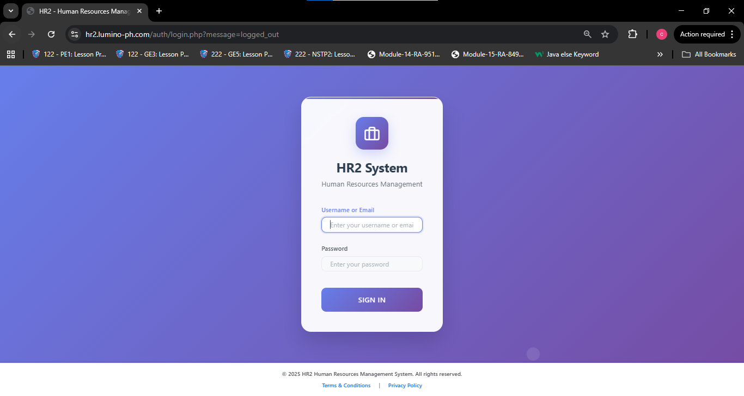

The **Login Page** serves as the secure access point to the Lumino HR2 System.  
**Purpose:** To authenticate system users — including employees, HR administrators, and managers — before granting access to their respective dashboards and system modules.

**Features:**

Username or Email and Password input fields for user authentication.

“Sign In” button that directs users to their designated dashboard upon successful login.

Built-in validation to prevent unauthorized system access.

Security protocols ensuring encrypted login credentials and session management.

**Functionality:**  
The login interface verifies user credentials against the HR2 system’s database and grants access according to the user’s role (Employee, HR Admin, or HR Manager). It ensures that sensitive HR data related to employee competencies, training, and succession planning is securely accessed only by authorized users.

1. **Competency Management**

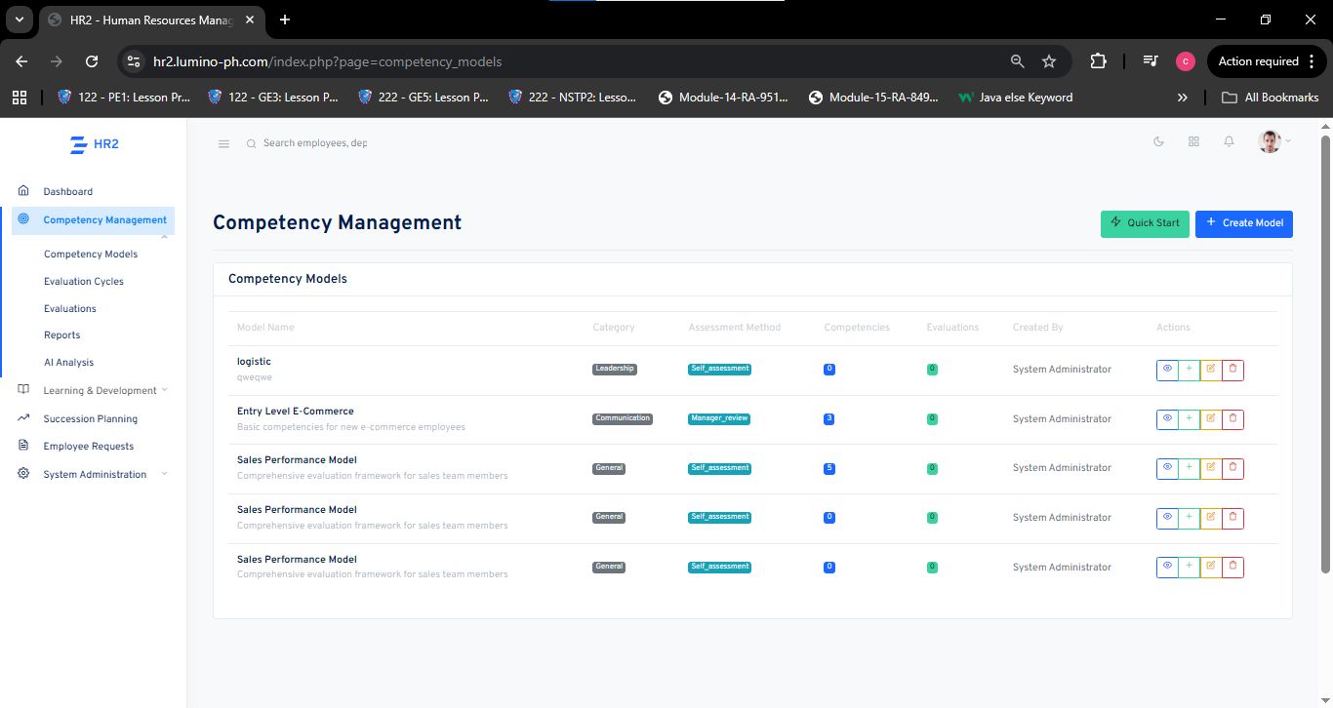

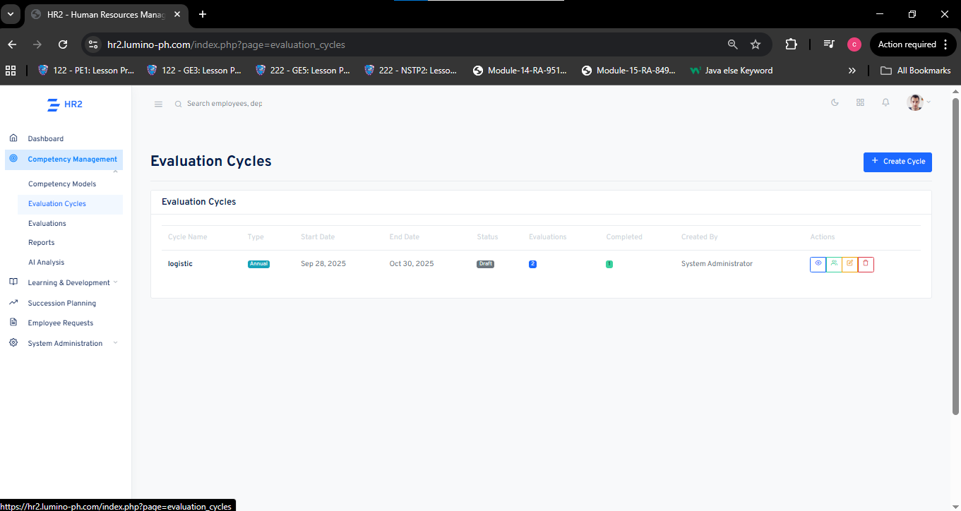

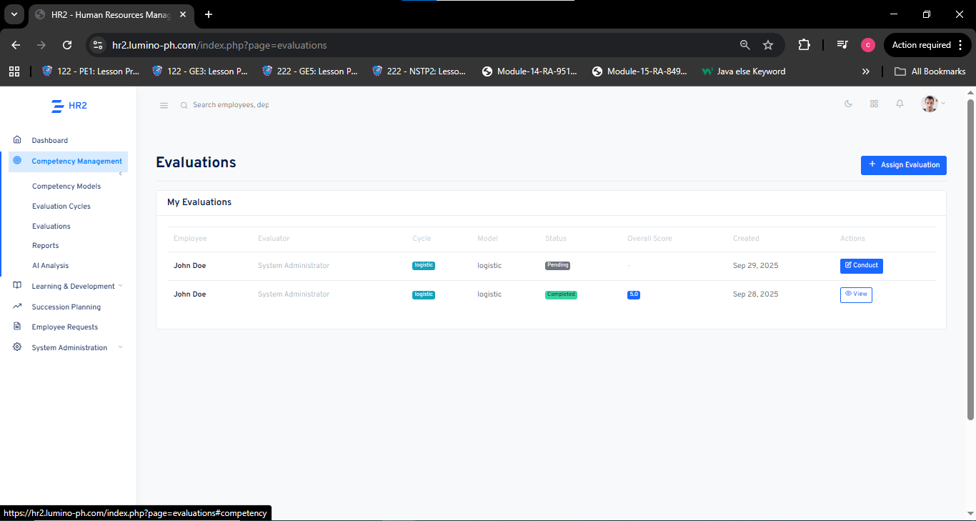

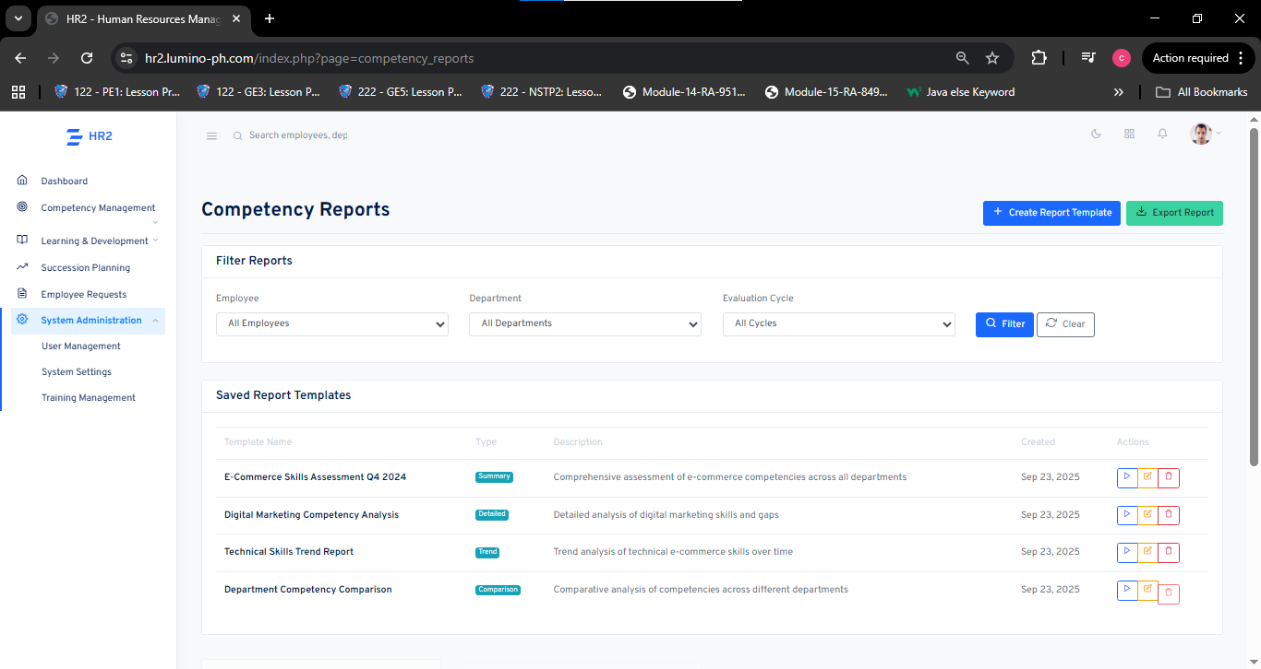

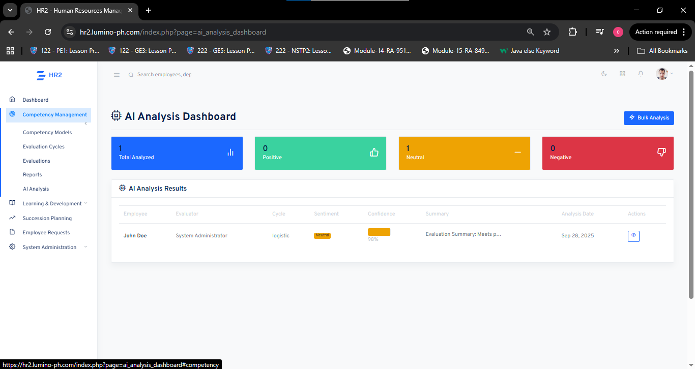

The **Competency Management** interface serves as the foundation of the Lumino HR2 system. It enables HR administrators and managers to define, organize, and assess employee competencies based on their roles and performance levels within the organization.

**Purpose:**  
To establish competency models, manage evaluation cycles, and monitor employee skill progression across different job categories, ensuring that performance and development are aligned with organizational goals.

**Features:**

* **Competency Models:** Allows administrators to create and categorize models (e.g., Leadership, Communication, Technical Skills) used to evaluate employees.
* **Evaluation Cycles:** Lets HR users define time-bound assessment periods such as quarterly or annual reviews.
* **Evaluations:** Enables HR or supervisors to conduct assessments and record competency scores for each employee.
* **Reports:** Generates analytical summaries and comparison reports to identify performance gaps, top-performing employees, and development needs.
* **AI Analysis Dashboard:** Automatically evaluates employee feedback to determine sentiment as positive, neutral, or negative. It helps HR quickly interpret performance data and make data-driven decisions for employee development.

**Functionality:**  
The module follows a structured evaluation process. HR administrators define competency models and assign evaluation cycles. Employees then undergo assessments through self-evaluation or manager reviews. The system automatically computes scores and stores results for future analysis. HR managers can generate reports to support data-driven decision-making in training and succession planning.

1. **Learning & Training Management**

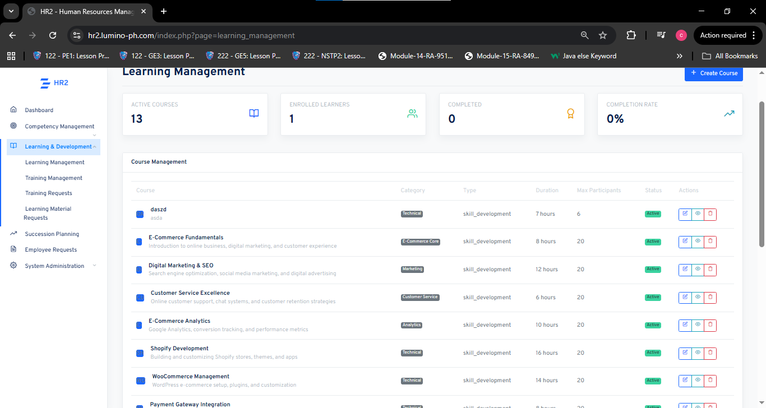

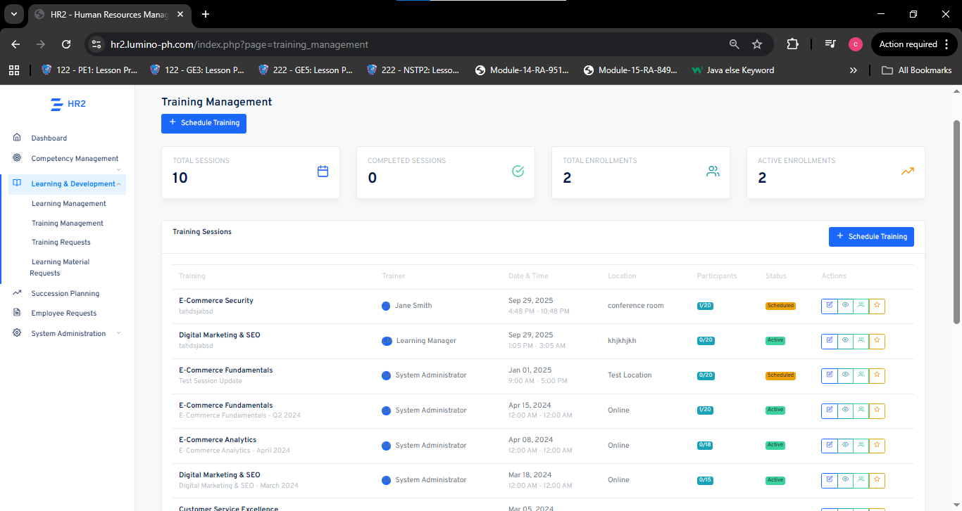

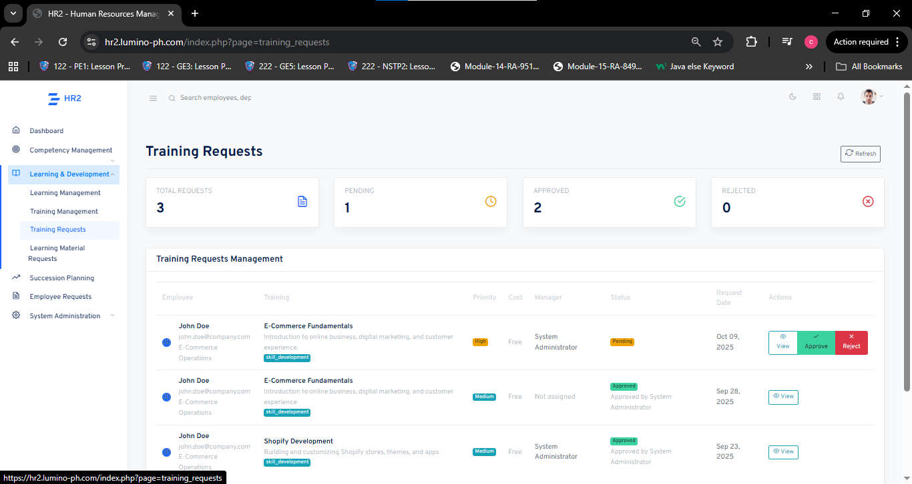

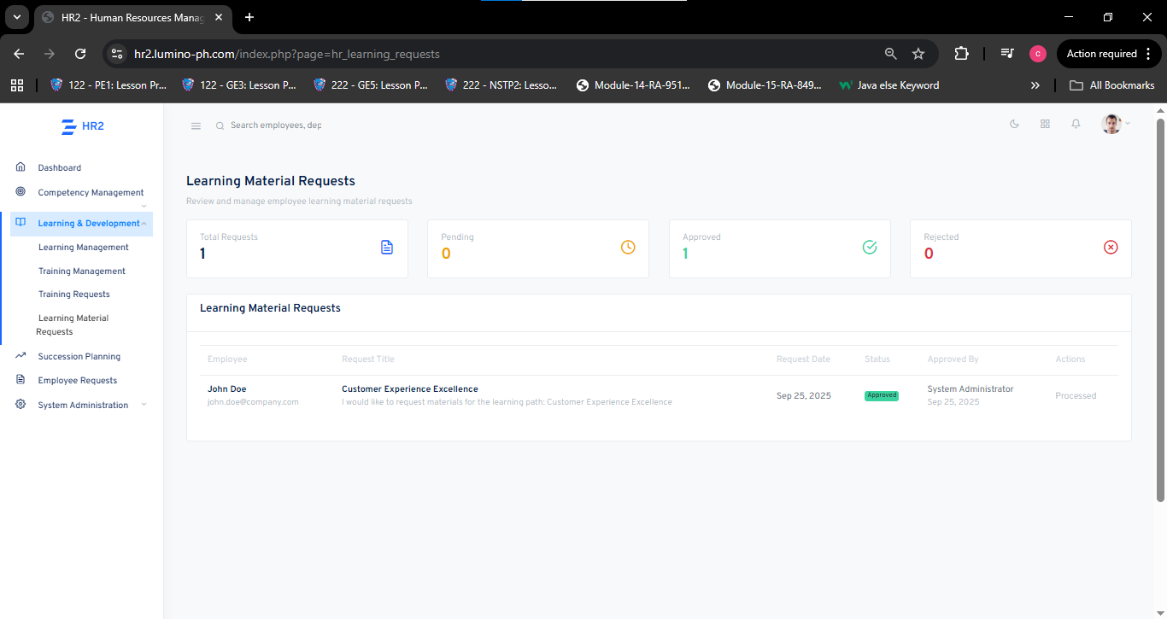

The Learning & Training Management module in the Lumino HR2 system consolidates learning courses, scheduled training sessions, training requests, and learning material requests into a single platform. It enables HR administrators and managers to create, organize, schedule, and track training programs, manage enrollments and trainer assignments, process employee requests for training and materials, and monitor progress and completion rates to measure training effectiveness.

**Purpose:**  
To provide a unified system that supports continuous employee development by managing courses and training sessions, handling training and material requests with an approval workflow, and producing actionable reports that align skill development with organizational goals.

**Features:**

* **Course Management:** Create, categorize, edit, and activate learning courses (Technical, Marketing, Customer Service, etc.).
* **Session Scheduling:** Schedule training sessions with assigned trainers, dates, locations, capacities, and format (online or in-person).
* **Progress & Completion Tracking:** Monitor active courses, enrolled learners, attendance, and completion rates.
* **Enrollment & Participant Management:** Manage enrollments, capacity limits, and participant lists per session.
* **Trainer Management:** Assign and manage trainer information for each session.
* **Training & Material Requests:** Allow employees to submit requests for specific training programs and learning materials.
* **Request Management & Tracking:** Track total, approved, pending, and rejected requests and display request details.
* **Approval Workflow & Priority Handling:** Route requests for manager/HR approval, support priority levels, and include cost considerations.
* **Learning Material Fulfillment:** Review, approve, and distribute study materials, guides, or references tied to courses.
* **Automated Status Updates:** Auto-update request and course statuses once processed or completed.
* **Reporting & Analytics:** Generate summaries and comparison reports to identify performance gaps, top-performing learners, and training ROI.
* **Role-Based Access:** Restrict create/edit/delete capabilities to administrators while allowing employees to view their enrollments and request statuses.

**Functionality:**  
HR administrators define and categorize courses, create training sessions with trainer assignments and capacity limits, and open enrollments. Employees enroll in courses or submit training and learning material requests specifying priority and justification. Managers and HR review requests, approve or reject based on relevance, cost, and resources, and approved requests are scheduled or fulfilled; the system automatically updates statuses and records distribution of materials. Throughout the cycle, the module records learner progress, attendance, and completion data and provides reports and dashboards for HR to analyze effectiveness, identify skill gaps, and plan follow-up development actions.

1. **Succession Planning**

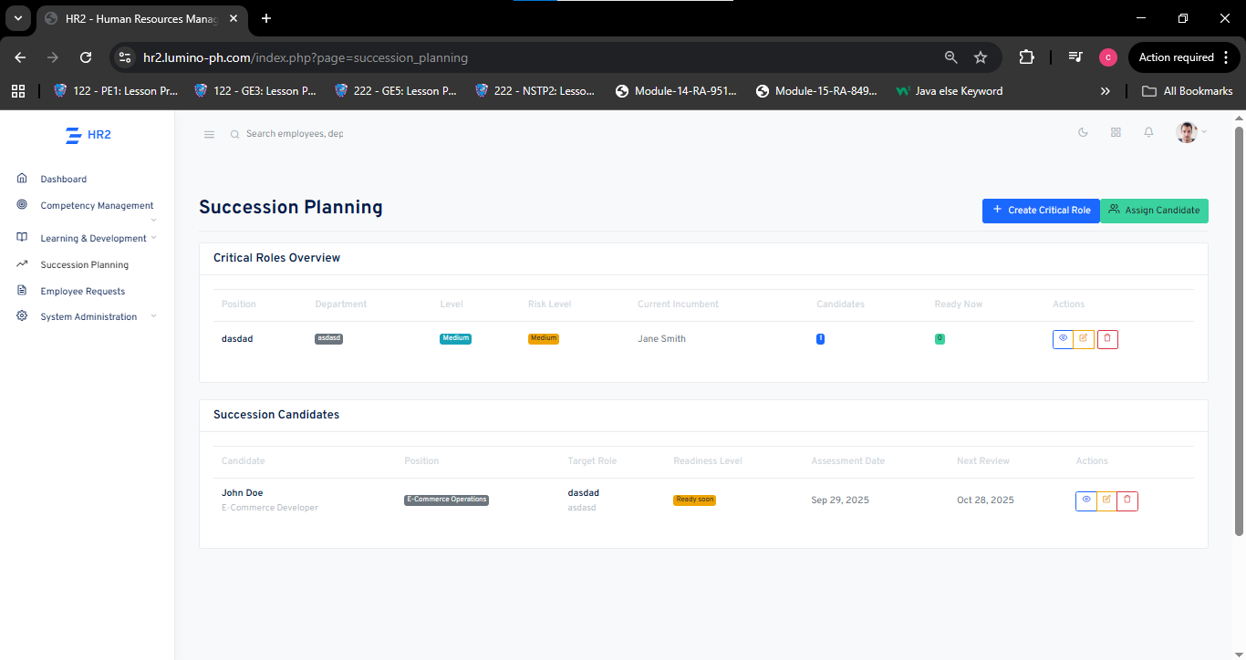

The **Succession Planning** module in the Lumino HR2 system helps organizations identify, assess, and prepare potential employees to fill critical roles in the future. It enables HR administrators to manage key positions, assign qualified successors, and monitor readiness levels to ensure smooth leadership transitions and business continuity.

**Purpose:**  
To maintain organizational stability by proactively identifying potential successors for key roles and preparing them through performance tracking and readiness assessments.

**Features:**

* **Critical Role Management:** Allows HR to define and manage essential positions within the organization.
* **Candidate Assignment:** Enables the assignment of employees as potential successors for critical roles.
* **Readiness Tracking:** Displays readiness levels such as “Ready Now” or “Ready Soon” to monitor candidate preparedness.
* **Risk Assessment:** Identifies positions with medium or high risk due to lack of ready successors.
* **Assessment & Review Dates:** Tracks assessment and next review schedules to ensure timely evaluation.
* **Current Incumbent Overview:** Displays the employee currently holding each critical role for easy reference.
* **Candidate Overview:** Lists potential successors, their current positions, target roles, and readiness levels.
* **Action Controls:** Provides options to view, edit, or delete roles and candidates directly within the interface.

**Functionality:**  
HR administrators can create critical roles, assign qualified candidates, and assess their readiness based on performance and potential. The system automatically tracks role risks, readiness statuses, and review timelines, allowing HR to make informed decisions and ensure leadership continuity throughout the organization.

1. **Admin Dashboard**

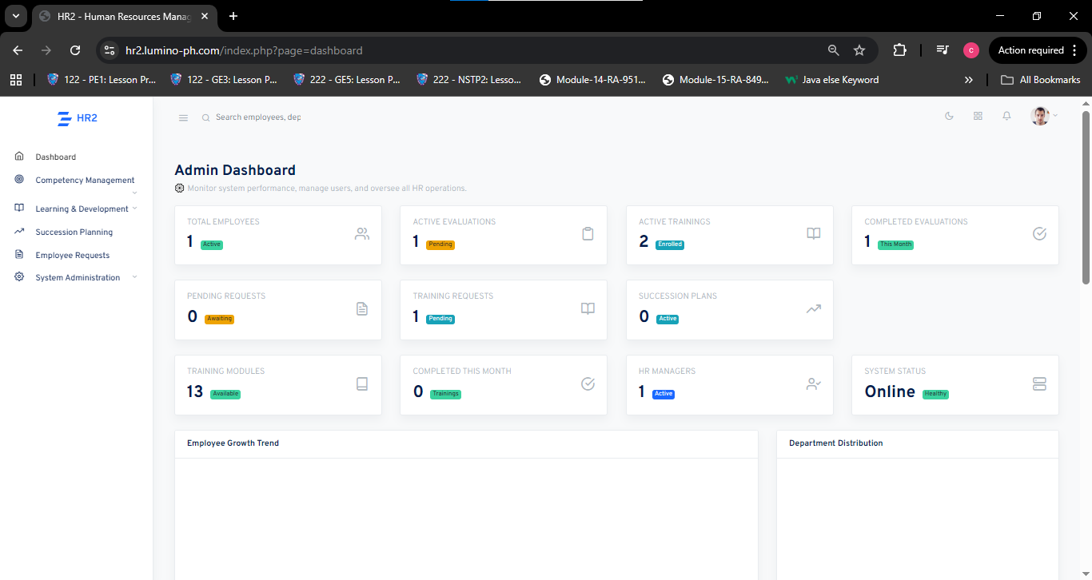

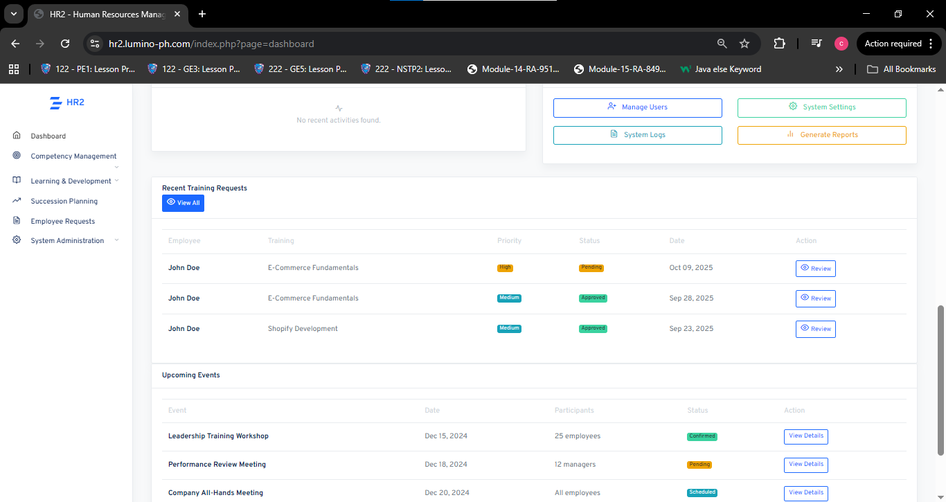

The Admin Dashboard in the Lumino HR2 system provides a centralized interface for monitoring HR operations, employee activities, and overall system performance. It allows HR administrators to manage users, oversee evaluations, monitor trainings, and track system status for efficient organizational management.

**Purpose:**  
To offer HR administrators a comprehensive overview of all human resource functions, enabling data-driven decisions and streamlined management of daily HR operations.

**Features:**

* **Employee Overview:** Displays the total number of active employees for easy workforce tracking.
* **Evaluation Monitoring:** Shows active and completed evaluations to assess employee performance.
* **Training Management:** Tracks active trainings, completed sessions, and total available training modules.
* **Request Tracking:** Lists pending and approved training or employee requests for better transparency.
* **Succession Overview:** Provides a quick look at active succession plans to ensure leadership continuity.
* **System Status:** Monitors the overall health and online status of the HR system.
* **User and System Controls:** Includes options to manage users, access system settings, view logs, and generate reports.
* **Recent Training Requests:** Displays employees’ recent training applications with priority and approval status.
* **Upcoming Events:** Lists scheduled HR events such as workshops and meetings with details and statuses.

**Functionality:**  
HR administrators can use the dashboard to monitor all active HR processes, track progress, and review real-time data from evaluations, training, and employee requests. This feature ensures smooth coordination across HR activities and supports efficient decision-making within the organization.

1. **Employee Self-Service (ESS)**

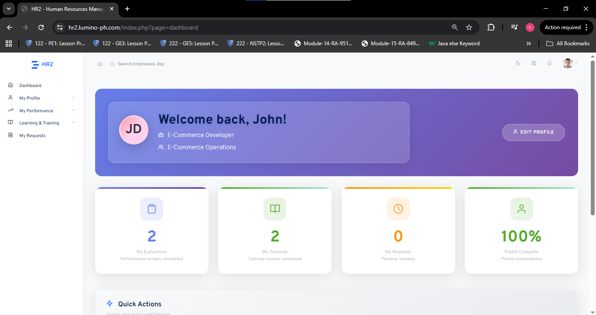

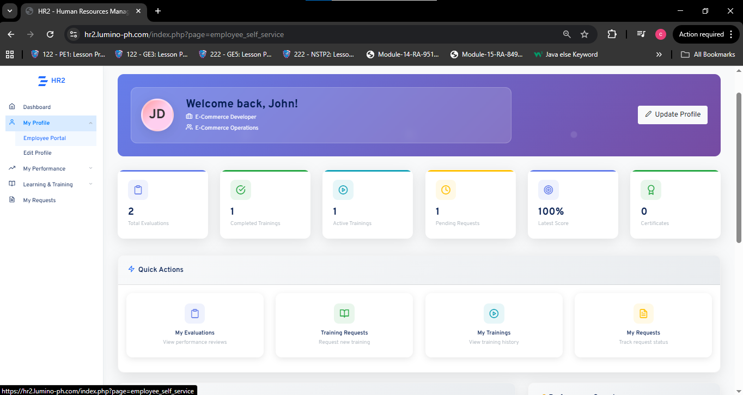

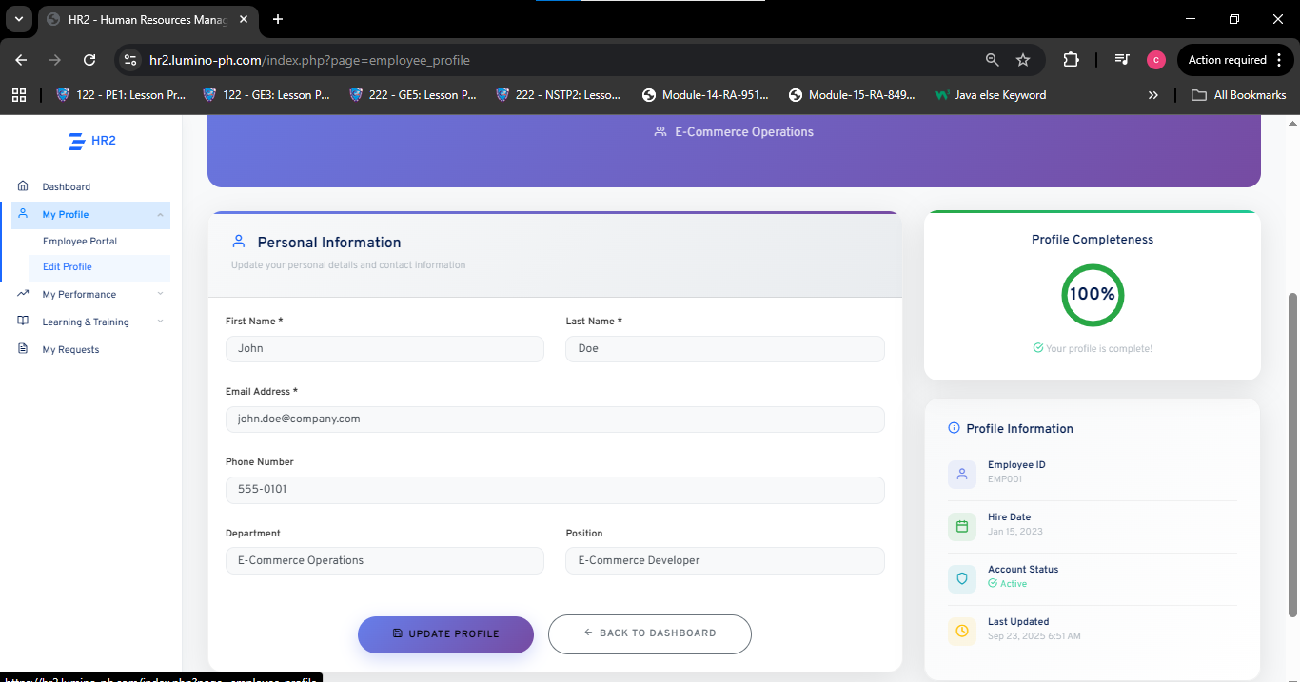

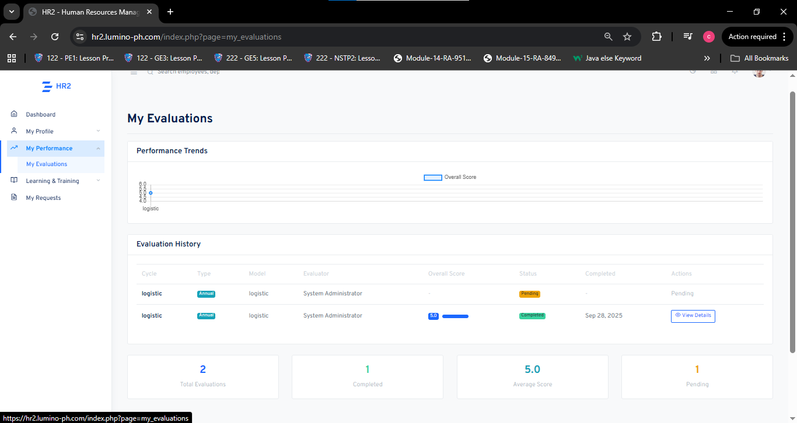

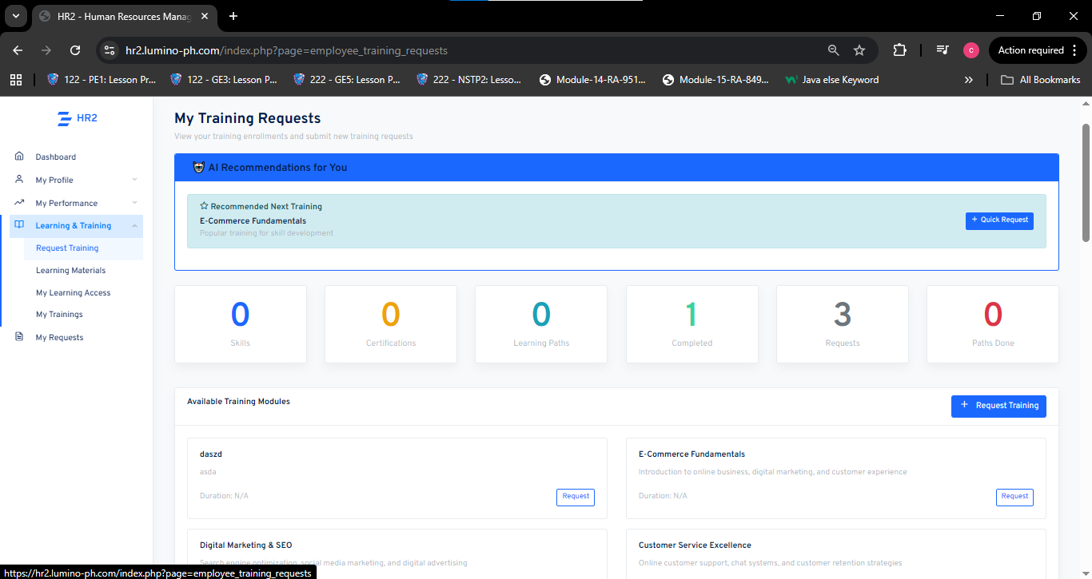

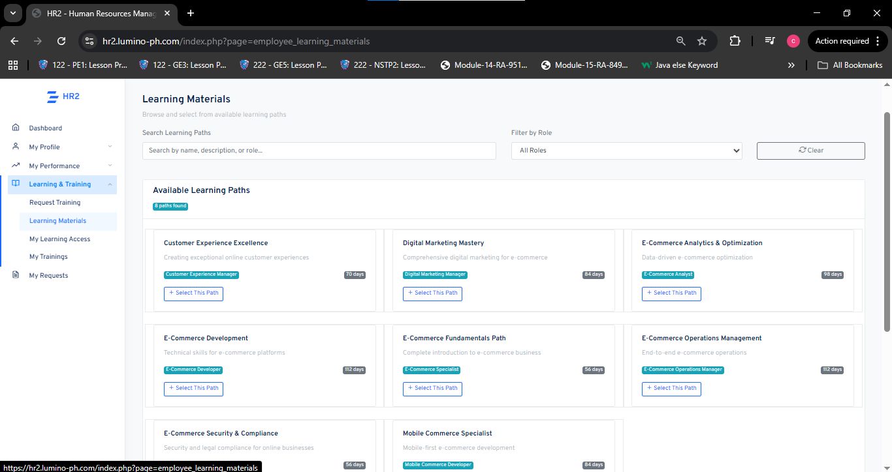

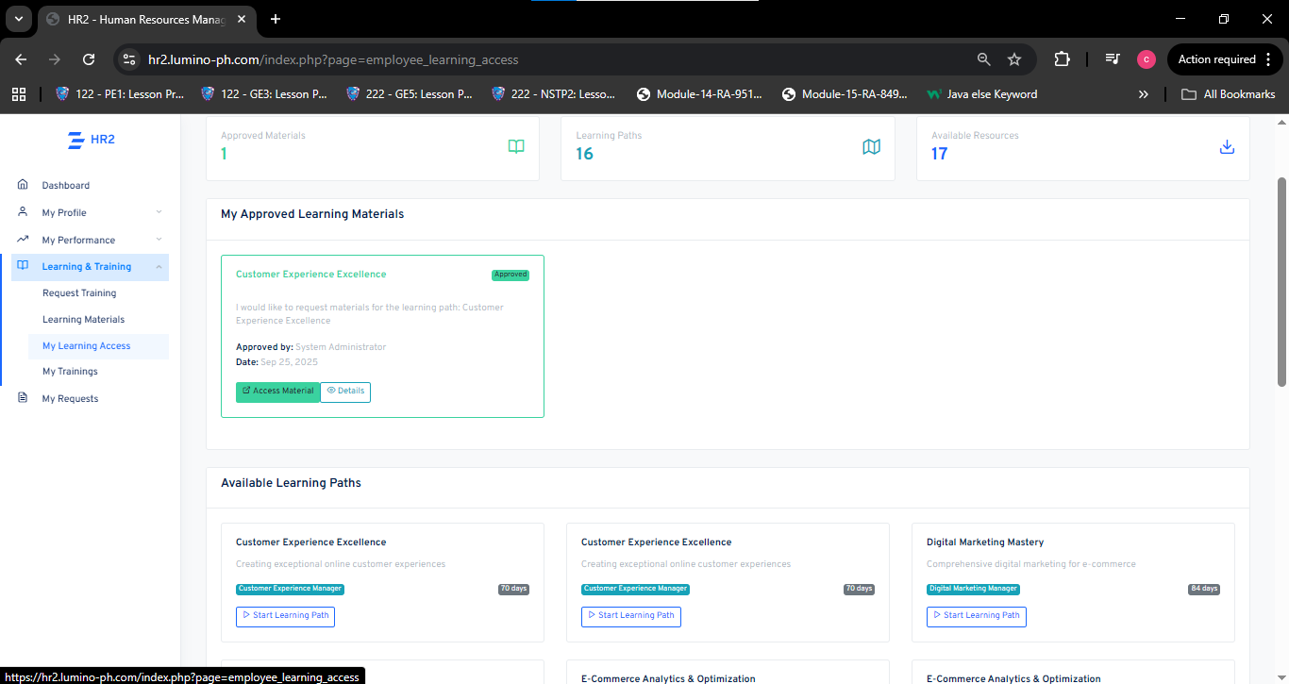

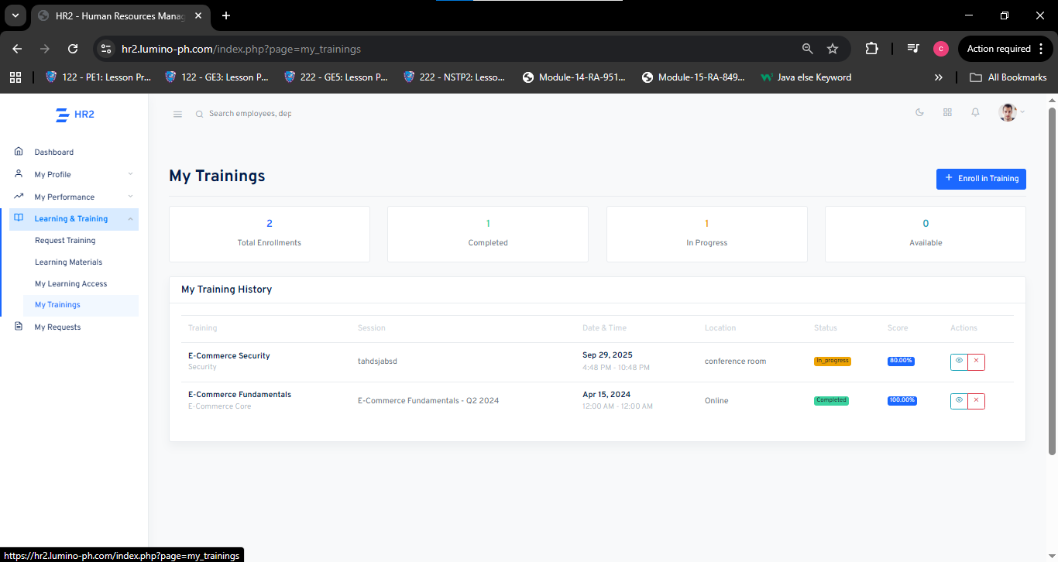

This section manages recruitment needs and job postings.

**Purpose:** To create and monitor job request and open positions.

**Features:**

* Overview of Total Jobs, Open Positions, Pending Approvals, and Applications.
* Job Requisition table(currently empty in the sample) showing Job ID, Title, Department Location, Type, Openings, Status, and Posted Date.
* Buttons for creating and exporting requisitions.

**Functionality:** Helps the HR department organize recruitment requests and manage the hiring process effectively.

**1. Security Measures**

To ensure the protection of employee data and maintain the confidentiality, integrity, and availability of information within **Lumino HR2: AI-Based Performance Tracking for Competency Evaluation in Remote E-Commerce Workforces**, robust data security practices are implemented. These measures are crucial in safeguarding sensitive information related to employee evaluations, competency profiles, training participation, and career development analytics.

**Role-Based Access Control (RBAC)** governs system accessibility, ensuring that only authorized users—such as HR administrators, HR managers, and employees—can access specific submodules and datasets according to their role. The principle of least privilege is enforced to prevent data misuse or unauthorized entry into restricted areas. **Multi-Factor Authentication (MFA)** strengthens this protection by adding an extra verification step during login, while secure session management (unique session IDs and automatic timeouts) minimizes risks of unauthorized access from unattended sessions.

**Data encryption** is applied to safeguard confidential records during storage and transmission. All sensitive data, including employee competency results, training completion records, and succession lists, are protected using secure protocols such as HTTPS/TLS and AES-based encryption standards. Regular key rotation and limited encryption key access further ensure data confidentiality and system integrity.

**Data minimization and retention policies** are enforced to limit the collection and retention of employee data to what is strictly necessary for HR2’s operational functions—Competency Management, Learning Management, Training Management, Succession Planning, and Employee Self-Service (ESS). Obsolete data is safely removed following secure deletion protocols that comply with the **Data Privacy Act of 2012 (RA 10173)** and company policies.

**System hardening and continuous monitoring** are carried out to maintain resilience against cyber threats. Regular vulnerability assessments, system updates, and penetration testing are performed to detect and mitigate potential security weaknesses. Firewall configurations, audit logs, and Intrusion Detection and Prevention Systems (IDPS) enable the early identification of suspicious activities. The system also follows secure coding practices to prevent exploits such as SQL injection and cross-site scripting (XSS).

Lastly, a **Security Awareness and Incident Response Plan** ensures that users and HR staff understand their responsibilities in data protection. In the event of a breach or attempted intrusion, established recovery procedures guarantee swift containment, investigation, and restoration of affected services. These combined measures provide comprehensive protection across all Lumino HR2 modules, ensuring confidentiality, integrity, and reliability of the organization’s HR data ecosystem.

**2. Testing and Quality Assurance**

The researchers conducted extensive testing of **Lumino HR2: Talent Development & Career Pathing** to validate its performance, accuracy, and stability across its five submodules—**Competency Management**, **Learning Management**, **Training Management**, **Succession Planning**, and **Employee Self-Service (ESS)**. Testing emphasized user interaction flow, AI integration accuracy, and the responsiveness of interlinked HR processes.

The **AI-driven functionalities**—specifically the **AI Analysis** and **AI Recommendation** features powered by the Hugging Face API—were evaluated for reliability and consistency. Results confirmed that the AI Analysis correctly interpreted qualitative feedback from competency evaluations, while AI Recommendations generated relevant training and career development suggestions based on employee performance data.

During **load testing**, the system efficiently processed multiple simultaneous user interactions, including HR managers reviewing evaluation results and employees updating their training progress. Only minimal latency occurred under heavy data loads, confirming that the backend structure and database queries were well optimized for real-time performance. No data corruption or unexpected system crashes were observed, ensuring data integrity during concurrent access.

**Integration testing** verified successful synchronization between HR2 submodules and external HR modules such as HR1 (Recruitment) and HR3 (Probation). Competency and training data transferred seamlessly, maintaining accuracy across connected systems. The overall results demonstrate that Lumino HR2 performs reliably under operational stress and supports consistent, secure communication across its components.

**User acceptance testing (UAT)** with HR personnel and test users confirmed the system’s usability, intuitive interface, and effectiveness in supporting competency-based evaluations and development tracking. Participants found that the AI-assisted feedback summaries and personalized training suggestions improved clarity and decision-making in employee development processes.

The findings validate that **Lumino HR2** effectively supports data-driven talent development by combining accurate evaluation, automated recommendation, and secure data handling. To sustain performance as the organization scales, regular system maintenance, monitoring, and periodic AI model evaluation are recommended. Continuous testing for response efficiency, integration reliability, and AI accuracy will ensure that Lumino HR2 remains a dependable, intelligent HR platform for remote and hybrid e-commerce workforces.

**Appendix C: Grammarian Curriculum Vitae**

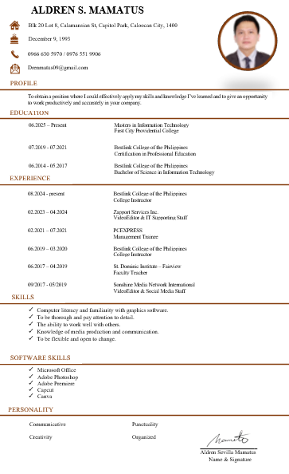

**AppendixD: Technical Adviser Curriculum Vitae**

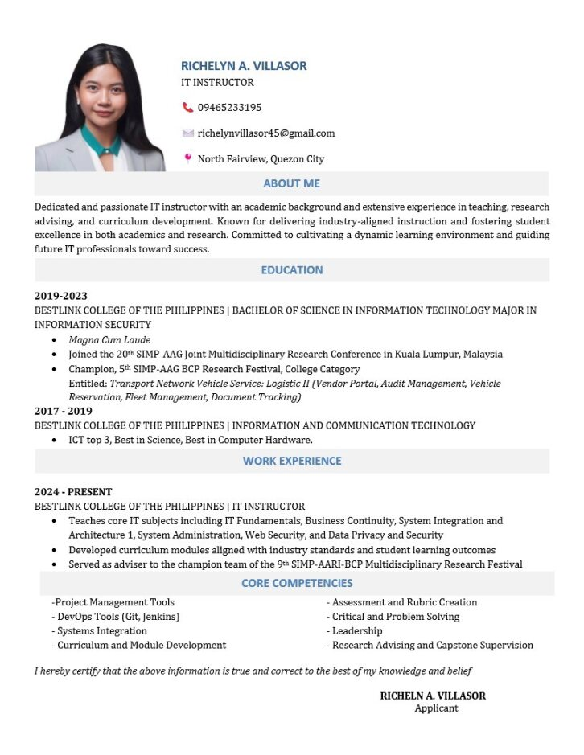

**APPENDIX E: Research Adviser Curriculum Vitae**



**AppendixF: Researcher’s Curriculum Vitae**



